

Boost Small Grants
2025/26 Programme Criteria

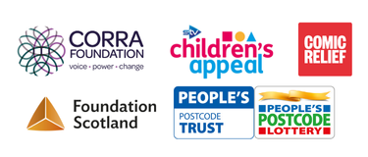
Contents
Introduction 3
Funding Criteria and Eligibility 4
What can you apply for and use the money for? 5
Application process 6
Decision making process 8


Introduction
The Boost Fund is for small community-led organisations across Scotland supporting local people affected by poverty or disadvantage. Groups can apply if their activities will support their communities and the people who live there. The work you are doing might be about providing practical help, or organising activities and gatherings, or addressing another local need. Boost provides grants of £500-£3,000 to constituted groups and charities with an annual income of £50,000 or less. Unconstituted groups can apply for grants of between £250-£1,500.
Thanks to an increase in the amount of funding available, Boost will re-open at the end of July 2025 and remain open until enough applications have been received to use all the money. From July 2025 there is £750,000 available to distribute through March 2026, and we will consider applications in the order they are received. Approximately 10% of the funding available will be made in grants to unconstituted groups.
Boost 2025/26 is delivered by Corra Foundation and is a partnership between STV Children’s Appeal, Comic Relief, Foundation Scotland, and Corra Foundation, and is supported by players of People’s Postcode Lottery.
If you have questions after you have read the online materials, we are happy to help. The fastest way to get hold of us is by emailing communitygrants@corra.scot.

Funding Criteria and Eligibility

Who can apply?
The following types of groups can apply, as long as they meet the other criteria:
- Charities registered in Scotland;
- Constituted voluntary or community organisations or CICs;
  - All constituted groups and CICs must have at least three members on their Board/committee. If your group is registered on Companies House, we will check this.
  - If you are registered on Companies House, we will also check that no person has more than 50% control of your group.
  - All constituted groups and CICs need to have governing documents which clearly state that:
    - The organisation is not for profit, or has a clear clause ensuring that all income is applied to the organisation’s purposes and not distributed to members, shareholders, or owners.
    - There is a dissolution clause/lock in place requiring that assets are distributed to an organisation with similar charitable aims in case of closure.
- Unconstituted community groups;
  - An unconstituted group is likely to be a small group of people providing activities in their local community but without a written constitution. It is not a project of a larger organisation. Because these groups are unlikely to have the same information available about their activities as charities and constituted groups, we will want to speak with you as part of the application process.
If you received a Boost grant previously, you can apply again if it has been longer than 12 months since you received your grant and you have completed the project you wanted to do, used all of your Boost grant and have returned our progress report form.
We cannot accept applications from:
- Organisations with an income of more than £50,000 in their last financial year.
- Organisations that are not established as not for profit.
- Organisations based outside Scotland or working outside Scotland.
- Groups applying for funding to pass on to other groups or individuals.
- One organisation applying on behalf of another.
- Groups asking for funding to support faith-based work.
- Projects of larger organisations.
- Individuals.
- Groups that have had a Boost grant in the last 12 months.

What can you apply for and use the money for?

Priorities
This funding is to support the activities and running of small groups that improve lives in their local area. The application will ask you to explain what challenges, especially poverty, your community faces.
We will prioritise applications from groups that can show a need for funding. As part of the application, we will look at how much money you already have available. If you already have 12 months or more running costs, you are unlikely to get funding from this programme.

How much can you apply for?

- Charities, CICs and other constituted groups can apply for £500 up to a maximum of £3,000.
- Unconstituted groups can apply for a minimum of £250 up to a maximum of £1,500.

For all groups, funding should be used within 12 months of when you receive your grant.

What can you use the money for?

We understand that every group has different needs and ideas. We encourage you to think about what you need the funding for. It could fund a brand-new project, help you continue a project, buy small items of equipment, or support your running costs such as utilities or rent. We will ask you to explain how a grant will support your local activities.

What we can’t fund

The following are outwith criteria:

- Major capital appeals including building projects, motor vehicles and refurbishment costs.
- Retrospective funding.
- Promotion of religion.
- Activities which are party political.
- Mainstream activities and statutory requirements, for example of hospitals and medical centres, schools, universities, and colleges.
- Work that takes place outwith Scotland.
- Bursaries or scholarships.
- Contributions to funds which will be used for grant making to other organisations and/or individuals. This includes onward distribution of cash and/or vouchers.
- Sponsorship or marketing appeals.

Application process
We recognise that application forms and assessment processes can present barriers in accessibility and have tried to overcome these as much as possible.
If you feel that you would benefit from additional support – for example, by completing this form in a different language or accessing the form in a different format – please get in touch with us at communitygrants@corra.scot or by calling 0131 444 4020. The quickest way to reach us is through email.
Application Process
Stage 1: Read the fund guidance
Please read this document in full to ensure you have all the information you need before applying. Advice and support are available throughout the application process. Please contact us at communitygrants@corra.scot.
Stage 2: Complete your application online
The online form is available to access on the Boost Fund webpage. A Word version of the form is available if you would like to draft your responses. You will be asked to first complete an eligibility checker which will tell you whether you meet the main criteria to apply for a Boost Fund grant.
The application is then broken into sections:
- Information about your organisation.
- Contact details for a person in your organisation.
- How you would use a grant from the Boost Fund.
- Bank account details.
- Attachments, including a recent bank statement (no more than 6 months old), your most recent financial accounts (less than 18 months old), and your organisation’s constitution or governing document if you are not registered as a charity.
Unconstituted groups may not have a bank account, annual accounts, or governing documents. We understand this and will be in touch to discuss your application and how any grant awarded can reach you. You will be able to submit your application without these documents.
Stage 3: Confirmation that we've received your application form.
When we receive your application, you will receive an email confirming we have received your form. If you do not receive this, please contact us at communitygrants@corra.scot.

Key principles
It is important that charities and groups working with communities are well run, manage money properly, and treat people fairly. You can show this by:
- Knowing what your group can do to keep children and vulnerable adults safe. This is often referred to as ‘safeguarding’. You will be asked about this on the application form.
- Working with openness and transparency. We will read your constitution to look at this (unless you are already a charity registered with OSCR) or discuss this with you on the phone if you do not have a constitution.
- Listening to, and actively involving, the people who use your group or service.
- Keeping accounting records, including recording money received and spent by your organisation and producing annual figures/accounts. If requested, we can provide you with a simple form for keeping track of how you use this grant. If you are already used to managing funding, then the way you currently do this is probably fine. Please see our application guidance notes for more information.
If you are a charity, CIC or other constituted group, you operate with good governance including:
- having a governing body which has a minimum of three Committee Members, Trustees or Directors;
- If there are family members on the board/committee that there is always one independent member;
- No one member of the board/committee has 50% or more control;
- Meeting at least quarterly;
- Any payments to members of the committee/board being detailed in a formal written agreement.
If you are an unconstituted group:
  - we will speak to you about your group (how you manage any monies you receive, how often you meet, how people can get involved);
  - we will ask you to provide the name of a referee for your group. This should be someone local who knows about your group. It needs to be someone who is willing to speak with us to confirm that they know and support your activity. Examples of referees include:
      - someone working in a charity that knows your group,
      - a local teacher,
      - a local faith leader,
      - the manager of your village hall or community centre,
      - a community councillor or other elected official.

Decision making process
We will consider applications in the order they are received. When the funding is all distributed, the programme will close for this year.
All applications are assessed in the following process:

 | Your application is reviewed and assessed by a Corra grants advisor. They may be in contact with you at this point to ask some follow up questions.
 | Applications are peer reviewed by other Corra staff. At this stage, some applications may not progress if they are not eligible or a good fit with the fund theme.
 | If successful, the main contact listed on the application will receive an email advising them of the grant amount and payment information.

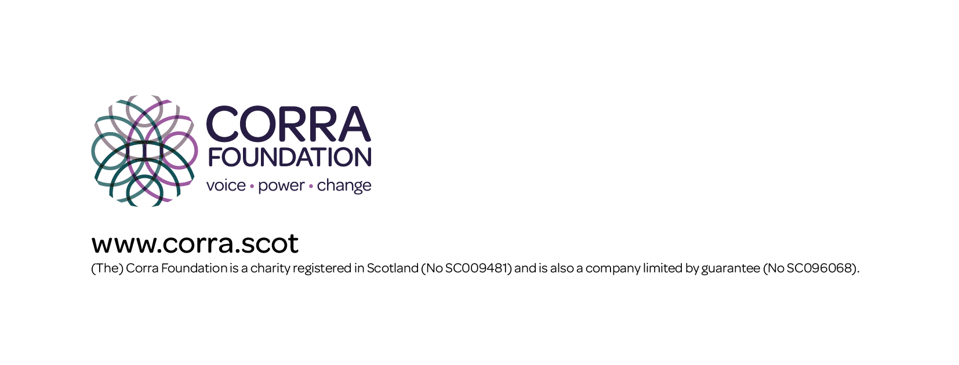
About Corra Foundation
Corra Foundation exists to make a difference to the lives of people and communities. It works
with others to encourage positive change, opportunity, fairness and growth of aspirations which improve quality of life. Corra wants to see a society in which people create positive change and enjoy fulfilling lives.

In 2020 Corra launched a ten-year strategy. It is long term because making a different on the big challenges will take time. At its heart is the strong belief that when people find their voice, they unlock the power to make change happen.

Our ways of working
At Corra we have a set of principles that we strive to put into practice across our roles as an
employer, independent funder, charity and partner, as well as in our influencing activity.

We will:

- Listen and respond to people, communities and organisations and amplify voices that are less well heard – their wisdom is at the heart of Corra’s approach.
- Build relationships, always working alongside others on the basis of shared power, mutual trust and shared learning.
- Pursue diversity, equity and inclusion (DEI), trying to challenge structural discrimination and contribute to radical shifts in the funding sector.
- Be an open, trusting and flexible grant maker.
- Ensure we contribute to tackling climate change, through our investments, operations and grant making and encouraging others to take action alongside us.
- Be bold, taking considered risks and supporting others to do the same.

Date of publication: 21st July 2025

Corra Foundation
Office Suite 30 Pure Offices
4 Lochside Way
Edinburgh EH12 9DT
e: hello@corra.scot
t: 0131 444 4020

