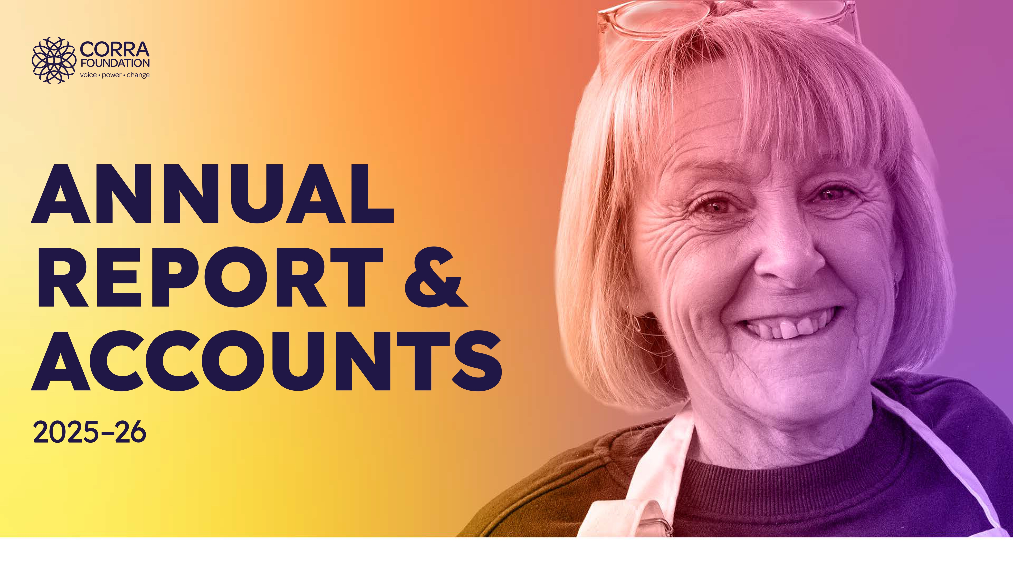
Introduction Highlights Stories of change Bold ten-year strategy Working into practice Looking ahead Accounts 02

CONTENTS


03 Introduction
05 What we do
06 Our strategy 2020 – 2030 07 Our ways of working
08 A Message from our Trustees 09 Thank you from our Chair
11 Impact
12 2025 – 2026 Highlights
14 Stories of change
31 Delivering our bold ten-year strategy
33 Power to create change rests with people themselves
40 People with ideas for radical change are supported, skilled, connected and confident
43 People are working together to respond to the big challenges in Scotland
47 Putting our Ways of Working into practice
51 Looking ahead
53 Accounts
54 Financial Review and Carbon Reporting
54 Statement of Financial Position
63 Structure, Governance and Management
65 Governing document
68 Independent Auditor’s Report To The Trustees Of Corra Foundation
72 Statement of Financial Activities
- Statement of Cashflows
- Notes to the Accounts


Introduction Highlights Stories of change Bold ten-year strategy Working into practice Looking ahead Accounts 03

INTRODUCTION
Corra is a Scottish grant-making charity that is about strengthening and amplifying people’s voices and their power to make change.

Introduction Highlights Stories of change Bold ten-year strategy Working into practice Looking ahead Accounts 04

Corra’s vision is for a society where people can create positive change and enjoy fulfilling lives.

Our mission is to make a difference with people and communities, by encouraging positive change, opportunities, fairness and growth of aspirations which improve quality of life.

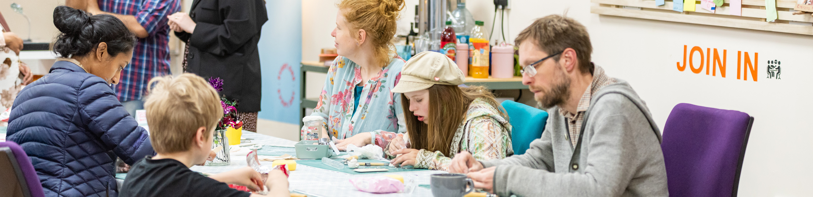

Introduction Highlights Stories of change Bold ten-year strategy Working into practice Looking ahead Accounts 05

WHAT WE DO

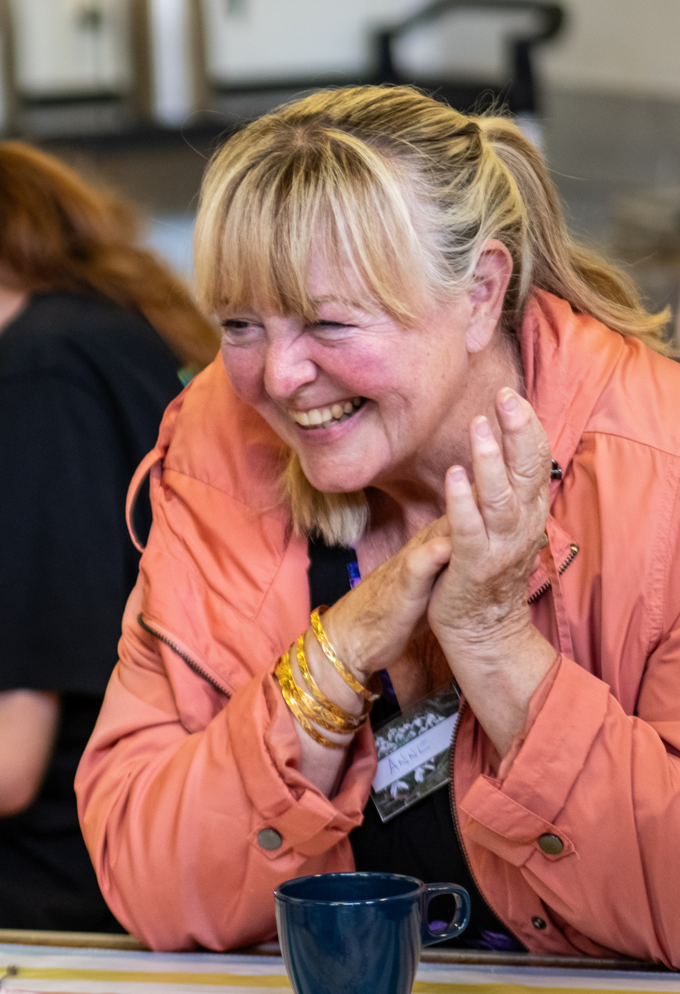
Grant-making is an important part of Corra’s contribution – increasingly via participatory approaches, ie. via lived experience panels. Corra also manages grants on behalf of others.
Our place-based work hopes to support communities to connect with each other and to use their
voice and power to influence wider system change.
Corra aims to influence policy and the wider funding landscape. We use learning and evidence and create opportunities for people who hold power, and those furthest from it, to come together.

Introduction Highlights Stories of change Bold ten-year strategy Working into practice Looking ahead Accounts 06

Our strategy 2020 – 2030

Corra’s strategy is a response to the world we live in, and to the one we want to play a part in building. It is long term because making a difference on the big challenges will take time. At its heart is the strong belief that when people find their voice, they unlock the power to make change happen.

From 2020 – 2030, Corra will help to bring about three big changes, so that:
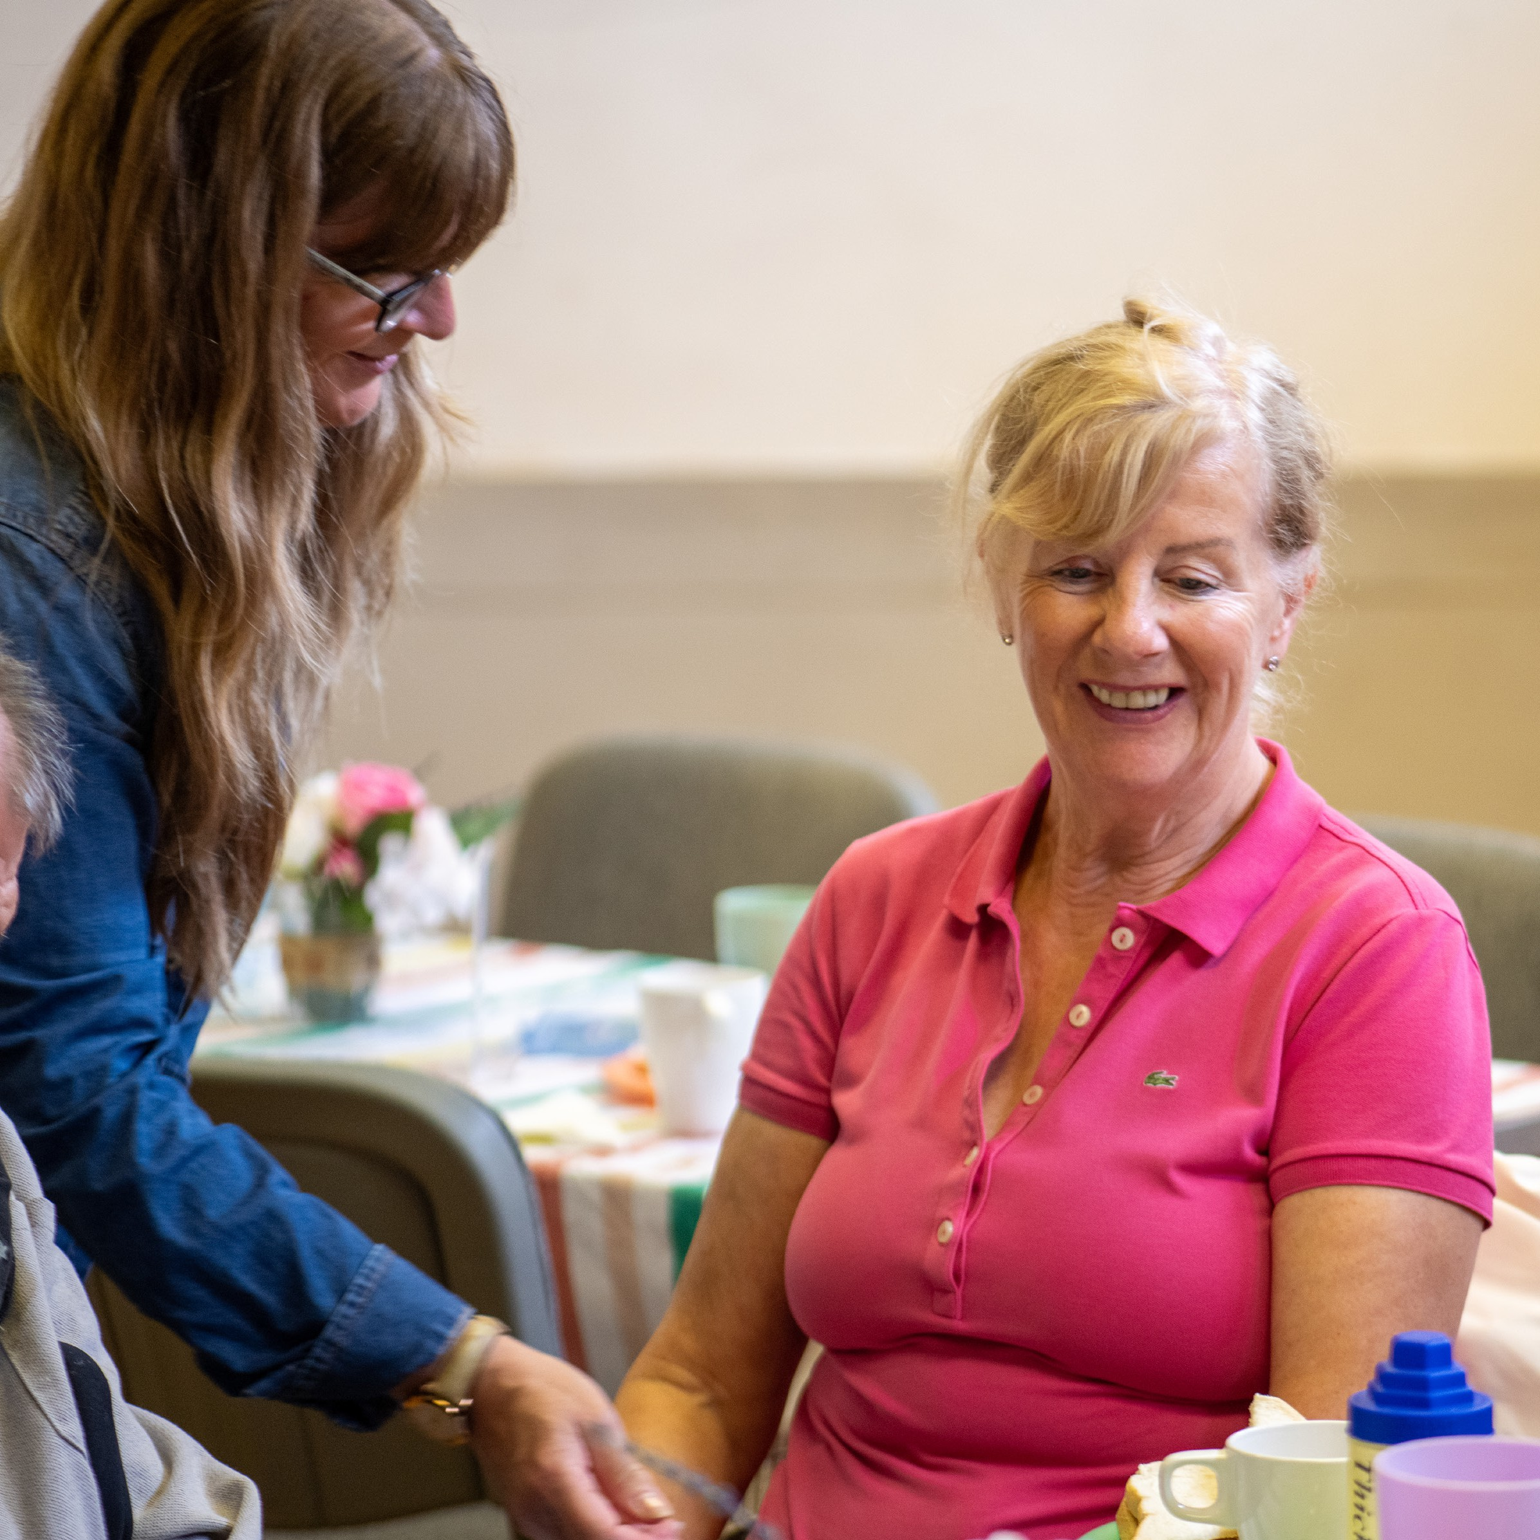
- The power to create change rests with people themselves.
- People with ideas for radical change are supported, skilled, confident and connected.
- People are working together to respond to the big challenges facing Scotland.
Having a bold ten-year strategy means that Corra can develop new ways of working, as well as building and deepening partnerships. We’ll continue to work alongside communities and make grants, with a growing focus on supporting voice, power and action.

Introduction Highlights Stories of change Bold ten-year strategy Working into practice Looking ahead Accounts 07

Our ways of working
At Corra we have a set of principles that we strive to put into practice across our roles as an employer, independent funder, charity and partner, as well as in our influencing activity.

We will:
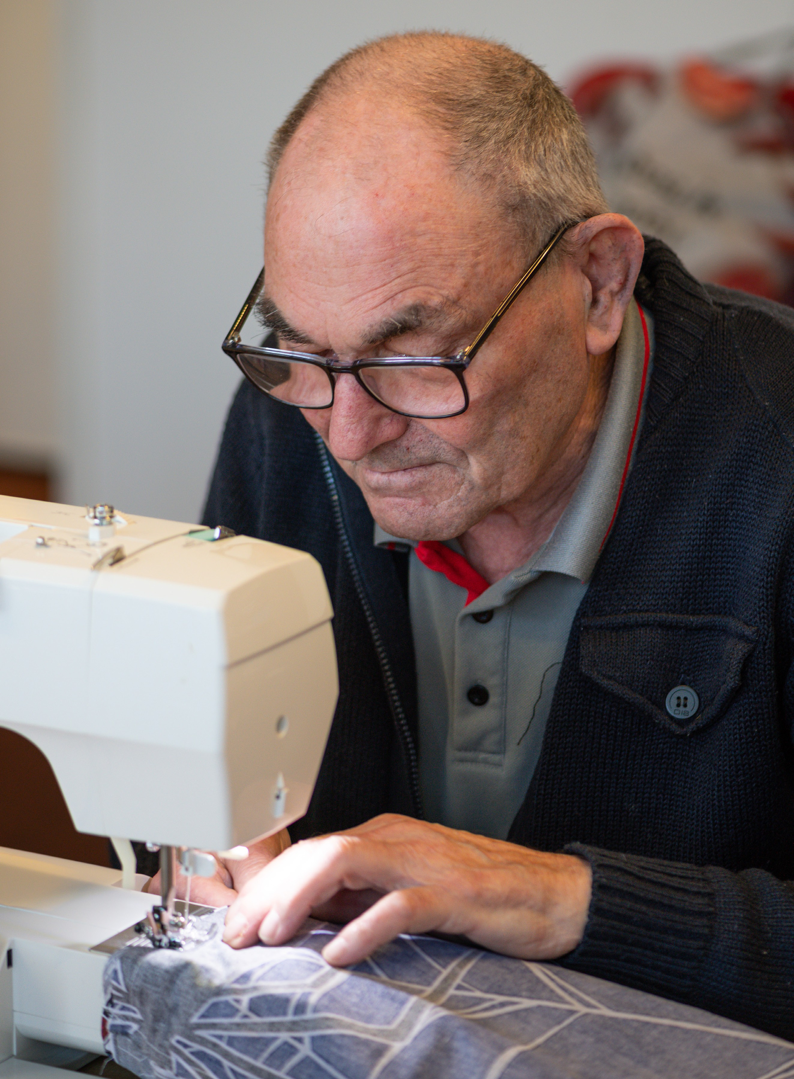
- Listen and respond to people, communities and organisations and amplify voices that are less well heard – their wisdom is at the heart of Corra’s approach.
- Build relationships, always working alongside others on the basis of shared power, mutual trust and shared learning.
- Pursue diversity, equity and inclusion (DEl), trying to challenge structural discrimination and contribute to radical shifts in the funding sector.
- Be an open, trusting and flexible grant maker.
- Ensure we contribute to tackling climate change, through our investments, operations and grant making and encouraging others to take action alongside us.
- Be bold, taking considered risks and supporting others to do the same.

Introduction Highlights Stories of change Bold ten-year strategy Working into practice Looking ahead Accounts 08

A Message from our Trustees

Over the past year it has been a privilege to support groups across Scotland working to create positive change. This has been against a backdrop of financial pressures, global turbulence, and efforts
to divide people. Against these
headwinds the third sector has shown itself to be critical in our everyday lives, and a powerful force for hope. Charities and groups have created spaces that let people come together, get to know one another and build strong communities.
At Corra we made a commitment in 2020 to becoming an anti-racist organisation. In the past year we have spoken out in solidarity with Black and racially minoritised communities impacted by racist violence, the increasing threat of the far right and daily experiences of a hostile environment. Alongside this, we have increased our funding to groups tackling racism and promoting racial equity.
Positive change happens when we listen to communities. Corra’s ten-year Getting Alongside Communities programme concluded this year with a legacy of increased community leadership, voice and action. In Kirkcaldy our Every One Every Day team has been pioneering the We Build Bridges approach in Scotland, and we have established the new Community Leadership Collective to support local leaders from across the country.
Lived expertise is at the heart of our grant making, with participatory approaches shifting power towards people closest to the issues. Our funding has been guided by commitments to open and trusting grant making, to increasing
long-term and unrestricted funding, and to supporting un-constituted groups.
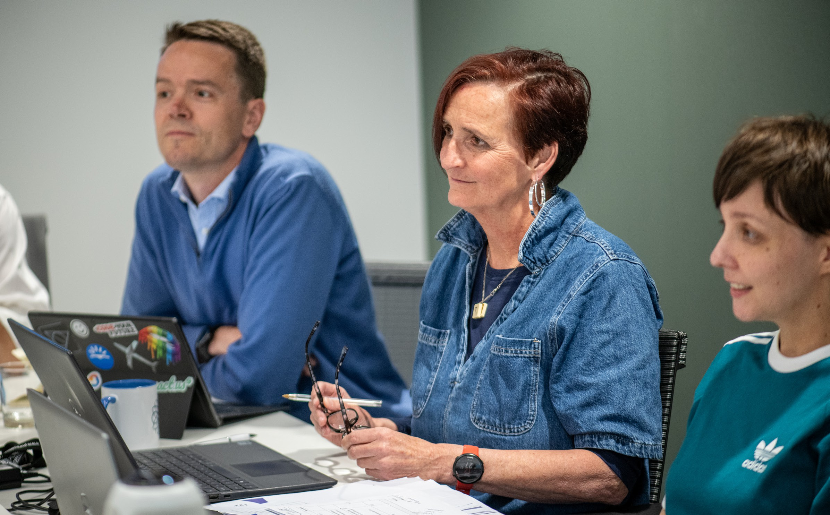
As we look back at the past year, we will reflect carefully to learn and improve as we move into the year ahead. We hope to further extend our reach and deepen our relationships with diverse communities. We will seek to sustain Boost as a rolling programme supporting crucial community-focused activity. And we will continue to build partnerships so we can make a bigger difference on the issues that matter to people.

Introduction Highlights Stories of change Bold ten-year strategy Working into practice Looking ahead Accounts 09

Thank you from our Chair

On behalf of everyone at Corra I would like to thank all those who have worked alongside us in the past year. Collaboration is at the heart of our strategy. Only by coming together can we hope to make the difference we aspire to.
I would like to thank my fellow Trustees who so generously contribute their time and expertise. We said farewell to colleagues David Johnson and Claire Gibson, whose terms concluded in 2025, and to Nosheen Ahmed in early 2026. David, Claire and Nosheen brought a wonderful combination of
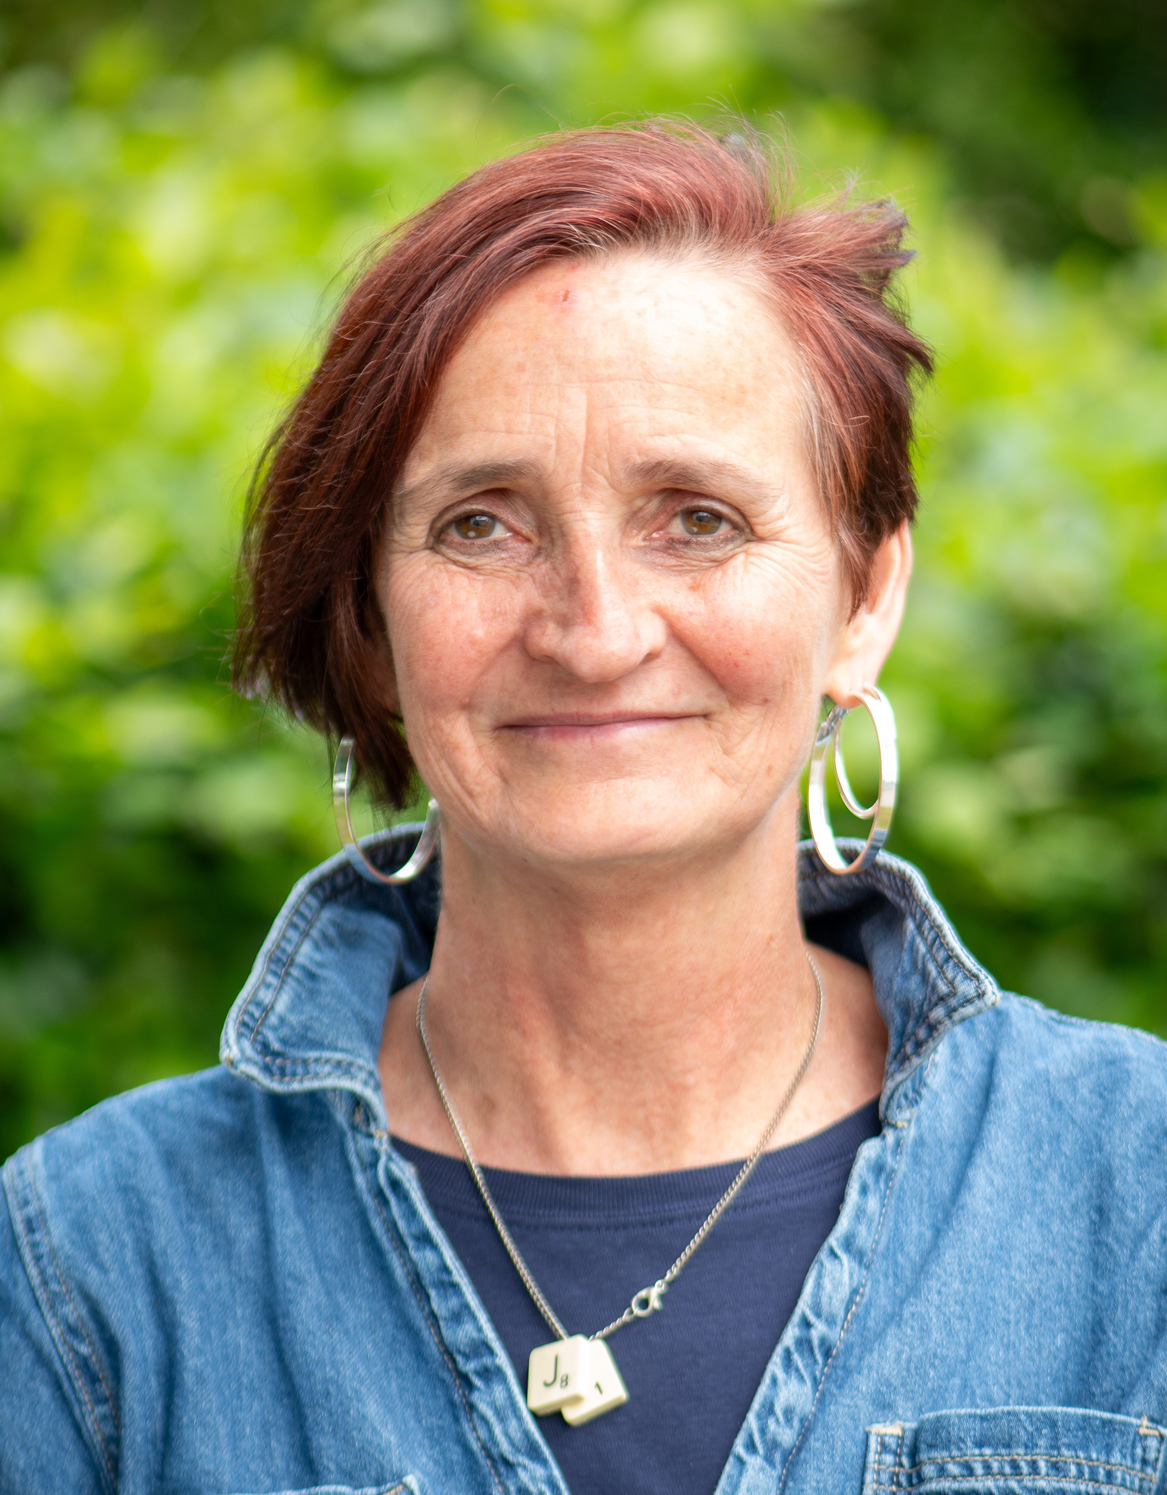
professional and personal skills. Claire joined Corra in December 2016 with a background in youth work, a deep knowledge of the third sector and a focus on
helping drive lasting transformation. David became a Trustee in August 2016, bringing extensive experience from the third sector and government. He made a substantial contribution to Corra’s anti-racism work, championing this within the board and providing thoughtful, supportive input as part of Corra’s Anti-racism Working Group. Nosheen served on the board between September 2022 and April 2026, bringing valuable insights on day-to-day realities for smaller charities and how Corra’s support and grants could best reach them.
In the past year we have been delighted to welcome two new Trustees. Rob Scholes joined in December 2025 and Kirsten Tollerton in March 2026, both bringing significant financial expertise.

Introduction Highlights Stories of change Bold ten-year strategy Working into practice Looking ahead Accounts 10

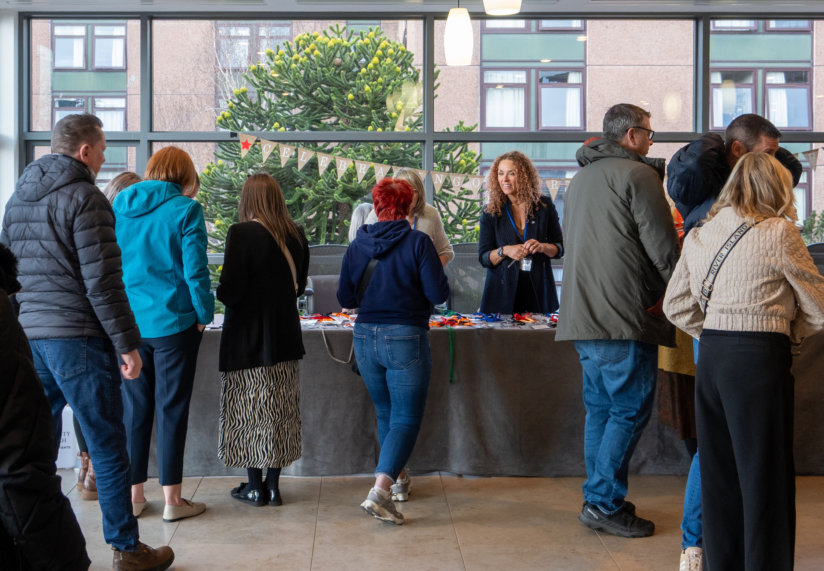
None of what is in this report would have been possible without the dedicated staff team. I extend a deep thanks to everyone who works as part of Corra, and to Carolyn Sawers for her skilled leadership and her invaluable support to Trustees.
At Corra we believe that when people find their voice, they unlock the power to make change happen.
I would like to thank all the people across Scotland who have allowed us to work alongside them over the past year. We have learned, been inspired and had the true privilege of seeing what is possible when communities shape the change they need.
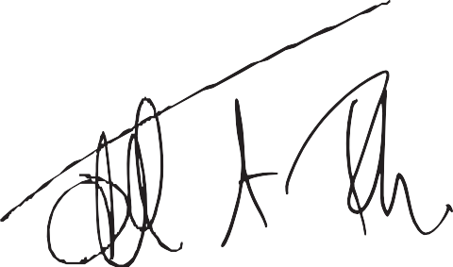
Judith Turbyne
Chair, on behalf of board of Trustees 17th September 2026


Introduction Highlights Stories of change Bold ten-year strategy Working into practice Looking ahead Accounts 11

IMPACT
HEAD
Body
Our impact over the 2025-26 financial year.


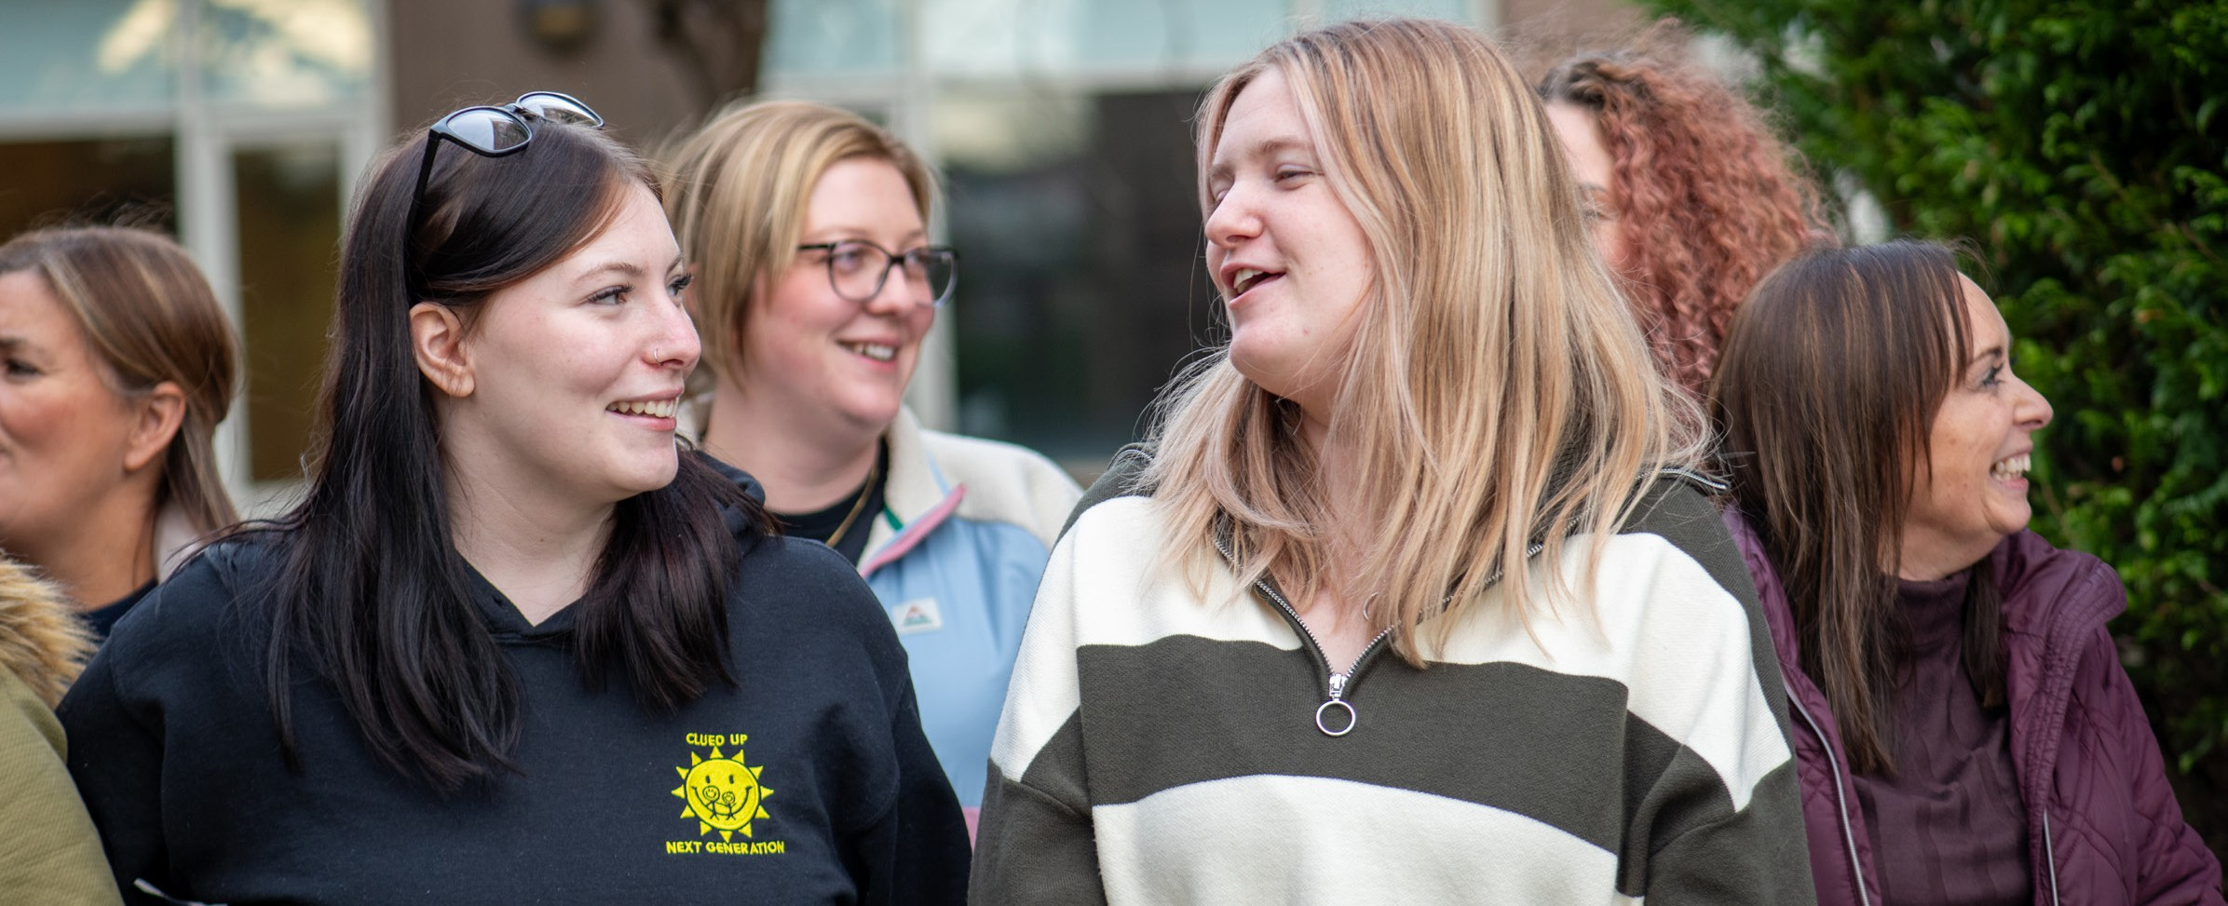
Introduction Highlights Stories of change Bold ten-year strategy Working into practice Looking ahead Accounts 12
Almost half of all grants were made to organisations that were new to Corra.
Contributed to work supporting 182,000 people.

2025 – 2026 Highlights
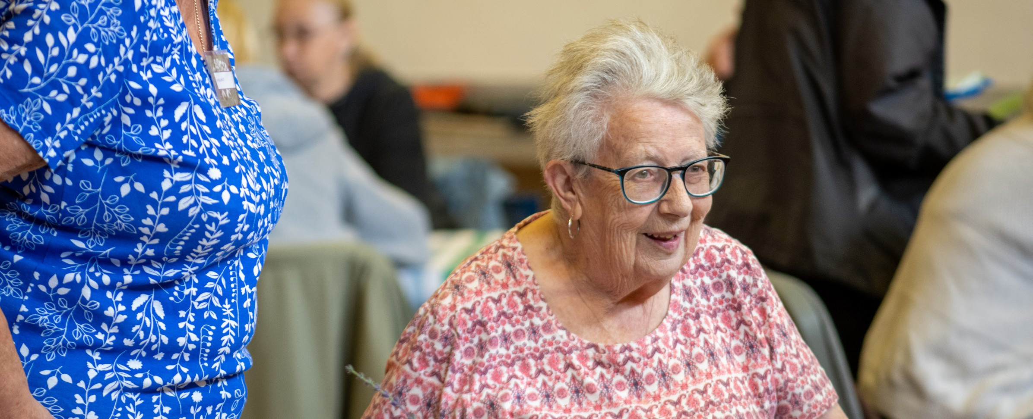
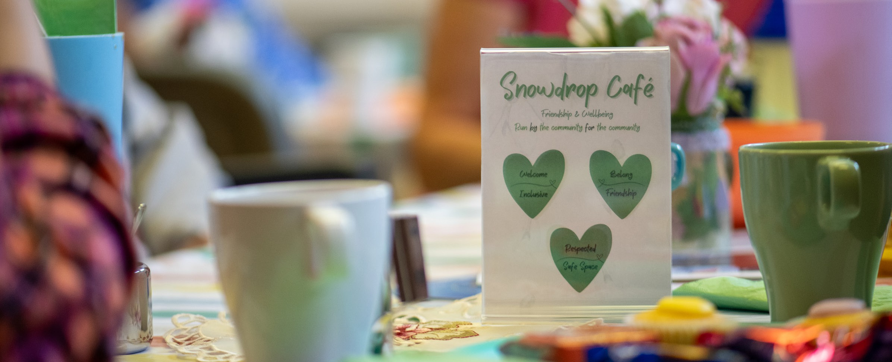
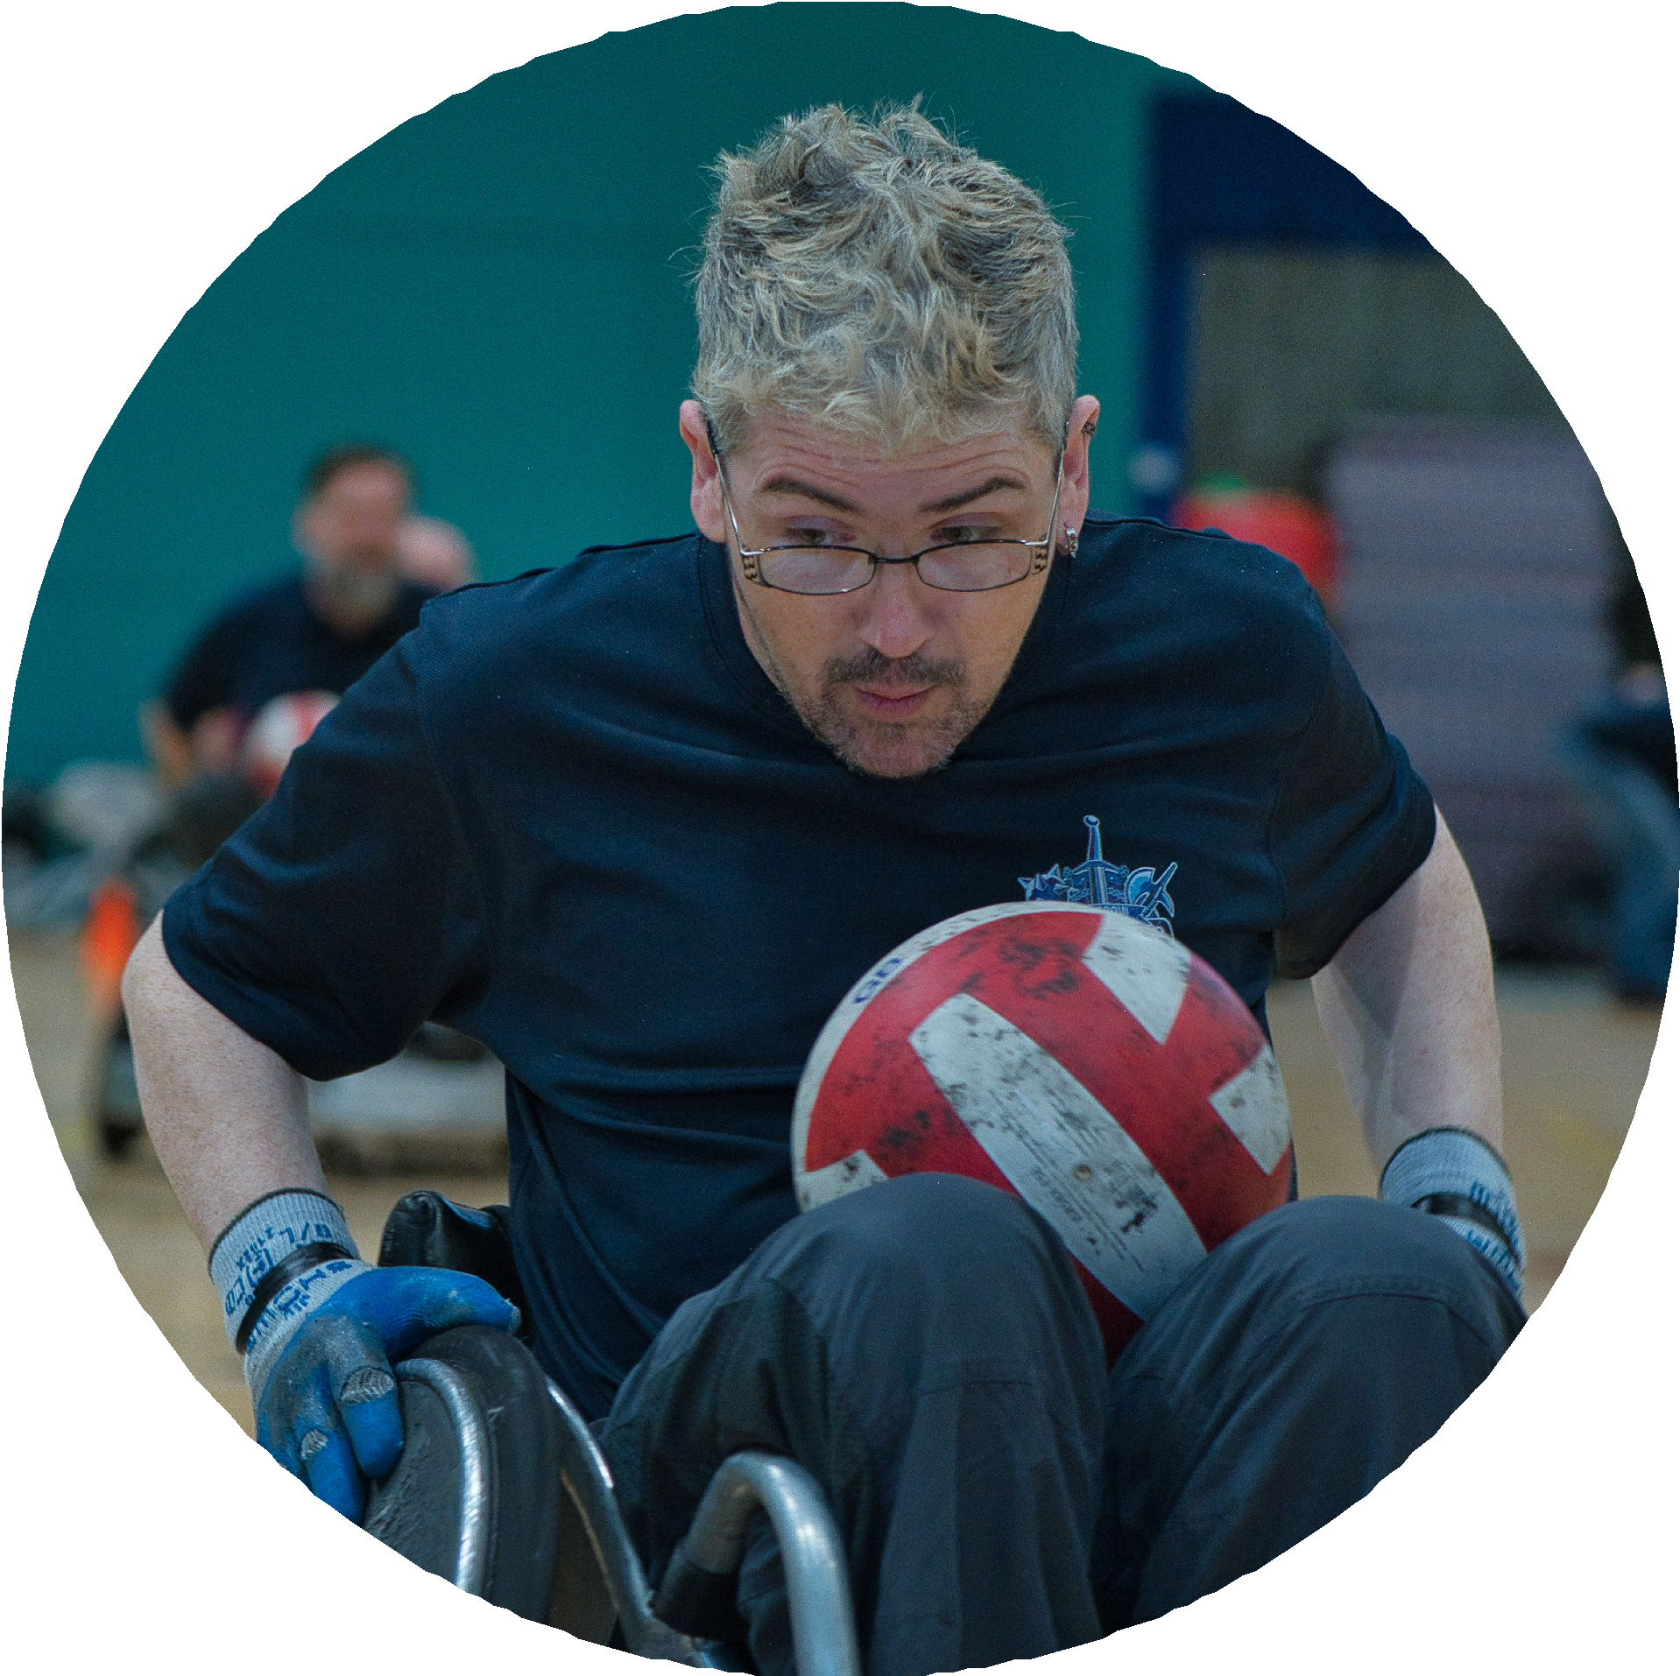
Distributed £27.9m across Scotland.
674 new grants totalling £7.75m across 17 funds.
91% of funding distributed was multi-year (up from 83% last year).

Introduction Highlights Stories of change Bold ten-year strategy Working into practice Looking ahead Accounts 13

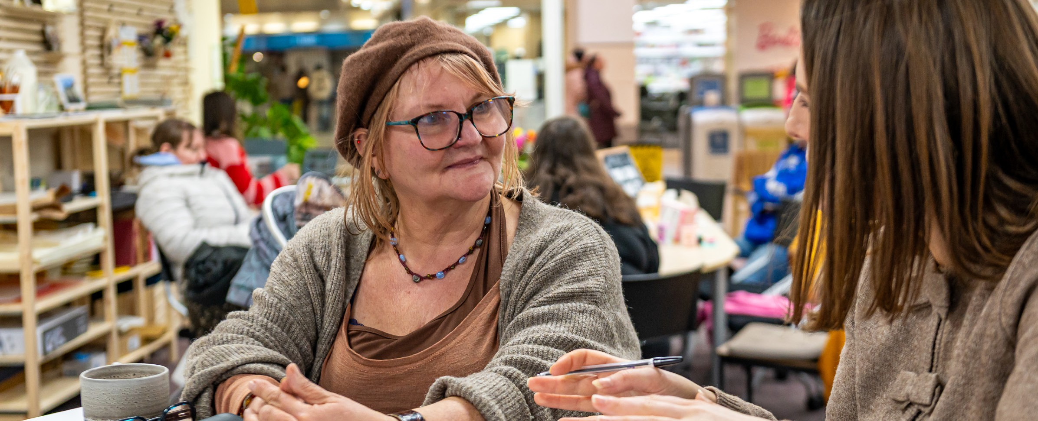
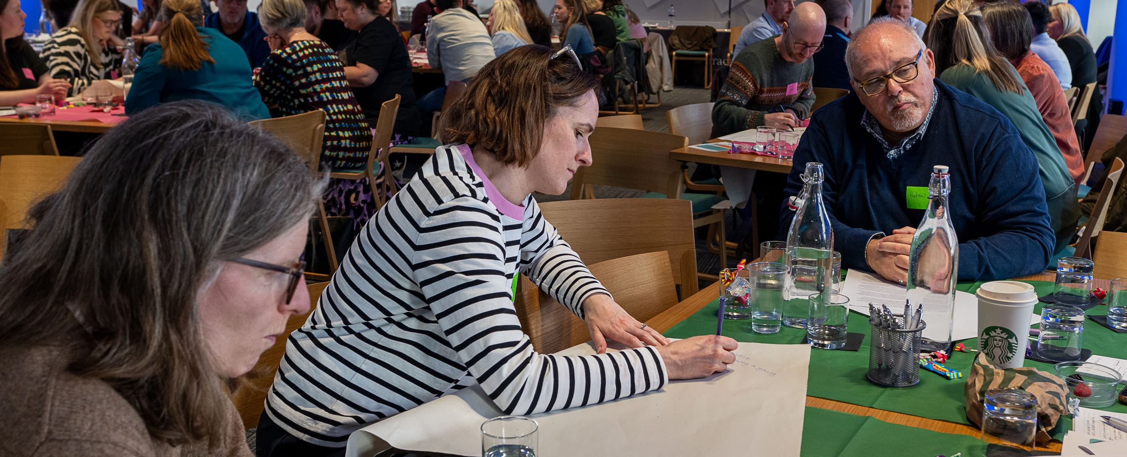

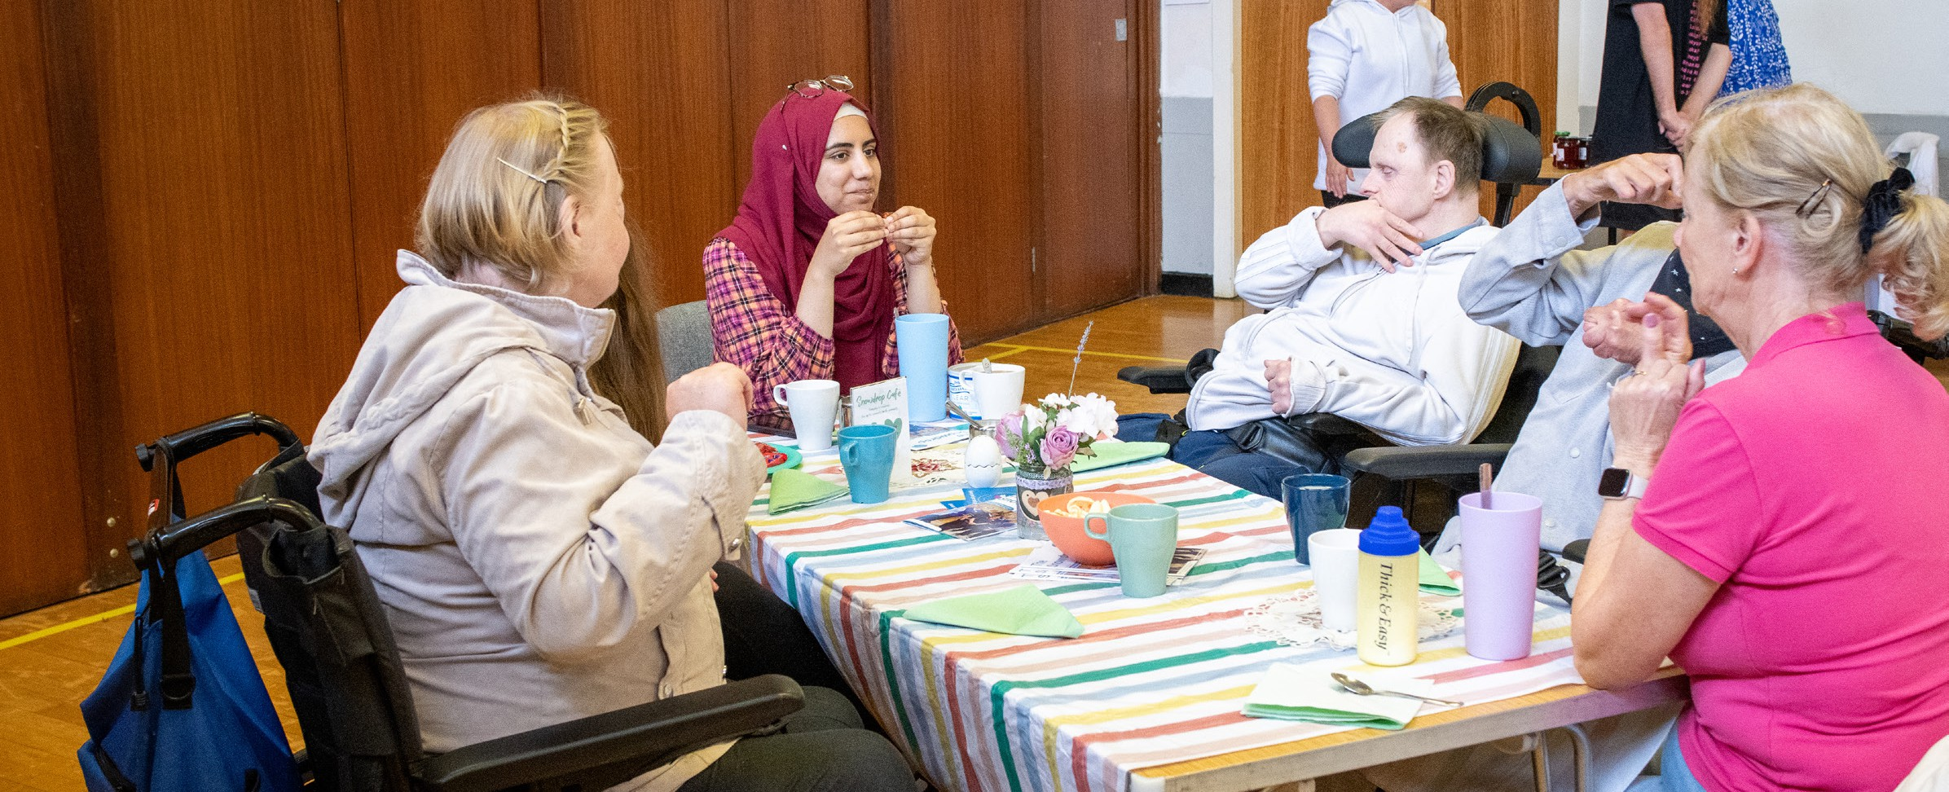
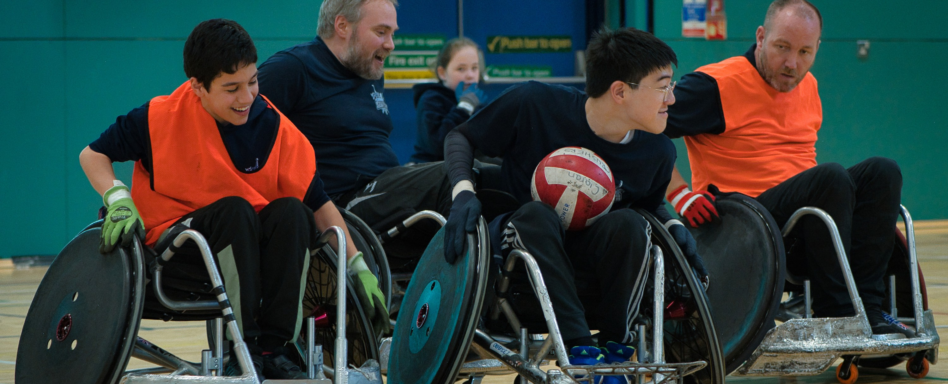
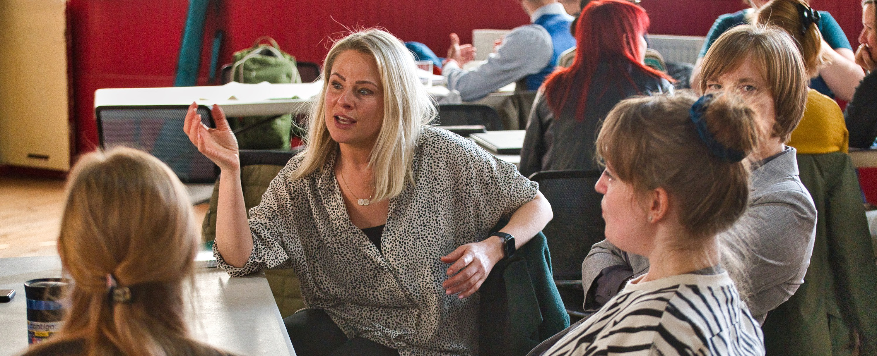
Average success rate for grant applications was 68%.
Almost a third of applicants were groups led by people with lived experience.
37% of the organisations that applied to Corra in 2024/25 were led by people from Black and racially minoritised communities.
Reached a milestone of having distributed over
£7.3m since 2020 to groups led by communities who have experienced racial inequality.
Received 1,100 applications from all 32 local authority areas across Scotland.
Collaborated as part of 26 partnerships.


Introduction Highlights Stories of change Bold ten-year strategy Working into practice Looking ahead Accounts 14

STORIES OF CHANGE
Many of these stories are drawn from pieces written by the groups themselves. Several are based on longer pieces written by Mairi
Damer. Most can be found on Corra’s website. We are deeply grateful to the groups for taking the time to share their stories with us.
This is just a snapshot of the incredible work that Corra has the privilege to play a small part in supporting across Scotland.

Introduction Highlights Stories of change Bold ten-year strategy Working into practice Looking ahead Accounts 15




Community activism and chaos – Pride Cumbernauld shines bright
(Cumbernauld and Carbrain were among the areas involved in Corra’s Getting Alongside Communities work)

In 2025 members of the local community held the inaugural Pride Cumbernauld. A group of volunteers came together, including Alix, the teenage founder of Club at the Hub, an LGBTQ+ youth group that runs out of Cumbernauld and Carbrain Community Hub. The group formed a board, with Alix acting as vice chair and around 10 other core members who drove the project.
The grounds of Palacerigg Country Park were
offered for the event, alongside the Park staff’s expertise in event management.
The group decided early on that the format of the inaugural Pride Cumbernauld was to be a community event rather than a parade – a
celebration open to absolutely everyone. Thanks to good community connections, some funding was secured, and a programme for the day was planned featuring drag queens, entertainers and a best dressed dog competition – all pulled together at a cost of £2,000.
The event was a joyous community celebration, welcomed as a success by over 500 people who came along. Feedback was universally positive, reflecting truly inclusive community collaboration.

“The organising group didn’t decide on
a date for the first Pride Cumbernauld until quite late on – we ended up only having
6 weeks notice to pull everything together. Most of us weren’t very experienced and it was fly by the seat of our pants stuff – everything was planned in a mad rush, but myself and Beth, another teenager,
got stuck right in.” Alix – Vice chair of Pride Cumbernauld organising board

Introduction Highlights Stories of change Bold ten-year strategy Working into practice Looking ahead Accounts 16

Little Stars – creating a safe, inclusive environment for kids to play and be themselves
(Little Stars was supported through Boost)

Little Stars was created in 2025 by a local woman whose grandchildren are autistic. The family had found it nearly impossible to find places that were accessible for them, with everywhere being too busy or noisy. The group began with around six children and has grown to a list of over 20. It is run by the family, with support from the local community.
The group has offered stay and play groups, inclusive swimming, Halloween and Christmas parties and trips.

The grant from Boost has meant Little Stars has been able to offer more groups, free groups and hire ASN friendly places, as well as enabling the group to move to larger premises.

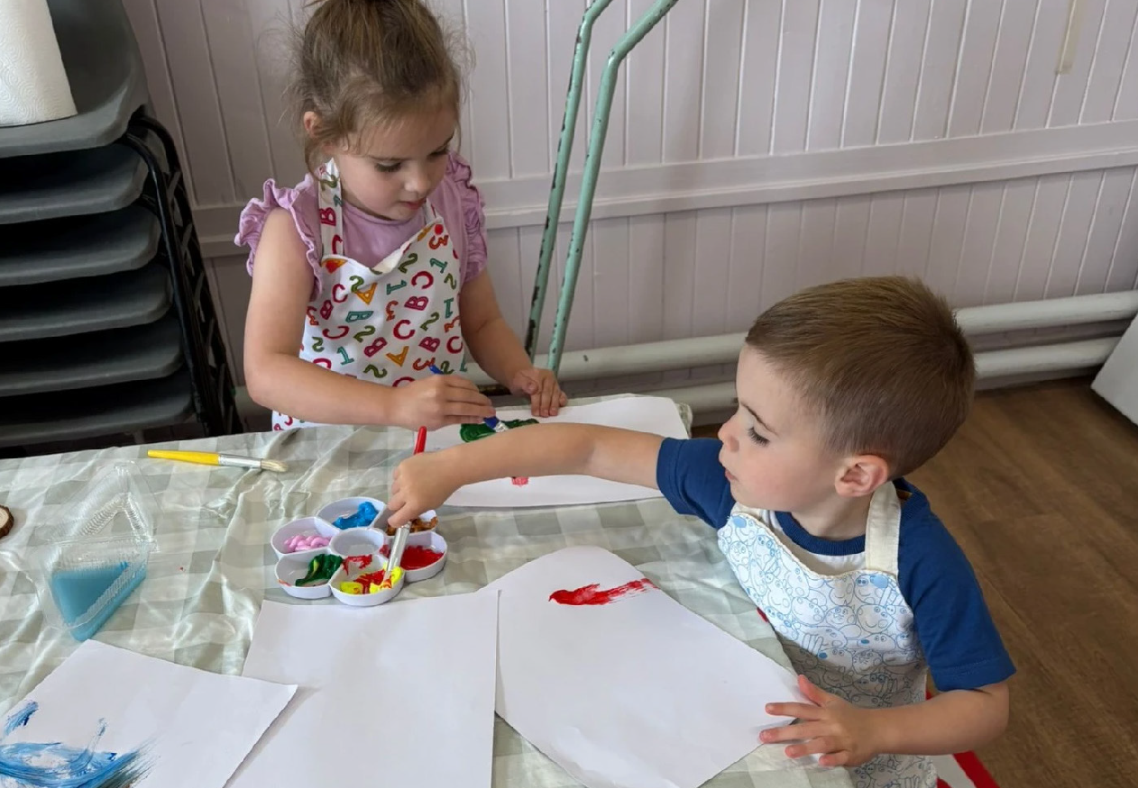
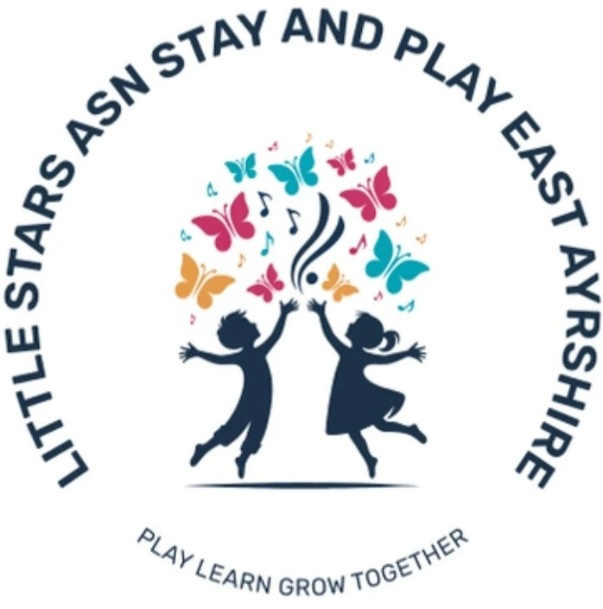
“It’s a safe place for our kids to play and enjoy themselves without the judgement of anything. So good to get speaking to other families who are in the same situation and can help each other. The fact that it is local makes a massive difference. Both my kids love the group, especially the sensory and messy play. I don’t feel as lonely now.” Participant in Little Stars activities

Introduction Highlights Stories of change Bold ten-year strategy Working into practice Looking ahead Accounts 17

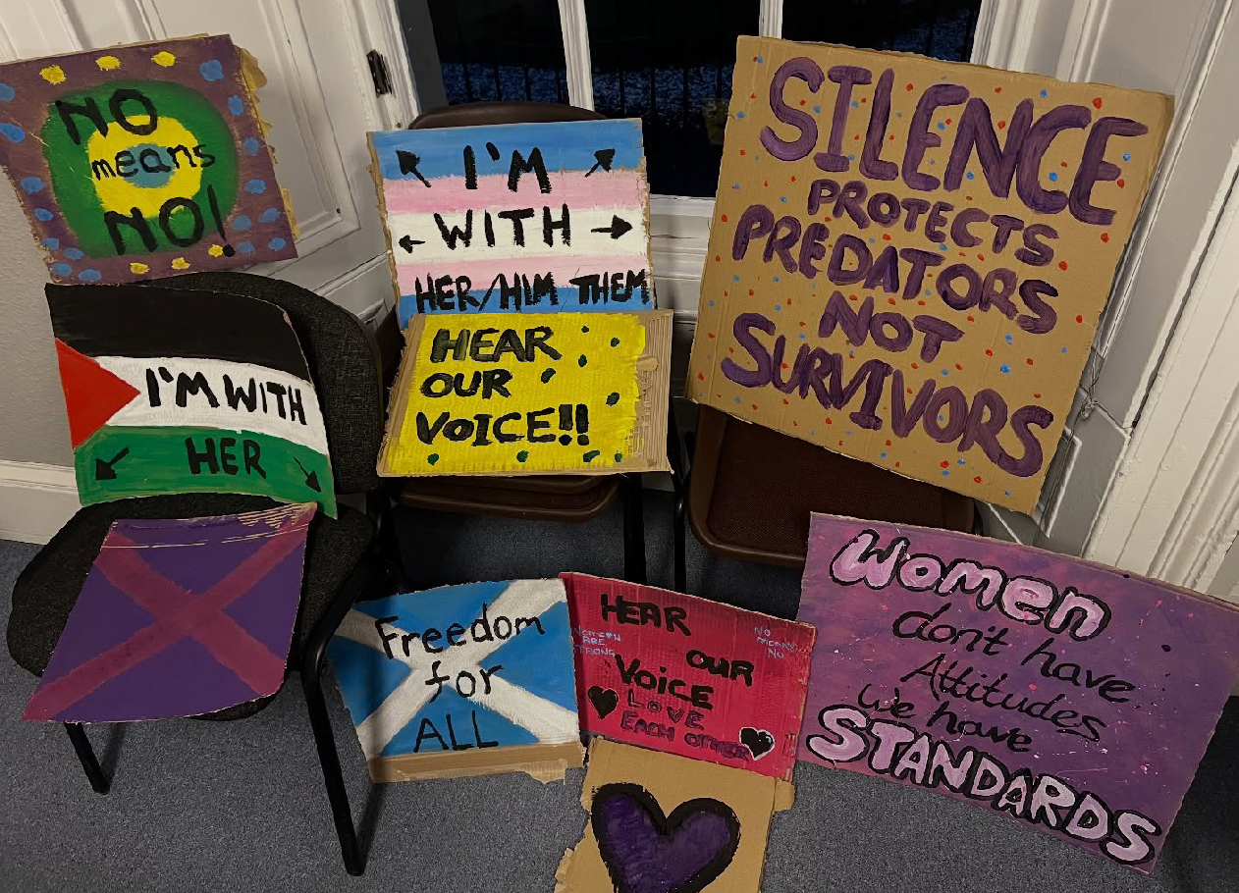


Supporting women in Dundee and Angus
(Women’s Rape and Sexual Abuse Centre Dundee and Angus (WRASAC) were supported through a National Drugs Mission Fund grant)

The Dundee Women’s Hub was created by WRASAC to offer multi-agency support for women impacted by drug and alcohol use and other multiple disadvantage such as gender-based violence, homelessness, poor mental health, isolation, and trauma. It offers gender-specific, trauma-informed support for women to make informed decisions regarding their support options, reducing barriers to accessing support and to improve their overall health and wellbeing.

“Kelly1 remains in regular contact and continues to engage well with services. She frequently visits Dundee Women’s Hub, feeling confident that it is a supportive, non-judgmental environment where her needs are understood and met through a trauma-informed, person-centred approach.
Kelly has shown considerable progress over the past few months. Her confidence has grown, and she appears notably less anxious during visits to Dundee Women’s Hub. She actively seeks support and participates in decision-making regarding her wellbeing, finances, and future plans. Through trauma-informed, person-centred care, we continue to build a trusting and supportive relationship that empowers Kelly to move forward in her recovery and regain stability in her life.” Worker from the Women’s Hub speaking about one person’s experience of engaging with their support
1 This person’s name has been changed to protect confidentiality

Introduction Highlights Stories of change Bold ten-year strategy Working into practice Looking ahead Accounts 18



Making Rights Real –
a victory for residents in Leith
Making Rights Real has been supported through the Independent Human Rights Fund for Scotland to work alongside Human Rights Defenders)

A human rights campaign hastened a multi-million pound commitment from City of Edinburgh Council to bring a long-neglected block of flats in Leith into a habitable state.
A group of residents formed Cables Wynd House Residents Group (CWHRG) to campaign for improved housing conditions. Making Rights Real worked alongside them to take a robust rights-based approach to address problems such as damp, mould, vermin and broken lifts.

“This process has been frustrating for the volunteer residents, but incredible bonds have been formed. Members of the group are true human rights defenders- giving up a lot of their time to improve conditions and bring the community together. Residents are the experts and should be listened to
- while there have been improvements in communication, there is still a long way to go. They have been living in inadequate housing during austerity and the ongoing cost of living crisis – they’re not asking for a favour, they’re only asking for respect and for their rights to be fulfilled.” Lorraine Barrie, Making Rights Real

Introduction Highlights Stories of change Bold ten-year strategy Working into practice Looking ahead Accounts 19

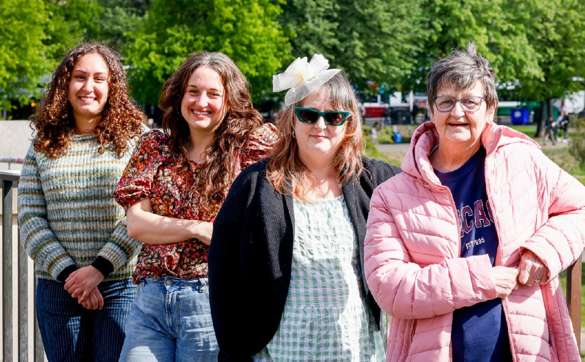
The ripples created by the CWHRG’s rights approach were still being felt in 2025 with the publication of a residents’ report detailing the numerous violations of their legal rights. Not only did the Council’s then Housing Committee Convener offer a full apology to residents for breaches
of their economic, social and cultural rights, the residents’ campaign was also reported to a United Nations Committee.

Introduction Highlights Stories of change Bold ten-year strategy Working into practice Looking ahead Accounts 20

Better Buses Barrhead
“We’ve been to meet other community transport groups and it was bit of a wake–up call – so many things have to be considered. It’s not as simple as just buying a bus – we’ve had to learn about transport legislation, timetable and route planning, permits, licenses, how many vehicles and drivers will be needed, and even how and where we’re going to store the vehicle overnight.”
“Dunterlie is not a wealthy area, and lots of people here are older or live with disabilities. Without a bus service it was going to be much more difficult to get to the shops, the health centre, the library, the community centre, five local schools, the post office and importantly, to the local food share. So many people were going to be left isolated or dependent on the goodwill of others for lifts or running errands.”
(Community campaign in Dunterlie, supported by Corra Getting Alongside Communities programme)


When a vital local bus route was withdrawn in Dunterlie and Barrhead in East Renfrewshire, with little or no notice or consultation, the community organised to respond. An informal group came together to campaign against the decision, undertake local work to assess the impact of the loss of the bus, and to work
towards a solution. The group became the Better Buses Barrhead group and when it became clear the route was not going to be reinstated, they began to investigate community transport options for Barrhead.
Despite the many considerations and hurdles to be overcome, the Better Buses Barrhead group are more determined than ever to bring a bus service back to an area that really needs it. A new route and timetable have already been developed in conjunction with local people, and with the support of SPT and East Renfrewshire Council. The community hopes a trial service might start in 2026, with Barrhead’s brand new community bus service on the road from 2027.

Introduction Highlights Stories of change Bold ten-year strategy Working into practice Looking ahead Accounts 21

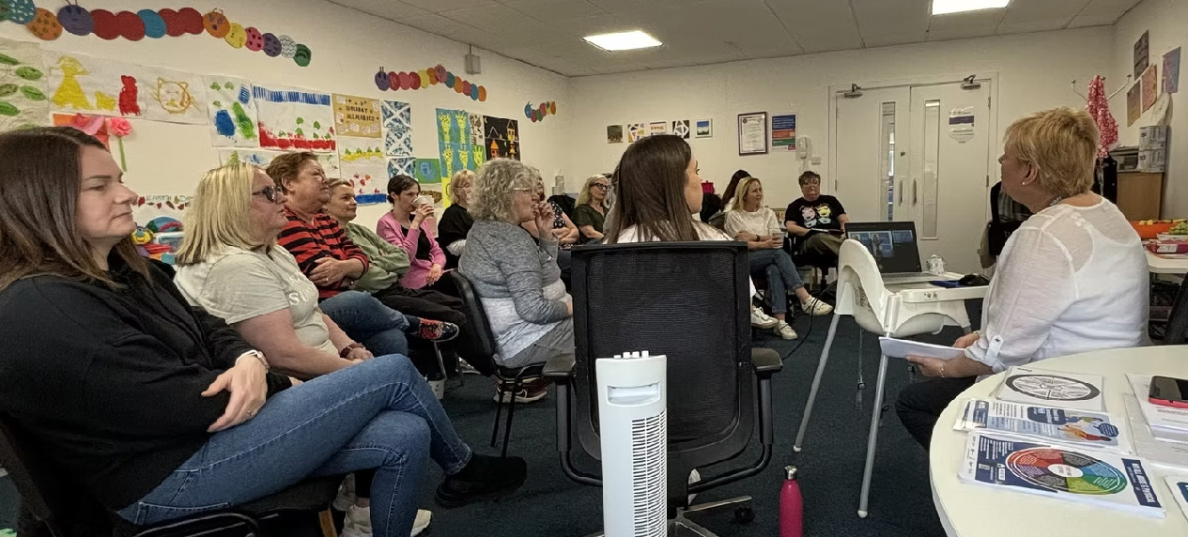

Restoring lives and women’s power at Jubilee House
(Jubilee House was supported through Henry Duncan Grants)

Since 2015, Jubilee House has been delivering services that support women affected by domestic abuse. The organisation was founded by Directing Manager Fiona, following her own experience of severe domestic abuse and personal knowledge
of just how powerless a victim / survivor can feel. Jubilee House was built to give women in these situations the ability to restore their own power to then start to build on and regain their lives after experiencing domestic abuse.
The team at Jubilee House have many ideas for the future, particularly about how to make their services accessible to all. They are working to try and secure long-term funding to try and turn their ideas into reality.

“I found Jubilee House in July 2024. At the time, I felt broken and confused. I knew something wasn’t right in my life, but I couldn’t quite believe it. When I came to Jubilee House, I was welcomed with such care and understanding. They gave me the space to slowly accept the reality of my situation in my own time. Their patience and support helped me make the decisions I needed to, without any pressure or judgment. Jubilee House has been a safe space where I’ve learned the skills to start changing my life. The wellbeing workshops and one-to-one support have truly helped me move from feeling hopeless to hopeful. For the first time in a long while, I’m beginning to recognise my own worth — and I finally feel safe.” Client at Jubilee House

Introduction Highlights Stories of change Bold ten-year strategy Working into practice Looking ahead Accounts 22

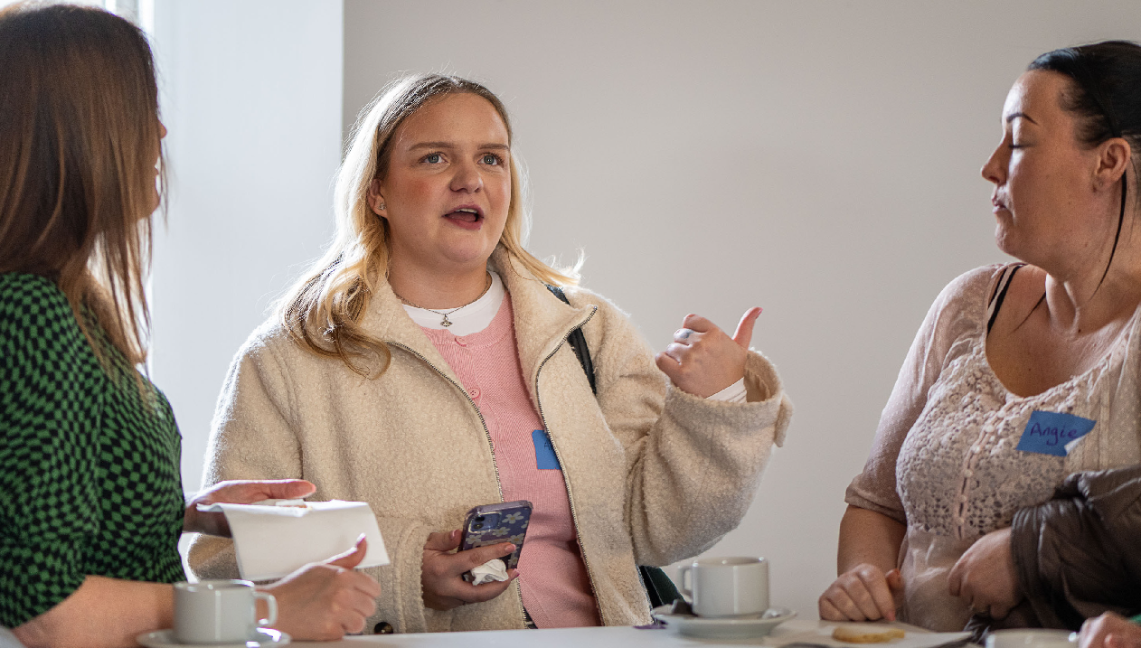
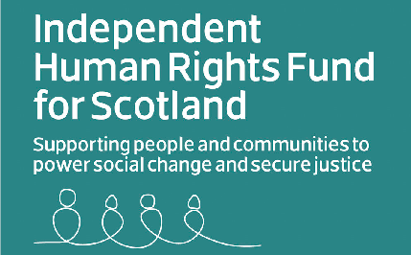

Human Rights: Homelessness Justice Legal Collaboration
(This work was supported by the Independent Human Rights Fund for Scotland)

The Homelessness Justice Legal Collaboration (HJLC) is a network of lawyers and rights experts.
They spent their first year sharing experience and raising awareness about burgeoning
breaches of people’s legal rights when it comes to housing. Breaches of the law have now become commonplace, particularly in Glasgow and Edinburgh. For members of the HJLC, there is a deep understanding that the housing emergency is a multi-layered problem with no quick fix solution. The HJLC has found that when breaches of rights are challenged through the legal system, the success rate is high.

“Everyone in the group is committed to resisting this systematic erosion of legally enshrined rights. We are exploring options for using test cases to challenge rights violations, but we’re also ready to further build on our shared knowledge and experience.” Rebecca Stafford, the Legal Services Agency

Introduction Highlights Stories of change Bold ten-year strategy Working into practice Looking ahead Accounts 23

The Nest – Cumnock recovery project with always-open doors
(The Nest has been supported through Corra’s Getting Alongside Communities work)

Everything about The Nest offers warmth and welcome. The rich, deep colours of the interior decor and the soft furnishings, and the wide smiles and ready hellos of all the people there. Situated in the East Ayrshire town of Cumnock, The Nest is an extraordinary community project. It is a space offering sanctuary, safety, support and healing for people who have experienced crisis or who are battling with a system not designed or able to cope with their
complex problems.

The Nest began with Natalie’s vision of creating a space which properly supports people, which sees people as being much more than the labels they are given. The idea was to create a sense of “home”, not just a physical place or a roof over heads, but somewhere where people can come home, to grow and flourish. After a difficult process of trying to find a physical space for the Nest, the group have
now converted a former industrial unit into a vibrant,
welcoming haven – somewhere everyone calls home.

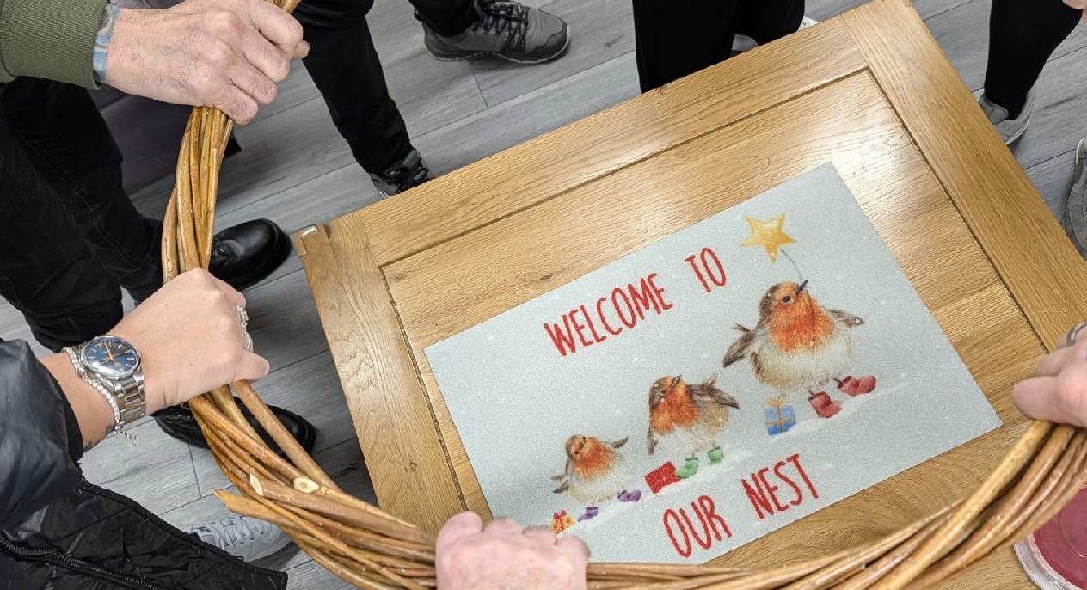
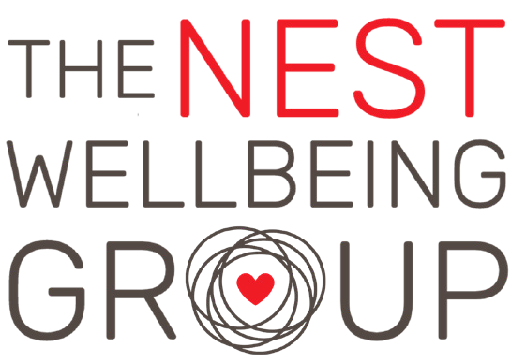

“The Nest is far more than just being a cool space where people can meet – it’s all about acceptance, compassion, love and hope. It’s a place with heart – somewhere which offers belonging for people who often feel pushed out and marginalised.” Natalie Carmichael, Nest founder

Introduction Highlights Stories of change Bold ten-year strategy Working into practice Looking ahead Accounts 24

Children and Young People’s Centre for Justice (CYCJ) – youth led grant making
(This work was supported through the Promise Partnership Youth-Led Grant Programme)

A group of seven young men delivered a grant fund that supported four projects in their local area. The men were in the care of HMP and Young Offenders Institute Polmont and were supported by the Children and Young People’s Centre for Justice (CYCJ).
“I think it’s more rewarding than a lot of stuff that gets done in here because we’re seeing a change in the outside, as well as in here.”
“I think the [funded] organisations will be really getting young boys off the street so they don’t end up becoming older and doing the stuff that we’ve done.”
Young men involved in the project

designed and led entirely by the group of young men, with help from CYCJ where they needed it, for example to advertise the grants online.

“The things that they’ve done in this process are directly transferable to things we won’t even see. Ten years down the line he might go ‘oh remember I done that participative democracy technique, maybe this would work in this setting. This is probably one
of the projects I’m most proud of ever. But also there’s a sort of tinge of sadness with it because… …for me this shouldn’t be
radical. We shouldn’t be in a position where empowering young people is bucking the trend.” Iain Corbett, CYCJ

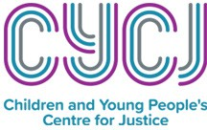


They decided they wanted to make an impact in the wider community and made four pots of
£10,000 available to support projects directly working with young people. The work was

Introduction Highlights Stories of change Bold ten-year strategy Working into practice Looking ahead Accounts 25



Baraka Community and Family Connection Hub – bringing people together in Clydebank
(Baraka Community and Family Connection Hub has been supported through Boost)

“One of our proudest highlights was seeing participants become advocates. Families who first arrived nervously started bringing neighbours, friends, and relatives. Word spread entirely through trust, because people genuinely wanted to share something good.” Member of the Baraka Community and Family Connection Hub team


Baraka Community and Family Connection Hub began as a grassroots initiative led by residents who believed in the power of community connection. They recognised that many families were facing isolation, digital exclusion, and limited access to support services. The Hub has become a consistent, trusted point of connection for families across Glasgow. It provides a warm, inclusive space where people can meet, share and feel less alone. The small, committed team co-ordinates the hub, supported by volunteers who are often participants themselves. There is a real sense of community ownership of the space.

“It’s a pleasure to be here as we are bonding and meeting new people in the community, getting to know each other and embrace the spirit of sharing.” Participant

Introduction Highlights Stories of change Bold ten-year strategy Working into practice Looking ahead Accounts 26

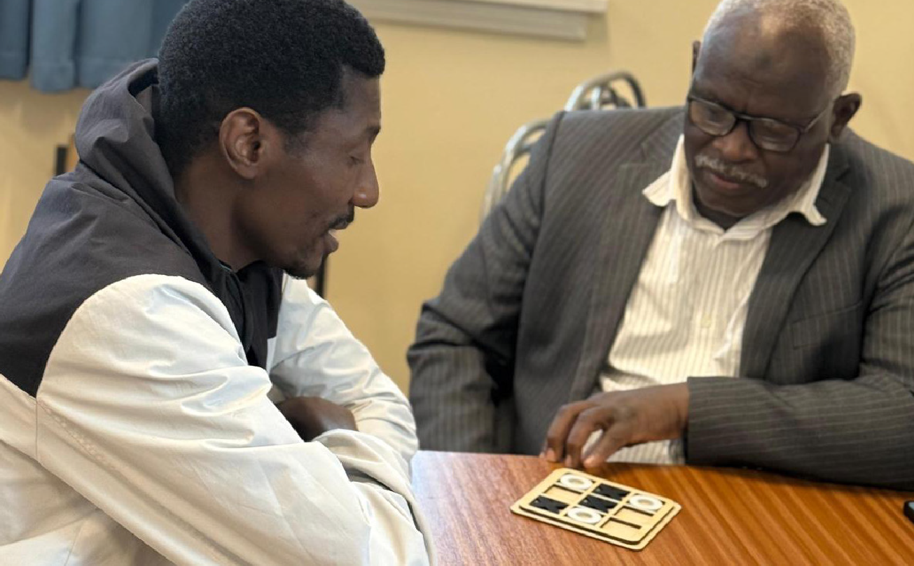
The group would like to sustain and grow the Hub. They have recently moved into a new base in Clydebank which will allow them to expand their reach and offer things like ESOL language classes, IT courses and skills sessions.
“We applied to Boost because it offered something different for a small charity like ours: a straightforward, accessible route to funding that trusted us to know what our community needed. The application process was clear, proportionate, and
designed in a way that felt respectful of the time and capacity that small charities like ours actually have.” Member of the Baraka Community and Family Connection
Hub team

Introduction Highlights Stories of change Bold ten-year strategy Working into practice Looking ahead Accounts 27



Sharing Jewish Scotland: Opening the doors to our community through education
(This work was supported firstly through Sky TV funding delivered by Corra and then from Corra’s own racial equity grants)

Sharing Jewish Scotland was a project to produce a series of educational resources to engage with young people and educators in schools across Scotland. It aimed to make information about Judaism and the Jewish community more accessible.

The project focused on speaking to young people and parents to better understand their experiences in school, and beyond. It reflected the rise of antisemitism and the impact of this on young people, particularly with an increase in online hatred and misinformation. The project aimed to make sure parents were aware of the resources and support that had been created.
“Schools often deal with the topic of Jewish people in history lessons, when teaching about the Holocaust, or when the Middle East is on the news. But our community is so much more than that, and we want to be able to talk about what being Jewish in Scotland is like today.
We believe that a key way of countering anti-Jewish hatred is by educating young people in a proactive way that confronts
assumptions, misconceptions and shows who we are – and who we are is more than just one thing!” Danielle Bett, Project Manager, The Jewish Council of Scotland

Introduction Highlights Stories of change Bold ten-year strategy Working into practice Looking ahead Accounts 28


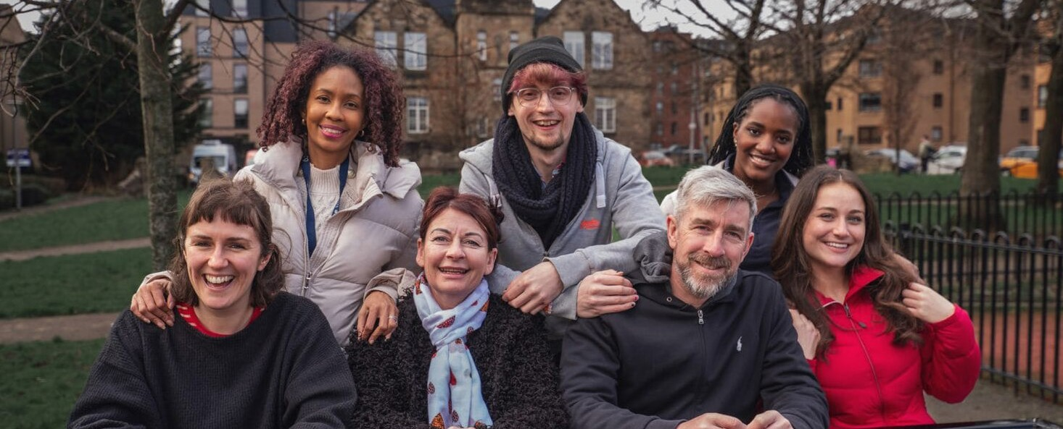

Intensive peer recovery support for people in Ayrshire
(Blue Triangle’s ROOTS programme was supported through a National Drugs Mission Fund grant)

Blue Triangle is a charity and registered landlord providing social care and homelessness support across Scotland. They provide safe, trauma-informed accommodation and 24/7 person-centred support to help people secure and maintain their own tenancy. Blue Triangle runs four Intensive Peer Recovery Support Services (IPRS), including ROOTS, based in Ayr. This service aims to reduce drug deaths among people experiencing homelessness and help connect people with the right support and the right time.
A peer worker slowly built up a working relationship with Jack2. Over time, Jack opened up about violence in his childhood and his experience of substance issues since he was 11. Jack was supported to attend appointments and communicate with professionals. This improved his relationships with other staff and helped build up his self-esteem. Eventually things began to improve and Jack shared that after years of feeling ignored, he was finally being listened to and treated well and shown some dignity.
2 This person’s name has been changed to protect confidentiality

“I am no longer handcuffed to a chemist, I get listened to when at appointments and people actually listen to me and my concerns.” Jack
Jack has applied to go to college as a volunteer Peer Worker. He has maintained his own tenancy for over one year after eleven failed tenancies in eight years and he recently began volunteering at a local drop-in service. IPRS has provided over 900 hours of intense support to Jack through
1-1 sessions and will continue to support him throughout his journey.

Introduction Highlights Stories of change Bold ten-year strategy Working into practice Looking ahead Accounts 29

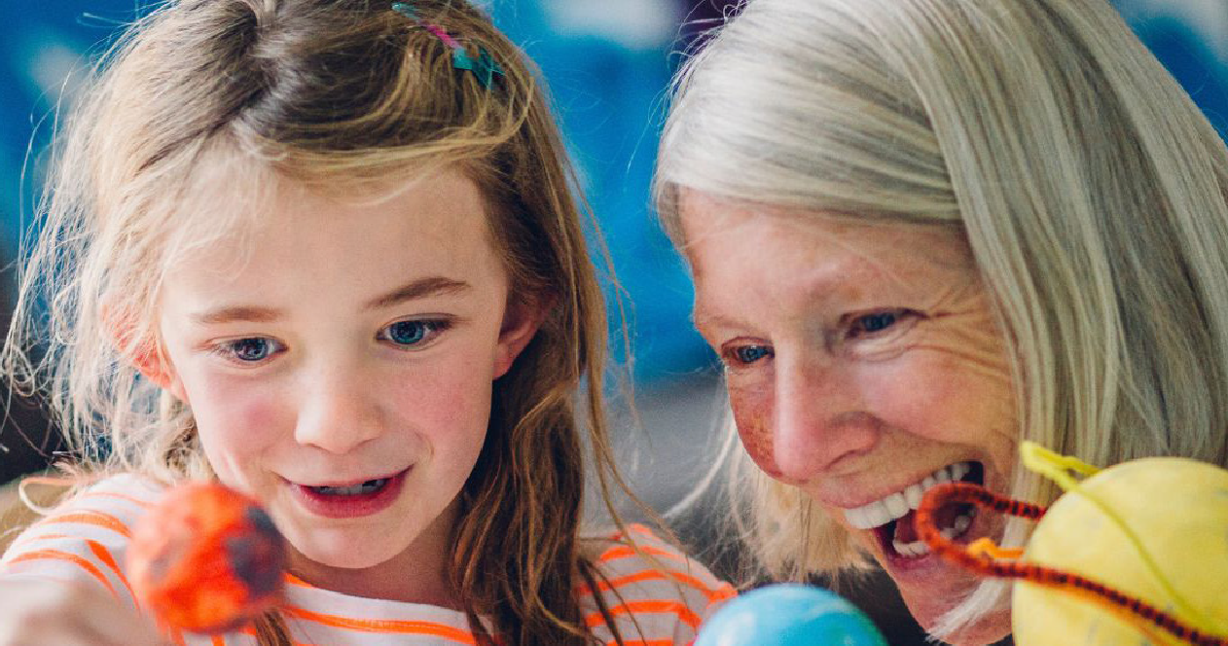

Creating space for community in Castlehill
(Castlehill is one of the areas involved in Corra’s Getting Alongside Communities work)

Castlehill is home to an active community of amazing community leaders running activities and initiatives to improve local spaces and create opportunities for people to connect. This includes an events group, sewing classes, gardening activities for children and the community, and so much more.
Access to agenda free space is a common challenge faced by the communities Corra has worked alongside. In Castlehill, in response to this challenge, Corra provided free community space within the Leven Valley centre. This supported several groups to meet, and new groups to form. Through this work, new ideas emerged, including Let’s Grow Together which was created by
“This is the first time that I’ve run a group on my own, the first time I’ve thought this is
something I really want to do” June Hopkins, local community leader who runs Let’s
Grow Together
a community member to transform green space.

Introduction Highlights Stories of change Bold ten-year strategy Working into practice Looking ahead Accounts 30

Bringing the community together in Langlees
(Langlees is one of the areas involved in Corra’s Getting Alongside Communities work)

Wilma, a community volunteer, reflected on the changes she has seen across the community over her own lifetime. She has seen an increase in people moving into the community who do not have existing ties and connections locally. She
shared her desire to connect with all these people and expressed her wish for these connections to form and strengthen.
‘Our vision is to create a vibrant, inclusive community where wellbeing thrives through active engagement and thoughtfully designed spaces’ Bainsford and Langlees ‘plan on a page’

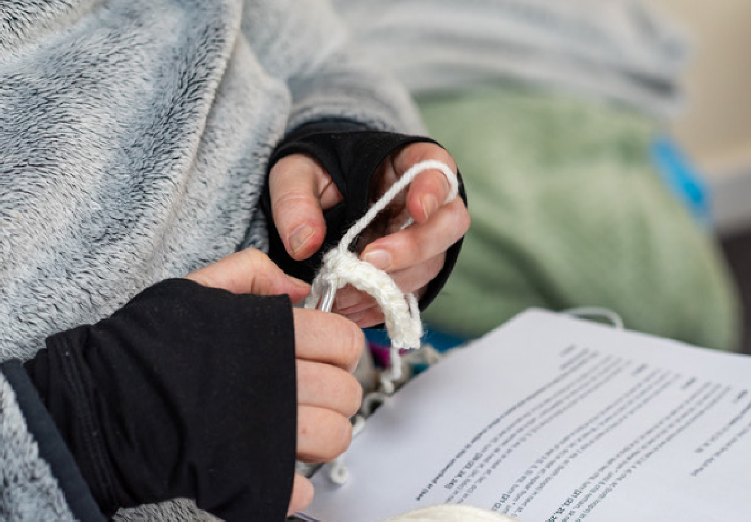
Langlees in Falkirk has a strong local identity and a deep sense of connection to its neighbours in Bainsford. Together, they share Bainsford
Hall, which has recently come under community control. The hall was under threat of demolition, however a local management committee,
with support from volunteers and the wider community, formed and developed it into a vibrant hub. The hall has transformed physically and has become a vital space for connection, creativity and support. It hosts regular activities including a wellbeing group, warm space café, fitness classes and activity groups for children and young people.


Introduction Highlights Stories of change Bold ten-year strategy Working into practice Looking ahead Accounts 31

DELIVERING OUR BOLD TEN-YEAR STRATEGY
Progress towards three big changes

Introduction Highlights Stories of change Bold ten-year strategy Working into practice Looking ahead Accounts 32

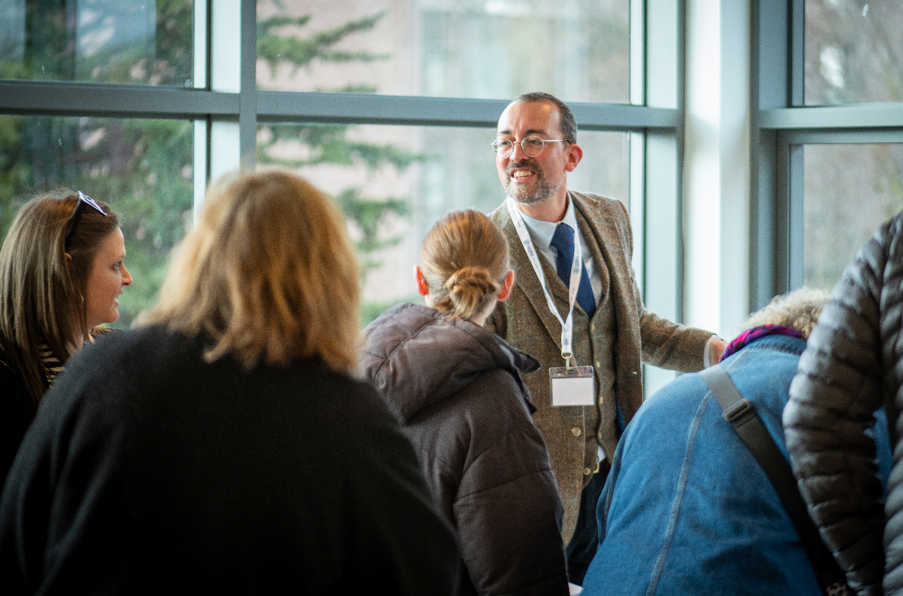
Our strategy sets out the big changes that Corra wants to contribute to. We do this through:
- Grant making
- Place-based work
- Using our learning to influence policy,
practice and funding

In this report we share a few examples to show how we are pursuing our strategy ambitions. More information on all our work is on our website www.corra.scot

Introduction Highlights Stories of change Bold ten-year strategy Working into practice Looking ahead Accounts 33

Change One – Power to create change rests with people themselves

The most powerful, meaningful change starts with people. For this to happen, we all need to be able to participate (in communities,
in decision making, in society),
to find our voices and make ourselves heard. Everyone should have power, control and the sense that they can make a difference through what they do. Too many people feel that their voice isn’t heard or listened to and that decisions that affect them are taken by other people.

Amplifying voices

Listening to birth parents
Corra, in partnership with The Village Storytelling Centre and Unlabelled Films supported birth parents to share their stories. Having a child taken into care is traumatic and has a profound impact on the child, birth parents, and their families. Through this work we published a
book of stories, short films and a practice guide on ethical and trauma informed storytelling.
The book is being shared throughout libraries, starting with Glasgow Women’s Library.
(This work was delivered as part of The Supporting Birth Parents Fund, managed by Corra on behalf of the Scottish Government)
Supporting Human Rights Defenders Through the Independent Human Rights Fund for Scotland, we provided support for Human Rights Defenders1 with grants to the Children’s
1 Human Rights Defenders are the people who stand up for themselves and others, often at great personal cost.
Parliament, Environmental Rights Centre for Scotland, Glasgow Disability Alliance, and Making Rights Real. We also supported engagement from the Scottish Human Rights Defender Fellowship to bring international learning to the Independent Human Rights Fund for Scotland.

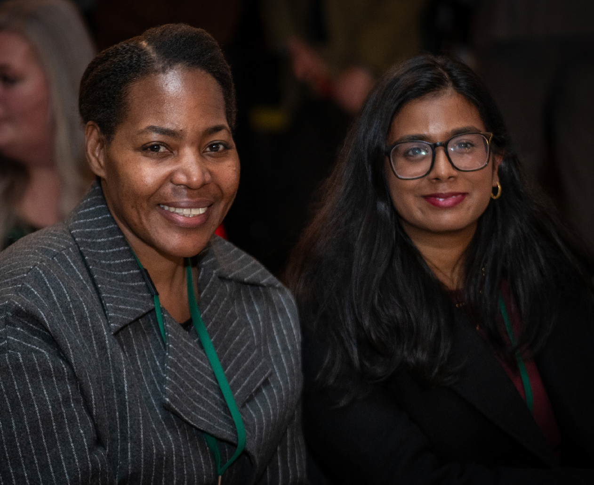

Introduction Highlights Stories of change Bold ten-year strategy Working into practice Looking ahead Accounts 34

Participatory grant making

Young people designing funding
“Being a part of Corra has given me confidence to speak my mind without being afraid of getting it wrong sometimes. Having difficult conversations is part of the process! It’s nice to see my peers having a
voice and knowing that the work we do isn’t just benefitting to us; but to the applicants we assess and people they may help too.” (Young person involved in YOYO Youth Advisory Board)

In 2025 Corra launched You’re Only Young Once Fund (YOYO) to provide support for children, young people and families affected by drugs and alcohol. Young people led every step of the process, including designing the fund criteria,

decision making process, name and logo. The funding decisions were made by young people to ensure money went to projects that would make a real difference.
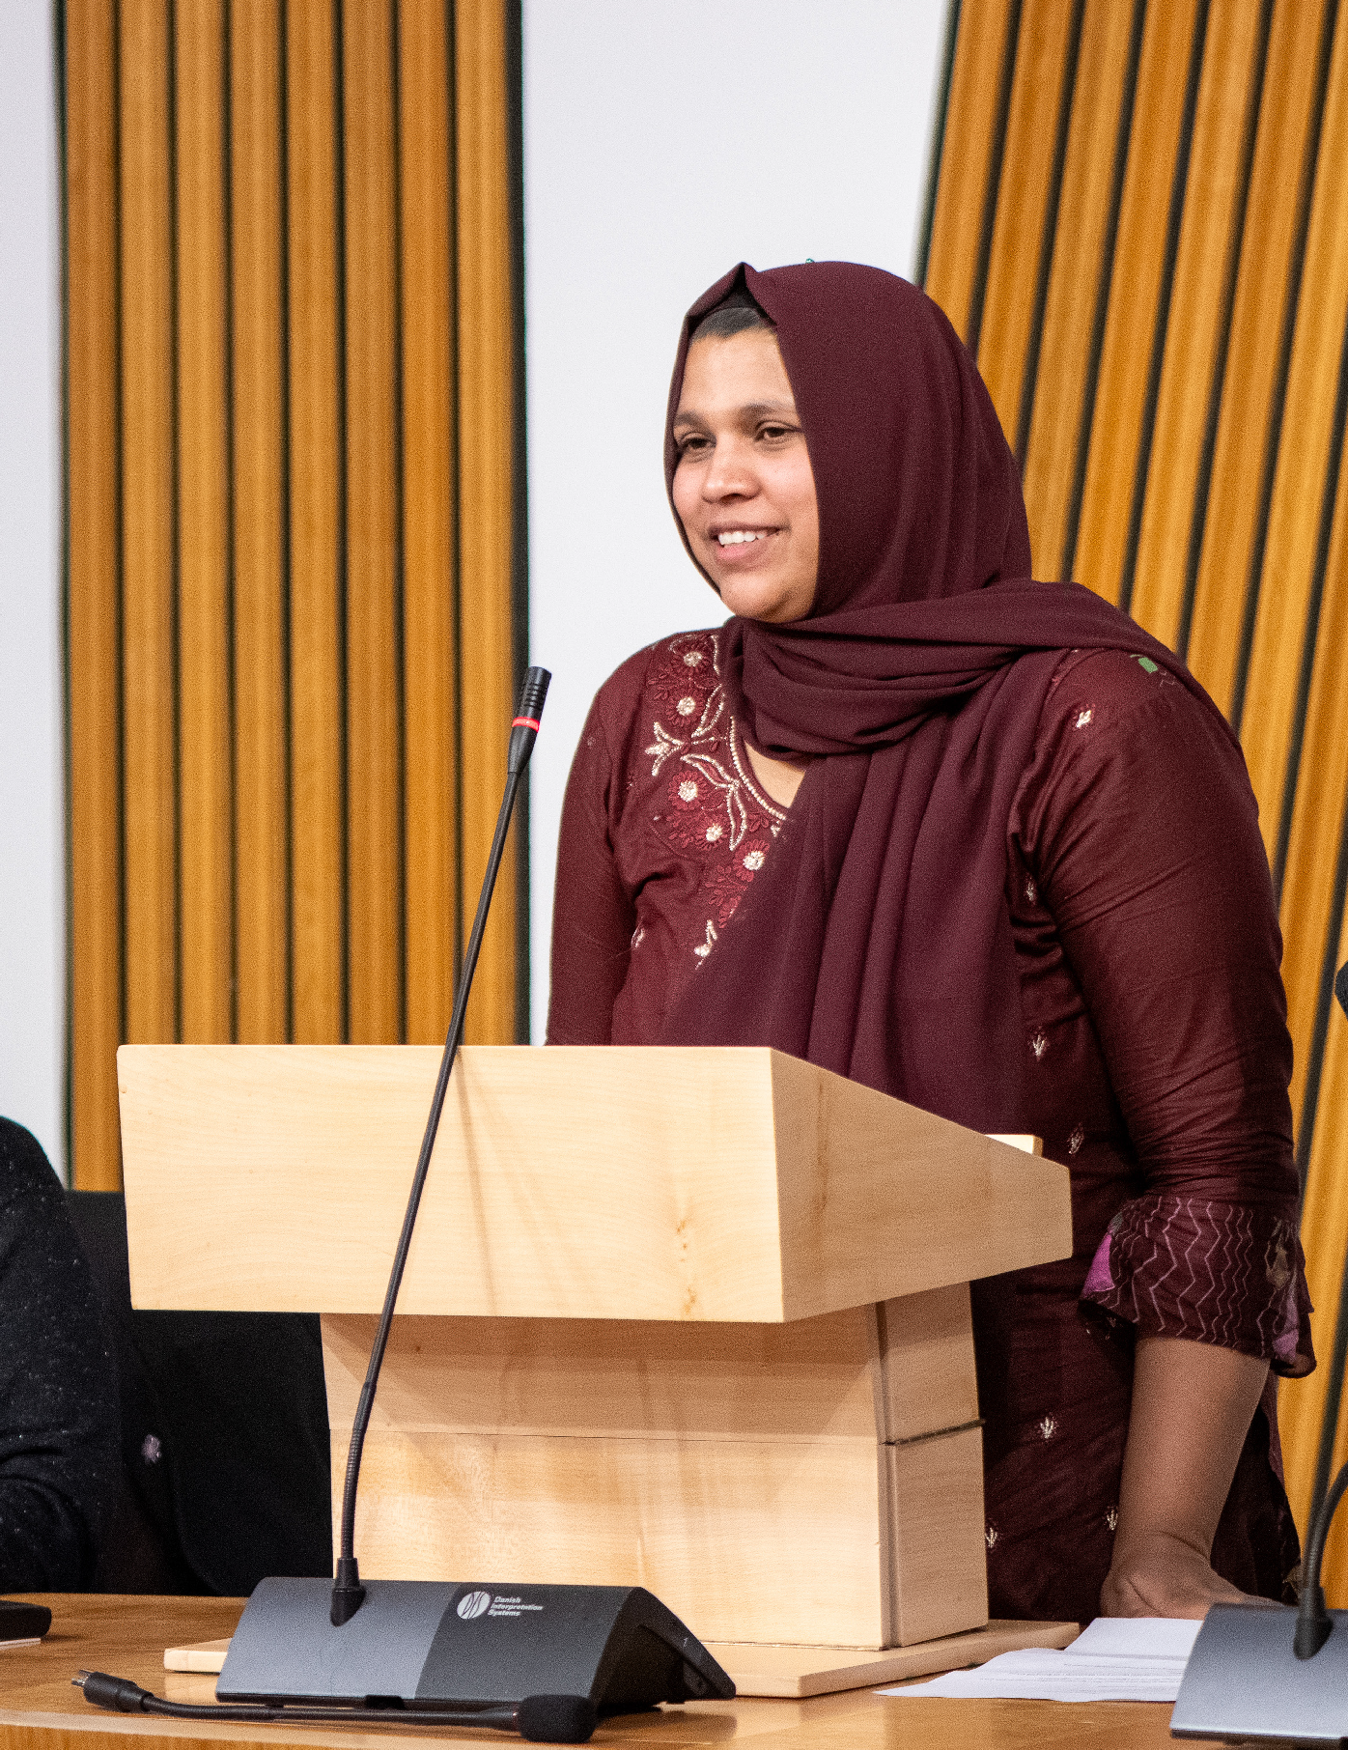
(YOYO was part of Corra and The Scottish Government’s The Way Forward for Families Partnership)

Shifting power – Corra Racial Equity Fund Lived Experience Panel
An independent panel of people from Black and racially minoritised communities decided which organisations were funded through the Corra Racial Equity Fund. This approach
reflected Corra’s commitment to shifting power, particularly towards groups that have historically been under-resourced and furthest from
decision making. The panel brought deep knowledge, skill and commitment to the difficult process of selecting from among the many proposals received.

Introduction Highlights Stories of change Bold ten-year strategy Working into practice Looking ahead Accounts 35

Community leadership

Pioneering a whole-place approach in Kirkcaldy (Fife)
In 2025-26 162 people hosted their own events or sessions as part of Every One Every Day, reaching 1,122 people in Kirkcaldy.

In 2025 Corra worked with partners to launch Every One Every Day in Kirkcaldy, creating opportunities for people to get involved in their community. Every One Every Day has its roots in the We Build Bridges approach, designed initially in Barking and Dagenham and Canada. Working with co-funders Fife Council and The National Lottery Community Fund, we are collaborating to develop this approach for Scottish places.
The model works by building infrastructure –
spaces, resources and support – in a local area so that people can try what they are passionate about, in ways that work for their lives. It is free,

open to everyone, and has been shown to build community capacity, participation and places where people can live in friendship and trust.

Nurturing community leadership across Scotland
In 2025 Corra launched the new Community Leadership Collective, supported by The Rank Foundation and Esmée Fairbairn Foundation. The first cohort of community leaders created the collective’s mission; to cultivate and empower community leaders by creating space for growth, a network to encourage and motivate, and opportunities for everyone to feel included, respected, and valued. Each year another group will come together, building a growing network of community leaders who support and inspire each other.

Locally-led funding
Corra has worked with What Matters to You (a partnership with The Hunter Foundation and BBC Children in Need with additional funding from Northwood Charitable Trust, The Robertson
Trust, William Grant Foundation and NHS Tayside

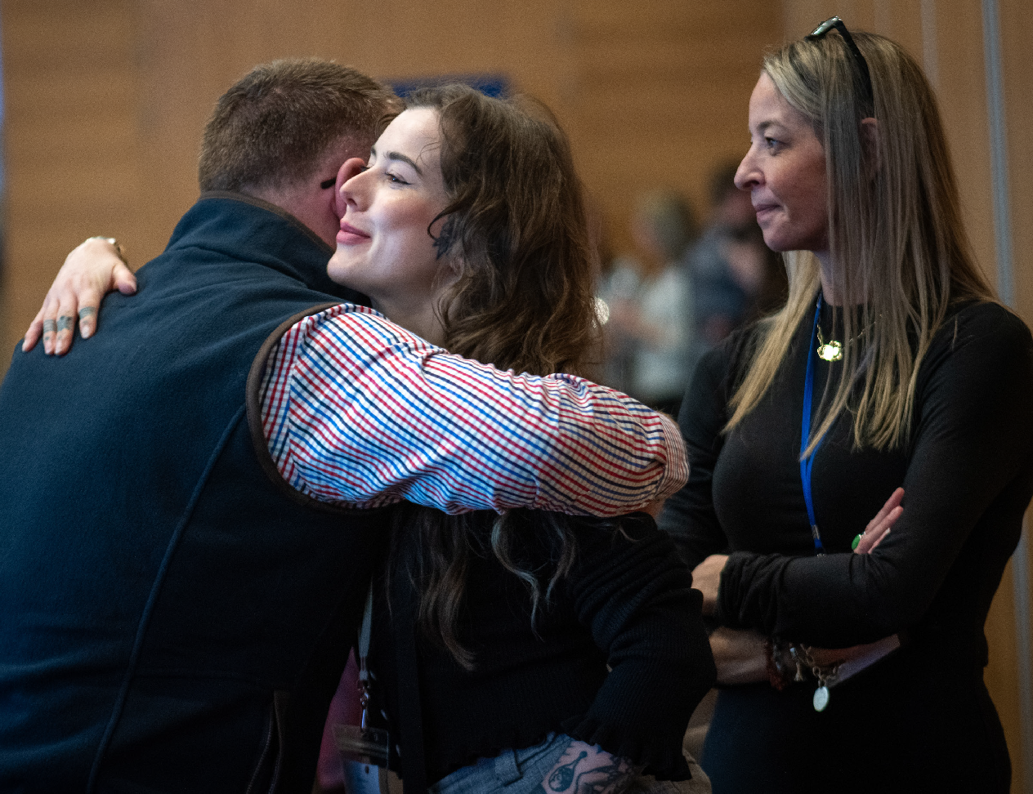
Charitable Foundation) to help deliver the Make it Happen Fund. We supported community members to design the criteria and make the funding decisions. In the past year 116 grants have been made to grassroots groups in Dundee and Clackmannanshire. Grants aim to support and encourage local groups, by backing projects and initiatives that create positive change within their communities.

Introduction Highlights Stories of change Bold ten-year strategy Working into practice Looking ahead Accounts 36

Getting Alongside Communities – learning from a ten-year journey
In 2015 Corra began the Getting Alongside Communities programme, and a bold ten-year commitment to the programme was made in 2016. The team has been working since 2023 on a transition to community leadership, and in the
final year we have worked hard with communities and staff to end as well as possible.

Getting Alongside Communities was supported by partnerships with eight local authorities – Falkirk, Fife, East Ayrshire, East Renfrewshire, North Ayrshire, North Lanarkshire, South Lanarkshire and West Dunbartonshire. It was also shaped
by a range of partners over the past ten years, including Esmée Fairbairn Foundation, Joseph Rowntree Foundation, Lankelly Chase, Tudor Trust, and The Scottish Government. Corra
- Longevity was critical in building trust.
- The work has created a legacy of community action, with many groups thriving and local people leading the change they want.
Getting Alongside Communities has also played a significant role in helping to shape Corra’s grant making, particularly our approach to participatory models and funding small community-led groups.
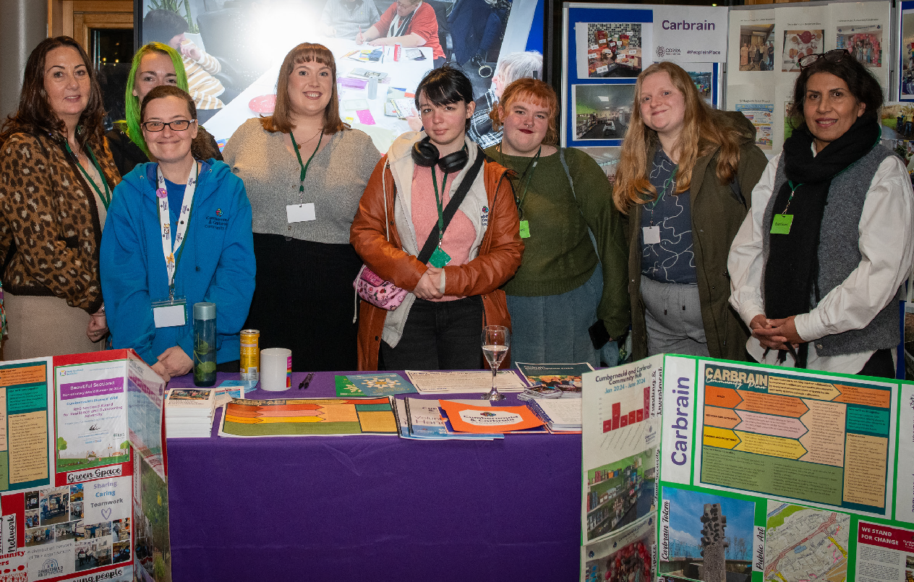
was also grateful to have expert insight from members of the Getting Alongside Communities Observer and Advisory Groups. The Observers were chaired by Sir John Arbuthnott, and then by Dame Julia Unwin, and Corra is deeply thankful to them both. Above all Corra is indebted to the communities who allowed us to travel alongside them, who shared their time and trust, and who are a powerful example of what is possible when local people lead.
The evaluation of Getting Alongside Communities showed:
- Communities felt that Corra believed in them, when they had previously often felt left behind or forgotten.
- Accessible resources and support – including small amounts of money that were easy to access – helped people to increase their skills and confidence.
- The approach supported local people’s aspirations and plans for long-term community-led change.

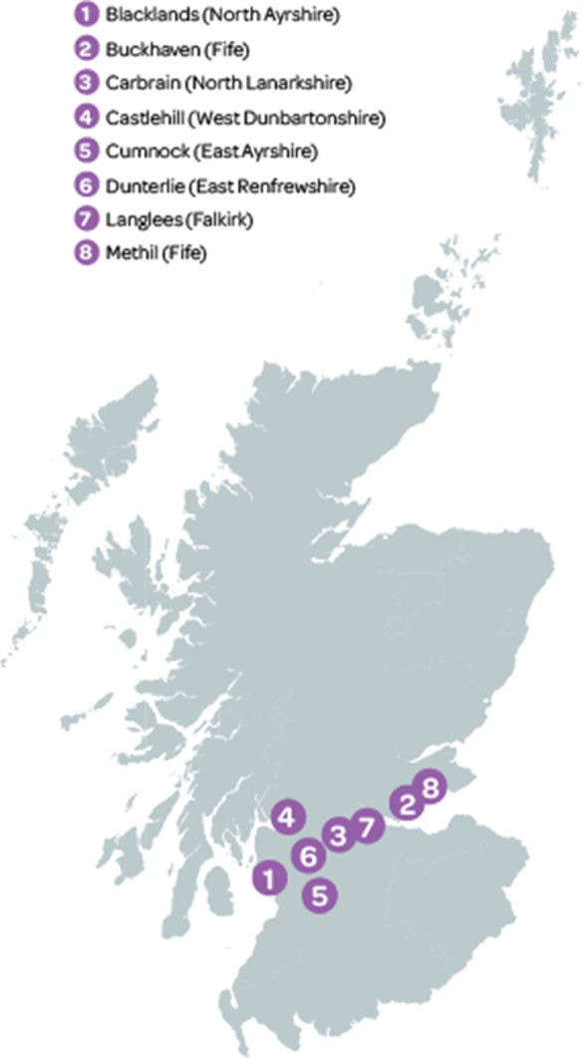
Introduction Highlights Stories of change Bold ten-year strategy Working into practice Looking ahead Accounts 37
2015
Listened and learned to understand the strengths of the communities.
Commenced recruitment of a Community Co-ordinator in each place.
2023 – 2025
Worked towards a planned conclusion of the programme and towards community leadership.
Shared learning about what’s needed so local people can thrive in the driving seat of change.
Co-designed an event where communities came together in the Scottish Parliament to celebrate, connect and have their voices heard by decision makers.
2015 - 2025
Worked alongside communities to keep listening, build capacity, widen participation and support ideas into action.
Built collective trust, deepened knowledge, and encouraged connections with communities and partners. Invested over £3m from Corra and leveraged a further £2m.
Saw 52,000 people engaging in local activities, with 16,000 volunteering hours being given by community members.
Community leadership, voice, ambition and action grew.
2013-14
Corra worked with other funders to find places in Scotland where we were not reaching.
Recognised that traditional funding models do not work for everyone and that we needed to work differently.
Identified nine communities (each of around 2,000 people) to work alongside.

Introduction Highlights Stories of change Bold ten-year strategy Working into practice Looking ahead Accounts 38

Working alongside community leaders in Dunterlie –
a Community
Co-ordinator’s view

Most people don’t set out to become leaders.
In many places people are just trying to get through the week – managing family life, money worries, services disappearing, and buses that don’t turn up. Leadership often doesn’t start with confidence. It starts with caring.
When we talk about community leadership, we’re not all starting from a level playing field. Challenges like poverty, drugs and alcohol, mental health
and educational outcomes have a real impact. Relationships can be strained, and trust, consistency and participation are all harder. When this is people’s reality the work is slower, more complex, and often less visible — but no less important.
And that’s where a Community Co-ordinator comes in.
A Community Co-ordinator doesn’t create leaders.
They take time.
They build relationships. They believe in people.
They stay present.

They hold space - literally and emotionally. They navigate poverty, pressure, and power. They stay independent.
And by doing that, they help local people lead in ways that make sense for their lives — not someone else’s agenda.

Relationships
A huge part of the role is relationships. People step into leadership because they trust someone. That trust matters even more when people have had bad experiences with institutions before. Local
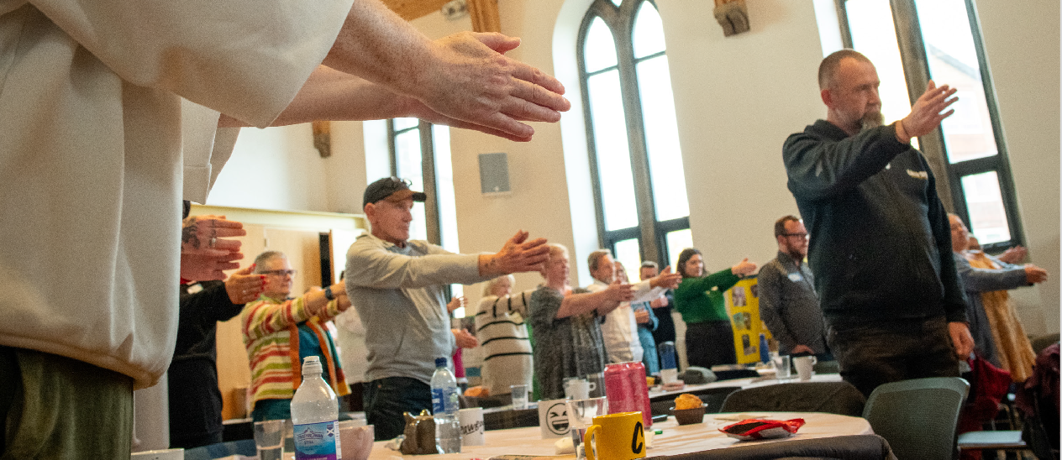
people had a strong sense of what was needed and my job was to listen, build trust and get alongside something that already belonged to them.

Introduction Highlights Stories of change Bold ten-year strategy Working into practice Looking ahead Accounts 39

Space
In Dunterlie there were real challenges around space. The community has its own space in the community centre, and people feel a strong sense that it belongs to them. But in practice, the way it’s run can get in the way – rooms not being available to book, no flexibility on fees for projects like Foodshare, and at times a lack of understanding, or willingness, to support how community groups actually grow and develop.
This creates a tension where the community
is building activity, growing groups, bringing more people in – but doing that in a space they don’t have a real say over. It’s a space that psychologically belongs to them, but is operated in a way that can feel frustrating, limiting and disempowering. And that has a real impact on momentum, confidence, and what’s possible.
Part of the Co-ordinator’s role is trying to navigate that – advocating for the community, smoothing relationships where possible, and helping people keep going even when the system around them makes things harder than they should be. At times Co-ordinators bridge the gap between systems and lived experience, while staying independent and trusted by local people.

Belief in people
Believing in people is another key part, often before they believe in themselves. Many local people will say, “I’m not the right person,”
or “I don’t have the skills.” A Community Co-ordinator helps by breaking things down, learning alongside people, and not making leadership feel like something only “qualified” people can do.
Another important aspect of the role is simply being around. Not parachuting in but being embedded in the community. It’s also about creating spaces where people feel safe to say what isn’t going well. Strong leadership doesn’t come from pretending everything’s fine. It comes from honesty and feeling you can trust a worker to understand the issues you face.
And finally, there’s knowing when, and how, to step back.
That’s difficult when leadership is still fragile, when volunteers are stretched, and when resources are uncertain. But the aim is always to build confidence and shared ownership, so leadership doesn’t rest on one person. And what you start to see over time is a new generation of leaders emerging – not because they set out to lead, but because they care.

Jolene is a leader because she cares about new mums.
Claire is a leader because she cares that her son - and other people’s children - have a bus they can rely on.
Cara is a leader because she cares about children and families and wants the best for them.
And Rena is still a leader because she cares deeply about the centre and her community.
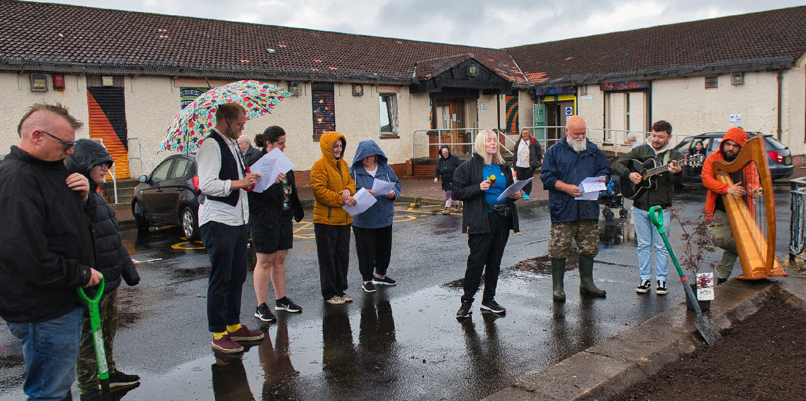
That’s what leadership looks like in Dunterlie now—something that goes beyond traditional ideas of leadership, fits with people’s real lives, and is rooted in care, consistency, and being there for one another.

Introduction Highlights Stories of change Bold ten-year strategy Working into practice Looking ahead Accounts 40

Change Two – People with ideas for radical change are
supported, skilled, connected and confident
- Reached a milestone of having distributed over £7.3m since 2020 to groups led by communities who have experienced racial inequity.
Impact of grants
- 81% of grant holders told us about the positive progress being made for the people they support.
- 59% of grant holders reported how the grant had helped reduce barriers to accessing services and support.
- 49% of grant holders reported how the grant had helped increase social connections for people they work with.

Radical change is needed if we are to respond to many of the challenges we face. The potential for this comes from people or small groups within communities of geography and interest. The people who know best how to respond to challenges are those who are most closely affected by them. Often though, they can’t access the support that would tip the odds in their favour. This
might include funding that comes
with trust and time, opportunities to build and share skills, and the chance to make connections with others, in Scotland and beyond.

Responsive funding
- 91% of funding distributed was multi-year (up from 83% last year).
- 43% of funding distributed by Corra could be used flexibly, including for core costs and as unrestricted funds.
- 45% of applicants were new to Corra and 320 grants made were to organisations who were previously unknown to Corra.
- 56% of Corra’s funding was reaching people who were experiencing poverty.
- 87% of people responding to Corra’s applicant and grant holder survey told us we listen and respond to feedback (up from 71%).

Introduction Highlights Stories of change Bold ten-year strategy Working into practice Looking ahead Accounts 41

The Boost Small Grants Fund (Boost) Boost was created to offer grants to small community-led organisations, including
un-constituted groups across Scotland. Over the
past year it has continued to provide funding that is accessible, flexible and targeted towards locally led activities that support people affected by poverty and disadvantage.
Boost has been powered by a growing partnership that in 2025-26 included STV Children’s Appeal, Comic Relief, Foundation Scotland, Corra and players of the Postcode Lottery. That has enabled the fund to grow from £300,000 to nearly £1m and created one streamlined rolling application process across multiple funders.
In the period up to 6 March 2026:
- Boost has invested £763,022 in communities across Scotland.
- 293 grants have gone to community-led groups across all 32 local authority areas.

- 55% of organisations led by Black and racially minoritised communities who were supported by Boost have gone on to access other funding from Corra, primarily Household Hardship Funds or a further Boost grant.
- In Corra’s most recent applicant and grant holder survey 80% of respondents who had applied to Boost said the application form was very easy or easy to complete. 82% said they were very comfortable or comfortable speaking with Corra staff. People applying to Boost, many of whom are volunteers, told us that they valued the personalised approach, for example receiving a phone call and connecting at times that suited them.

Household Hardship Fund
In late December 2025 the Scottish Government asked Corra to deliver its £1.5m Household Hardship Fund. Corra designed and delivered the fund with 204 grants made by the end of March 2026. This resulted in significant funding reaching families in urgent need of support over the winter months. This fund used a cash first approach in which local groups received money

that they then distributed directly to people. Cash first approaches reflect a commitment to human dignity and the principle of trusting that people know best what they need.

Corra Racial Equity Fund
In March 2026 Corra announced £749,850 of multi-year, unrestricted grants to seventeen groups promoting racial equity and tackling racism. The Racial Equity Fund was previously
part of Corra’s Henry Duncan Grants programme. Since 2021 around a third of the money available through Henry Duncan Grants has been ringfenced for Black and racially minoritised led organisations. This reflects Corra’s commitment to supporting groups that have historically been under-resourced, in turn limiting their voice and power. The ring-fenced amount was increased to 50% in 2024 and then in 2025 used to establish this new fund, focused on racial equity and
with decisions made by an independent panel
of people from Black and racially minoritised communities.

Introduction Highlights Stories of change Bold ten-year strategy Working into practice Looking ahead Accounts 42

Spaces for connection, collaboration and solidarity
In the past year Corra gathered in depth learning from across several programmes. This was designed to help understand the barriers and enablers to change and what matters most to communities and grant holders. This process reinforced how much people value connection and trusting relationships.

To help people come together, share learning and mutual support and engage with Corra throughout application processes, we have:
- Invited around 1,300 people to events and made proactive efforts to reach Black and racially minoritised communities to participate.
- Hosted seven peer networking events to support grant holders to build connections and share practice.
- Delivered four conferences aimed at sharing practice and influencing policy.
- Welcomed 250 people to the National Drugs Mission’s Frontline Project and Workers Conference. This included an inaugural award ceremony, co-designed by the National Drugs Mission Lived Experience Panel to recognise the efforts of frontline staff.

- Partnered with SCVO to offer £1622 in bursaries to enable 39 people from Black and racially minoritised communities
to participate in The Gathering. 70% of those accessing a bursary had not attended the Gathering before.
- Offered additional coaching for members of the Community Leadership Collective.
- Convened conversations among organisations funded through the Independent Human Rights Fund for Scotland. This has supported peer-to-peer learning, collaboration and ongoing input to the design of the Fund.
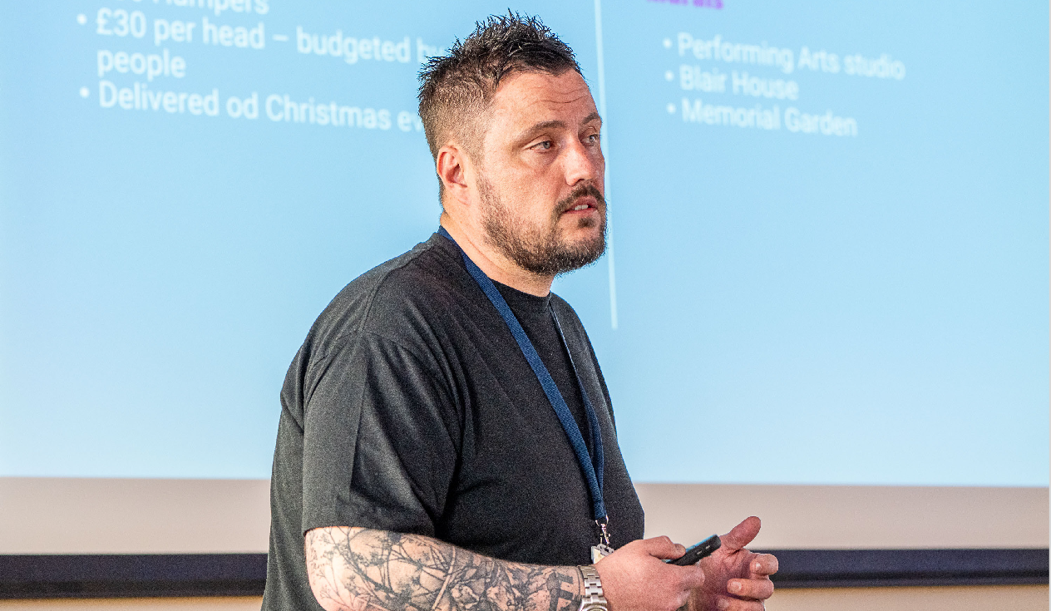

Introduction Highlights Stories of change Bold ten-year strategy Working into practice Looking ahead Accounts 43

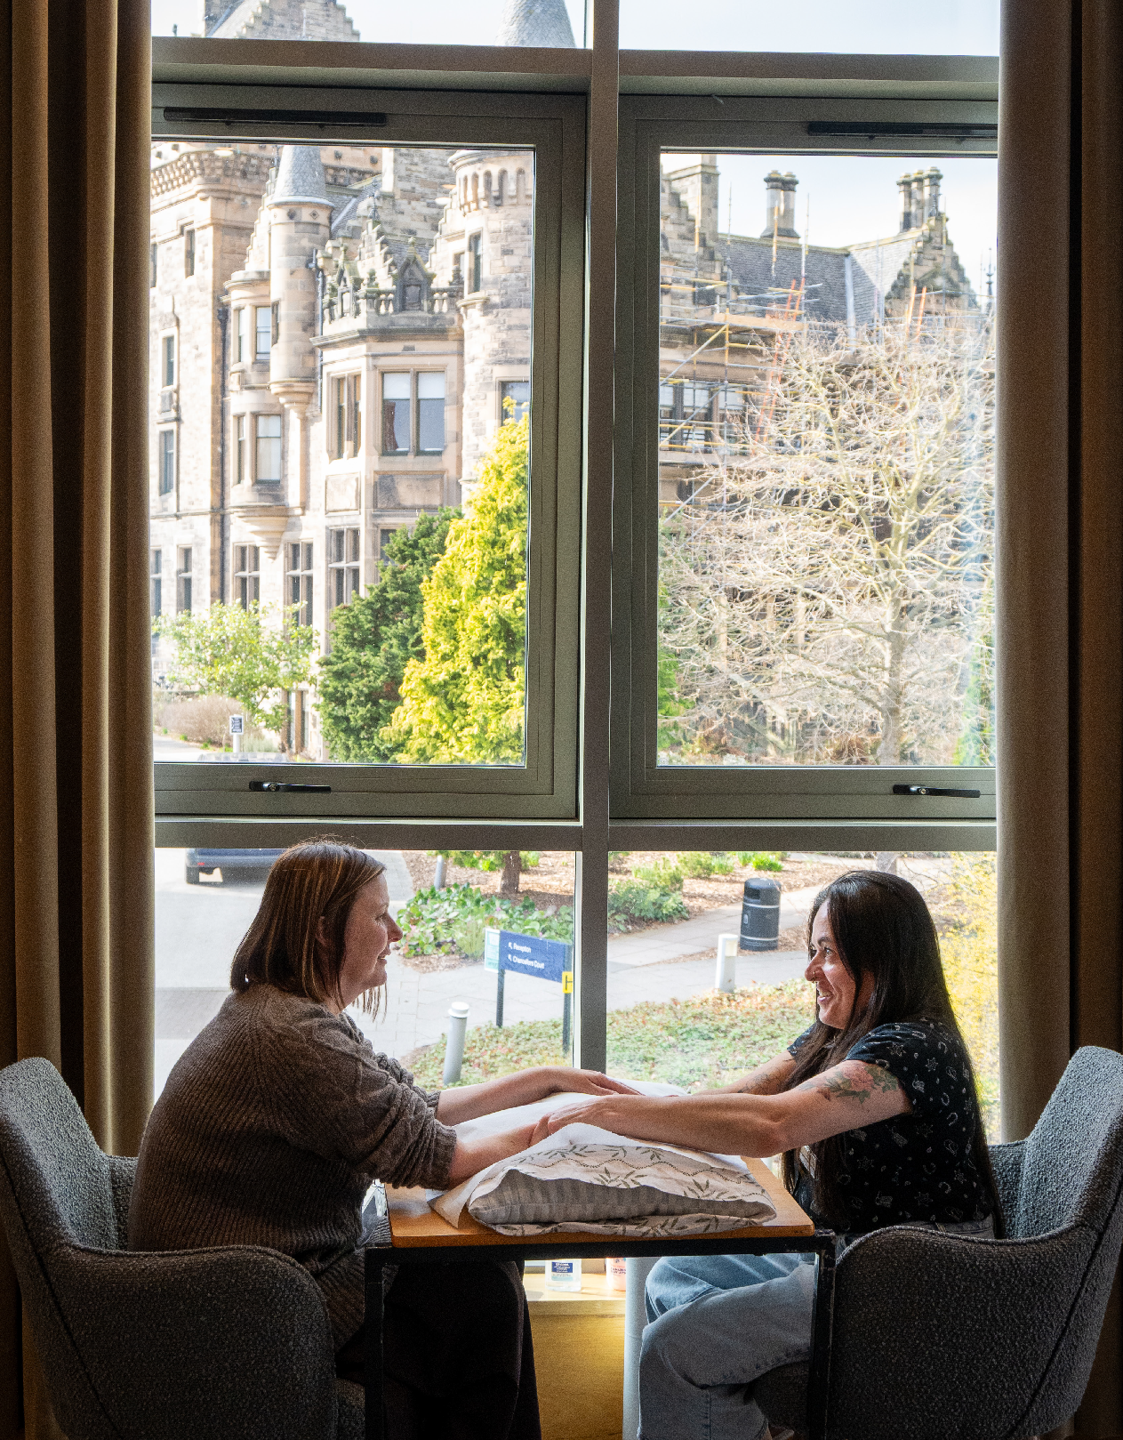
Change Three – People are working together to respond to the big challenges in Scotland

We can only rise to the challenges we face if people work together across groups, organisations and sectors. The most powerful way to find new solutions is by bringing lived and learned expertise to the table. This type of social change needs a whole range of tools, including: making best use of data; funding; helping people build their confidence and skills; networking; learning, sharing and campaigning.

Collaboration on big issues

Racial equity
Racism has increased over the past year, reinforcing the urgent need for collaboration to challenge this and pursue racial equity. Anti-racist action is incumbent on everyone and
should never sit only with communities impacted. A co-ordinated and collaborative response is needed from policy makers, duty bearers and funders to challenge, invest in and support front line services and long-term strategic change.
At Corra we have continued to work closely with other funders, including through the Ten Years’ Time Community of Practice. In late 2025 we delivered a session at the Association of Charitable Foundations (ACF) Conference to share our learning with senior leaders from UK philanthropy.

Introduction Highlights Stories of change Bold ten-year strategy Working into practice Looking ahead Accounts 44

Human rights
Human rights have remained a priority focus for many across civil society. Corra was privileged to be a sponsor of Scotland’s second annual human rights conference, convened by Human Rights Consortium Scotland and bringing together over 200 people. We were also one of over 180 signatories to an open letter to the Prime Minister and political leaders to mark Human Rights Day 2025. This called for political leadership and commitment to make universal human rights protections real for people,
every day.

Women and girls
In 2025 Corra developed two new partnerships supporting groups led by women and girls, with a focus on providing new investment, often to smaller groups. Funding of nearly £1m from Henry Smith Foundation allowed further grants to be made through Henry Duncan Grants and The Promise Partnership. These focused on children and young people growing up loved, safe and respected and addressing the impacts of gender-based violence on women and girls.
- Make additional grants to five organisations to support Human Rights Defenders.
- Bring grant holders together, facilitated by The Three Sisters Consultancy, to share learning and help inform the work of the Fund.
- Offer a range of support on leadership, risk management and wellbeing.
- Provide a small grant for a collaborative grant-holder led project on communicating about human rights.
A grant from Fondation Chanel will enable Corra to deliver support to small and medium sized organisations across Scotland led by women and girls. Grants prioritise groups working
As host of the Independent Human Rights Fund for Scotland Corra has been grateful for the ongoing support of fellow funders AB Charitable Trust, The Baring Foundation, The Binks Trust, Elevate Great, Indigo Trust, The Robertson Trust, and William Grant Foundation. Along with additional investment from AB Charitable Trust this
has allowed the Independent Human Rights
Fund in the past year to:
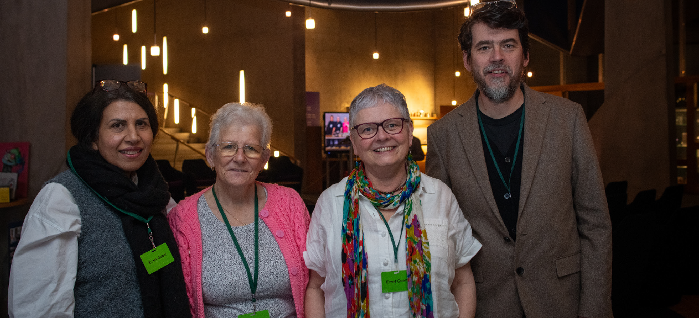
with women and girls facing multiple barriers, including racially minoritised women, survivors
of gender-based violence and women in recovery. It will also offer capacity building.

Introduction Highlights Stories of change Bold ten-year strategy Working into practice Looking ahead Accounts 45

Working with the Scottish Government Working with the Scottish Government has enabled Corra to make a difference on a range of Scottish policy priorities. These funds have
included a substantial level of multi-year core
grants to essential third sector organisations. They have also provided support for reflection, developing new approaches and peer-to-peer learning.
The timing of the Scottish Parliament elections has meant that several programmes concluded in 2025-26.
This was the final year of the National Drugs Mission Funds which will have seen Corra distribute £65m since 2021. Collectively the funded projects have reached many thousands of people, delivering rights-based support
for prevention, harm reduction, recovery and whole family approaches. Corra was pleased to be appointed to deliver the successor fund with a focus on drugs and alcohol. This further investment will support collective efforts to reduce harms, realise rights and support recovery. It will be designed and delivered

alongside people with lived and living experience of drugs and alcohol.
This was also the concluding year of Scottish Government funding for the Promise Partnership which has supported the ‘care system’ in Scotland to drive change that matters to children, young people and families. This £12m investment across several years has created time, space and support for organisations to reflect on existing practice, test new approaches, strengthen partnerships and embed the voices of children, young people and families in the design of services. Corra is delighted that the Henry Smith Foundation has invested funding to
support specific legacy work through the Promise
Partnership. This is vital to helping Scotland to keep the promise to children and young people that they will grow up loved, safe and respected.
Corra was appointed by the Scottish Government to deliver ongoing funding to the children and young people’s sector, through the Children, Young People and Families Early Intervention Fund and Adult Learning and Empowering Communities Fund and the Children, Young

People, Families and Adult Learning Third Sector Fund (CYPFEIF & ALEC and CYPFAL). These have provided vital core funding to organisations that are at the heart of supporting children, young people and families in Scotland.

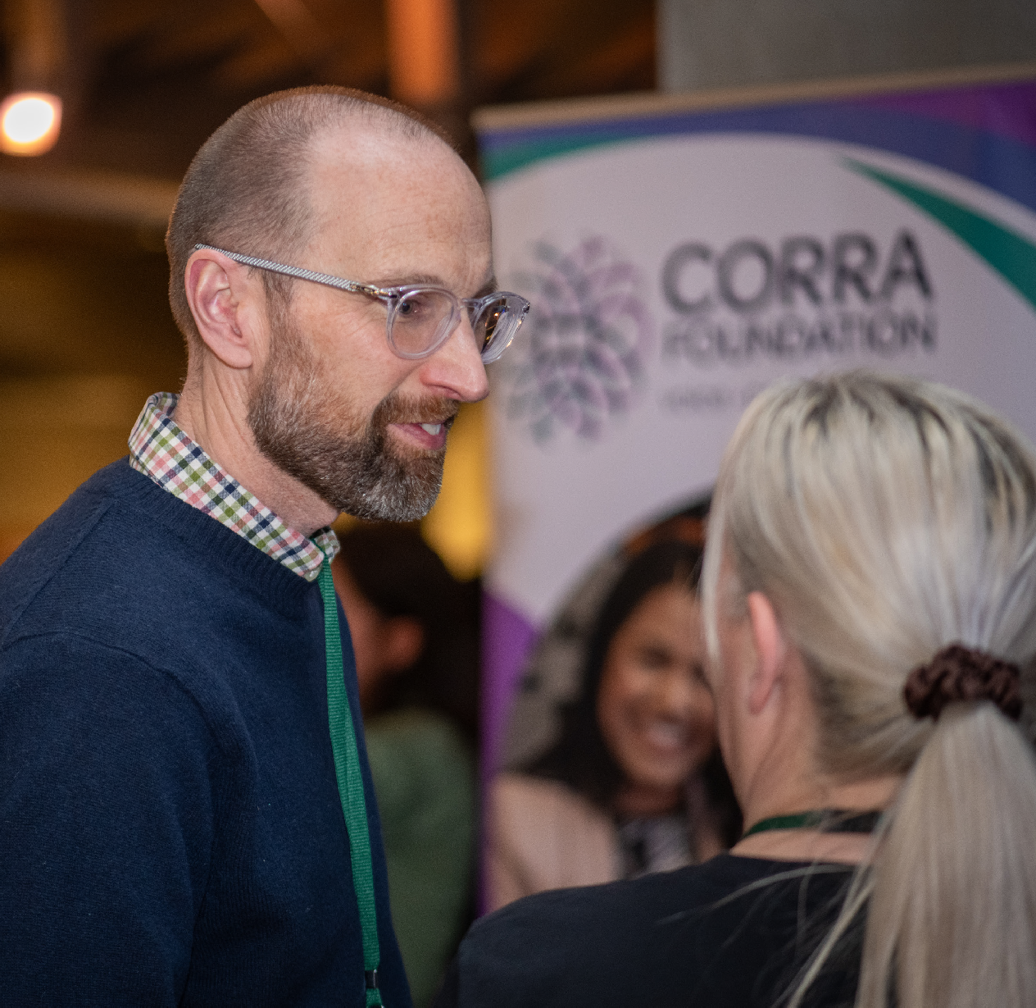

Introduction Highlights Stories of change Bold ten-year strategy Working into practice Looking ahead Accounts 46

Learning and influencing alongside communities
87% of the respondents to Corra’s applicant and grantholder survey felt we listened and understood the needs of the voluntary
sector and that we were willing to help offer advice and advocate alongside people.

Helping to create lasting change means influencing practice, policy and systems. In the last year Corra has worked to listen to communities and help amplify their voices.

platform for our voice to be heard and more importantly the voices of the girls and women that we work with to be heard.” Participant in Corra’s ‘policy academy’ process

In 2025 we brought together twelve community-led organisations working to support people (primarily women and girls) affected by domestic abuse and violence. The groups were funded through Corra’s Henry Duncan Grants and
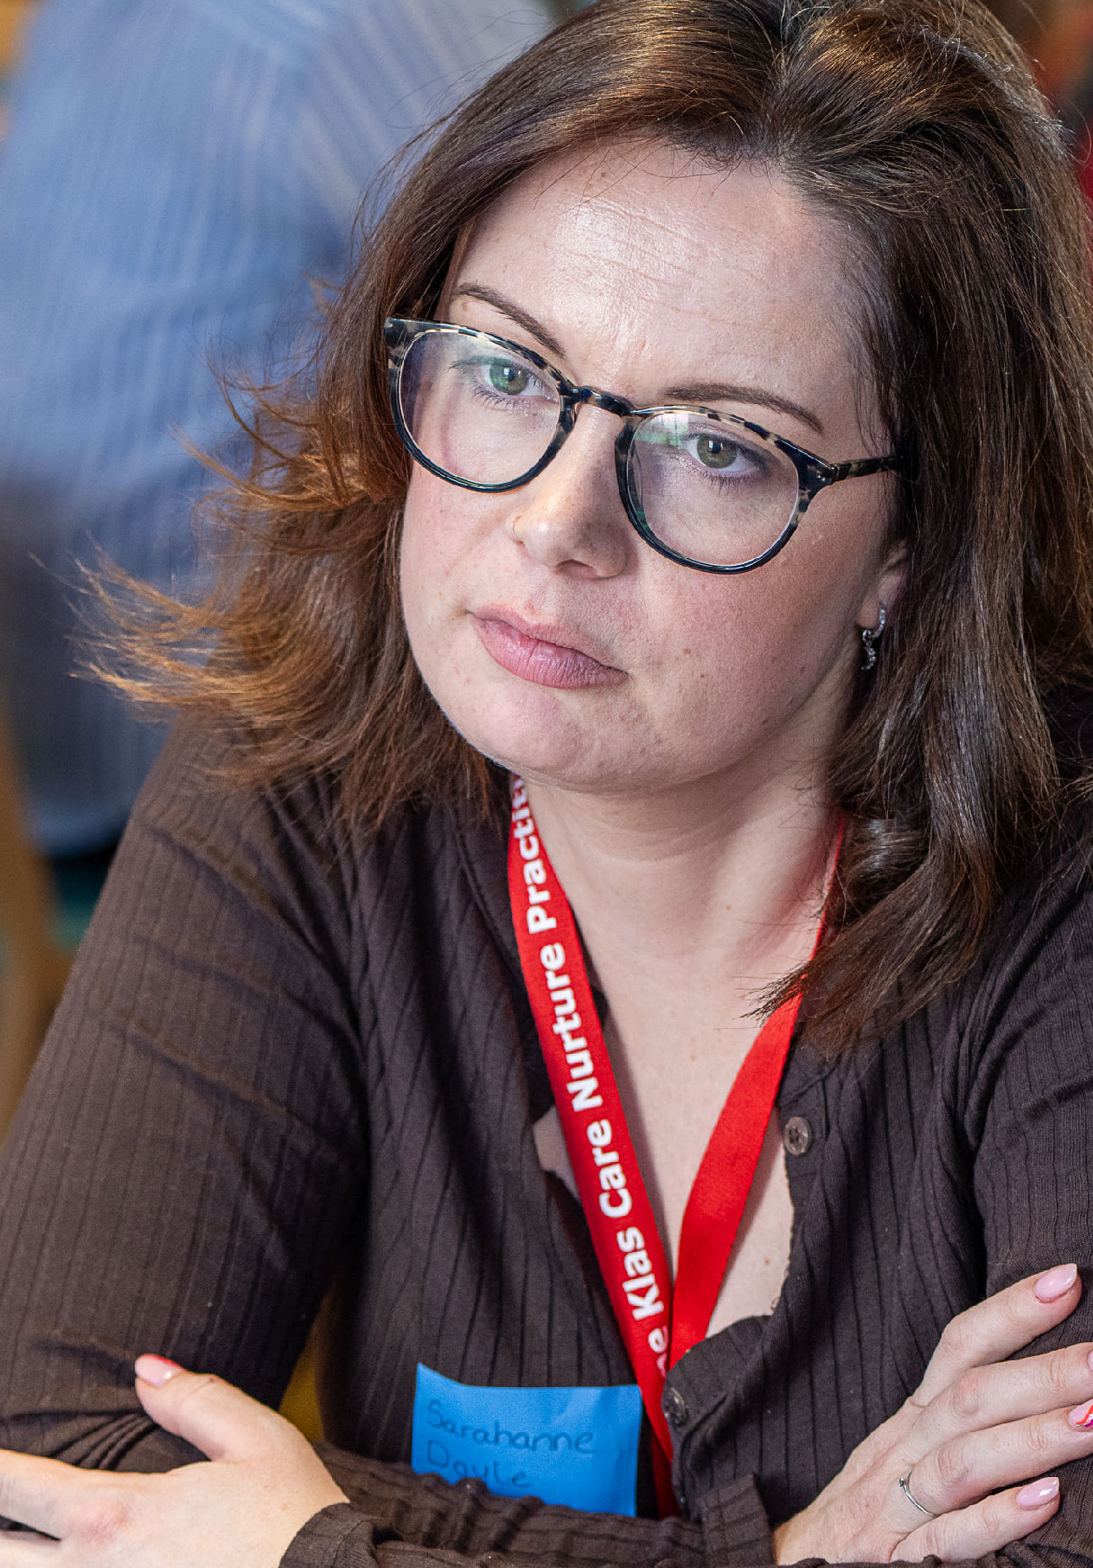
most were from Black and racially minoritised communities. The groups informed a collective response to the proposed Prevention of Domestic Abuse Bill and their input was referenced in
the report of the Scottish Parliament’s Criminal Justice Committee. Despite having crucial expertise to contribute, these women’s voices had not previously had a space in policy making.
“[The experience of] participating in the collective response was an extremely positive one. Was fantastic to hear about other organisations and the work they are doing. Was also incredible to be given the


Introduction Highlights Stories of change Bold ten-year strategy Working into practice Looking ahead Accounts 47

PUTTING OUR WAYS OF WORKING INTO PRACTICE

Introduction Highlights Stories of change Bold ten-year strategy Working into practice Looking ahead Accounts 48

Corra has a set of principles that we strive to put into practice across our roles as an employer, independent funder, charity
and partner, as well as in our
influencing activity.
This helps us to ensure we are following best practice based on sector-wide tools; ACF Stronger Foundations, Open and Trusting Grant-making and Foundation Practice Rating.
Our ways of working are designed to help us to support organisations. We aim to reduce the burdens we as a funder place on groups, and
prioritise relational approaches, flexible funding, and being open and responsive to asks for capacity building.

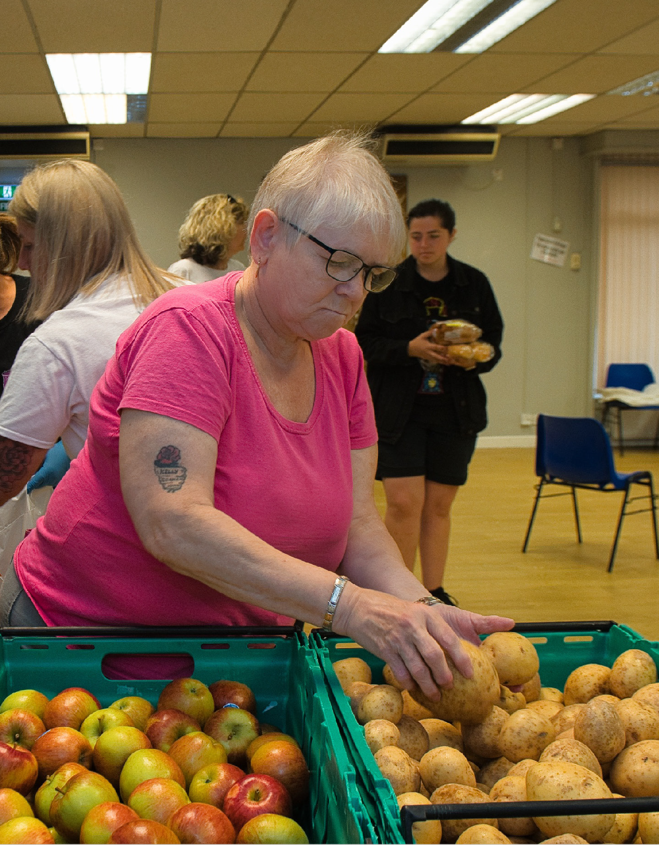
At Corra we try to continually improve, including through:
- Implementing learning from our partnerships with others.
- Offering relational and proportionate capacity building support.
- Using our influence to promote fairer funding.

Listen and respond to people, communities and organisations and amplify voices that are less well heard – their wisdom is at the heart of Corra’s approach
87% of people responding to Corra’s applicant and grant holder survey told us we listen and respond to feedback (up
from 71% last year). Over the past year we have continued to focus on relationships based on listening and respect. We have prioritised bringing grant holders together in response to feedback from groups about the importance of this.

Introduction Highlights Stories of change Bold ten-year strategy Working into practice Looking ahead Accounts 49

Across several programmes we have taken a deeper dive to understand what matters most to communities and grant holders. Common themes throughout these conversations have included:
  - People are making positive progress against their own outcomes. The ability to deliver person-centred approaches remain crucial.
  - Connections are critical with isolation a key theme, particularly among people who have experience of trauma. There is strong evidence of people looking for a sense of belonging, peer connections and ways to ‘give back’ and participate meaningfully.
  - Working across third and statutory sectors is vital. People have positive experiences of partnership but also acknowledge the challenges. Many grant holders told us that
mainstream services are not always accessible to people they support, whether due to stigma, cultural or language barriers.

Build relationships, always working with others on the basis of shared power, mutual trust and shared learning
Partnership is vital to Corra’s strategy. Across the past year it has been a privilege for us to work with people from across communities, fellow funders, local and national government and public bodies. We have been part of twenty-six collaborations, allowing us to maximise the
impact of our efforts. We have also been grateful for the opportunity to be part of networks, including Scotland Funders’ Forum, Scottish Grantmakers, the Association of Charitable Foundations, Open and Trusting Grant Making, SCVO, Human Rights Consortium Scotland and Ariadne (European Funders for Social Change and Human Rights). In 2025 we also joined
the Funders for Race Equality Alliance so we
can actively learn from others committed to a progressive approach to philanthropy with racial justice, equity, and equality at its heart.

Pursue diversity, equity and inclusion (DEI), trying to challenge structural discrimination and contribute to radical shifts in the funding sector
In the past year Corra has aimed to improve its approach to disability rights, including through staff training and work on inclusive
communications. We have also seen applications from groups led by disabled people increase in that time.
In May 2025 we published an update on progress towards our Anti-racism Action Plan, which included:
- Continuing to increase funding to support racial equity.
- Promoting anti-racist good practice in grant making.
- Contributing to advocating and influencing, directly and by amplifying the voices of Black and racially minoritised communities.

Introduction Highlights Stories of change Bold ten-year strategy Working into practice Looking ahead Accounts 50



Be an open, trusting and flexible
grant maker
Corra has remained committed to open and trusting grant making principles. We have continued to reflect on our practices to ensure they are accessible, proportionate and relational.
In 2025-26:
- 43% of funding distributed by Corra could be used flexibly, including to cover core costs.
- 87% of respondents to our applicant and

grant holder survey said they felt comfortable speaking with Corra.
- 61% of respondents to our applicant and grant holder survey reported finding completing our grant application form very easy or easy.

Ensure we contribute to tackling climate change, through our investments, operations and grant making and encouraging others to take action alongside us
Corra has continued to work towards its commitments as a signatory of the Funder Commitment on Climate Change (FCCC). We were proud to achieve the Carbon Literate Organisation silver award in June 2025. Corra’s Green Team have begun to consider options
to strengthen our work on climate. This could include producing a Strategic Environmental Action Plan, better integration of climate impact across our programmes, and further actions on Corra’s investments and grant making.

Be bold, taking considered risks and supporting others to do the same
74% of respondents to the applicant and grant holder survey in 2025 told us that Corra is supportive for people take forward new or different ideas.

As an independent foundation Corra has the privilege of being able to choose to be bold and take considered risks. In the past year we have continued to try and reach groups that traditional funding approaches have not worked well for. We have tried to support others to test new approaches and be bold through funding that is flexible and relationships that are open and trusting.


Introduction Highlights Stories of change Bold ten-year strategy Working into practice Looking ahead Accounts 51

LOOKING AHEAD

Introduction Highlights Stories of change Bold ten-year strategy Working into practice Looking ahead Accounts 52

The past year has been a period of change for Corra. We have seen programmes end, whilst others have evolved and new work has emerged. We will continue to use our resources to amplify less heard voices, shift power and collaborate in pursuit of real change. This will mean supporting grassroot groups, being alongside communities, and collaborating on big issues where strategic change is needed.
Priorities for 2026-27 include:
- Increasing unrestricted funding so that groups can use grants flexibly and in the way that works best for them. We will reflect on why this has proved challenging, with only 4% of all new grant money distributed by Corra in 2025-26 having been unrestricted. Although, for grant funding that was distributed using only Corra money 93% was unrestricted.
- Securing further investment to complement our own and partners’ funds in Boost so it can
continue to be open all year round. This reflects our commitment to flexible, accessible funding for grassroots groups who create opportunities for people to come together locally. This is

a powerful way of building friendships, trust and an inclusive sense of belonging within communities.
- Seeking to further build collaborations around racial equity, the Independent Human Rights Fund for Scotland and Every One Every Day.
- Extending our reach, particularly to people who have experienced the greatest barriers to funding. We will be mindful that this brings challenges when demand far exceeds the resources available. We will engage with
applicants and grant holders to understand the pressures they are under and how funders can help reduce, and not add to, these. We will also consider the issues of demand and success rates in light of Corra’s new Racial Equity Fund, which saw high demand and a success rate of 20% (considerably lower than Corra’s average of 68%).
- Continuing to offer more than money. We will invest in capacity building and using collective evidence to influence policy and practice. We will remain alert to the wider challenges and uncertainties facing all of us, responding with trust and flexibility.

- Working with a refreshed learning framework.
This will help guide the next stages of our ten-year strategy. We will share in-depth
evaluations of Getting Alongside Communities and the Promise Partnership, helping secure a strong legacy for this important work. We will reflect on our experience of involving people with lived expertise in grant making so we can continually improve our approach.
Human relationships will remain at the heart of how we work. This means listening to the communities we exist to serve, collaborating with our partners, and meeting challenges with understanding, empathy and trust.


Introduction Highlights Stories of change Bold ten-year strategy Working into practice Looking ahead Accounts 53

ACCOUNTS

Introduction Highlights Stories of change Bold ten-year strategy Working into practice Looking ahead Accounts 54

Financial Review
and Carbon Reporting
The reporting period is 12 months to 31 March 2026

Income
Statement of Financial Position
At the end of the period Corra had total net assets of £37.8m (2024/5 £38.1m), which includes the portfolio investment funds
of £19.2m (2024/5 £20.4m). Of the net assets
£19.2m is classified as unrestricted (2024/5
£20.7m).
This can be further broken down into the General Fund of £16.2m (2024/5 £17.8m) and the Designated Fund of £3m (2024/5
£2.9m) with the balance representing the Restricted Fund of £18.6m (2024/5 £17.4m).
Total income for the period to 31 March 2026 was
£30.4m (2024/5 £40.3m)
Corra received income to distribute from the Scottish Government during the year included the following:
- National Drugs Mission £14m (2024/5 £13.6m)
- CYPFEIF & ALEC/CYPFAL £9m (2024/5 £18m)
- Household Hardship £1.5m (2024/25 £0)
A full breakdown of all programmes and funders is shown in Note 21.

Expenditure
In the period to 31 March 2026, total restricted charitable grant expenditure amounted to £28.2m (2024/5 £37.6m), unrestricted charitable grant expenditure was £3.1m (2024/5 £3.2m)
A full breakdown of Corra’s charitable expenditure is shown in Note 7. Total governance and office costs were £1.2m for the period (2024/5 £1m).

Introduction Highlights Stories of change Bold ten-year strategy Working into practice Looking ahead Accounts 55

Financial Review and Carbon Reporting
The reporting period is 12 months to 31 March 2026

Going concern
The Trustees are satisfied Corra can operate for the foreseeable future based on the unrestricted funds held in the investment portfolio and cash, plus continuing success in attracting new funding and managing the current multi-year partner funded contracts. The Trustees review quarterly cash flow forecasts. The going concern basis
of accounting is therefore appropriate. Further details are given in the Going Concern accounting policy at 1(c).

Cash flow
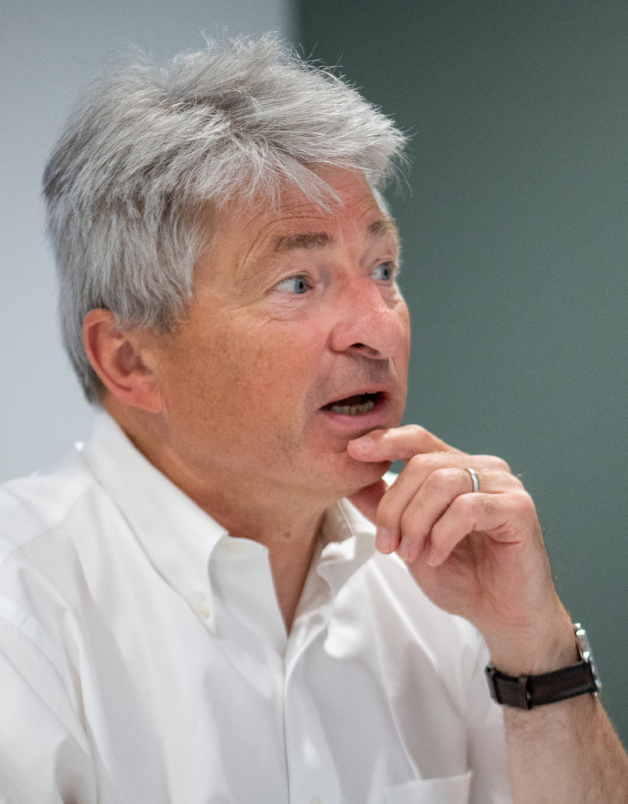
Cash resources held at steady at the end of the period at £18.5m (2024/5 £18.9m).
Corra recognises the importance of prompt payment for all our stakeholders. Corra targets grant payments being made within 10 days
of the successful recipient receiving the grant offer letter.

Introduction Highlights Stories of change Bold ten-year strategy Working into practice Looking ahead Accounts 56

Financial Review and Carbon Reporting
The reporting period is 12 months to 31 March 2026

Investment policy and performance Trustees have a duty to manage the investment portfolio in the best interests of Corra and in line with the legal duties conferred on charity
trustees by the Charities and Trustee Investment
(Scotland) Act 2005.
The Trustees refer to guidance published by OSCR and other relevant bodies such as the Association of Charitable Foundations (ACF) to ensure compliance with recommended good practice.
Corra aims to deliver its mission in an ethically responsible way. Corra will not knowingly appoint, partner, invest or seek income from companies whose activities are likely to, or will, cause harm and/or discriminate against people, communities, partners and not-for-profit organisations Corra works with and the planet. This is the basis of Corra’s ethical policy which is underpinned by an ethical operational decision matrix which serves as a reference point for staff.
In November 2022 the investment portfolio of
£22m was applied as £11m equally to Cazenove Capital and Sarasin & Partners, for a period
of five years, to continue the long-term investment strategy.
Trustees selected the Climate Active Endowments Fund from Sarasin & Partners and Cazenove Capital’s Responsible Multi-Asset Fund as best meeting the ethical and investment strategy criteria. The focus is on longer term growth, assessed over five years or more to provide
a total return, net of costs, that exceeds consumer price inflation by 4% per annum. Trustees monitor the performance on a quarterly basis.
The Trustees are encouraged by both investment managers proactive approach to responsible stewardship and environmental, social and governance (ESG) related policies, and active ownership, with the aim of improving financial outcomes and helping to secure tomorrow.
The two funds screen out investment in fossil fuel production and avoid businesses with significant activity in tobacco, alcohol, armaments, adult entertainment, gambling and high interest
rate lending (‘payday’ lenders). Among the funds’ holdings are investments in technology, pharmaceuticals and renewable energy firms. Corra’s investment portfolio is valued at £19.2m (2024/5 £20.4m), reflecting drawdown made during the period and any loss/gain in
market value.

Introduction Highlights Stories of change Bold ten-year strategy Working into practice Looking ahead Accounts 57

Financial Review and Carbon Reporting
The reporting period is 12 months to 31 March 2026

Risk policy
The Trustees have examined the major strategic and operational risks facing Corra and confirm that systems have been established to take
the necessary steps to mitigate or find an appropriate response to these risks. The Trustees consider both the likelihood and potential impact arising from risks to Corra and throughout 2025/26 gave special attention to the key
risks of, (1) global economic conditions and ongoing conflicts resulting in a significant fall in the value of investments, (2) the failure of the partnership model due to ending of existing
partnerships and/or failure to secure new ones/ inability to adapt to changing macro needs. All risks are monitored, managed and regularly reviewed through the risk register.
There are policies, procedures and contingencies in place to minimise and address all the risks identified. Actions to mitigate key risks include,
(1) monitoring of investment performance by
the F&I Committee and external experts, periodic assessment of Corra’s likely future investment resources required to meet the strategic plan objectives, appraise a range of options to
ensure long term financial sustainability; (2) regular engagement with current/potential partners, Scottish Government, policymakers and stakeholders, the implementation of an intentional plan to reinforce/build
cross-party support.

Introduction Highlights Stories of change Bold ten-year strategy Working into practice Looking ahead Accounts 58

Financial Review and Carbon Reporting
The reporting period is 12 months to 31 March 2026

Grantmaking policy
Grantmaking is the core activity of Corra in pursuit of delivering its strategy. We deliver and administer funding through our own
programmes, in partnership and/or on behalf of other funders.
Our Trustees will decide the strategic direction for Cora’s own grant making and may delegate these decisions to Corra employees, lived expertise panels and/or other groups and organisations.
Due diligence is carried out by Corra staff on all applications we receive.
We adopt best practice in grant-making to provide accountability, transparency and equity. We deliver this through eight principles that aim to offer trust-based and supportive grant-making for all our applicants and grant holders.
- Not to waste applicant and grant holders time by providing necessary and accessible information on funding priorities on
our website.
- Act with urgency – publishing timetables and making decisions as quickly as possible.
- Only ask relevant questions – making the application process fairer and easier
to complete.
- Accept our share of risk – making sure our risk measures are proportionate to the size of the grants.
- Transparency about our decisions – publishing our grant information on 360 Giving and providing an annual update on average grant size and success rate.
- Enable grant holders to respond flexibly to changing priorities – making our funding as flexible as possible.
- Be clear about our relationship from the start – providing upfront communication with
grant holders and setting out all requirements (including reporting) in our grant offer email/letters.
- Commit to light touch reporting – ensuring all reporting is relevant and proportionate to the size of the grant.
We regularly review our grant-making and update our practices based on feedback received from our annual Applicant and Grant holder survey. Membership of bodies such as the Scottish Grantmakers, Scotland Funders’ Forum, Association of Charitable Foundations, Institute for Voluntary Action Research (IVAR) Open and Trusting Grant-making ensures we are up to date with best and current practice.
Trustees make decisions on grants from Corra’s investments and may delegate these decisions to Corra employees, other organisations or groups.

Introduction Highlights Stories of change Bold ten-year strategy Working into practice Looking ahead Accounts 59

Financial Review and Carbon Reporting
The reporting period is 12 months to 31 March 2026

Reserves policy
The Reserves Policy is reviewed each year and the Trustees are satisfied that adequate reserves are in place. Corra’s reserve policy, to which management ensures ongoing compliance, is
to have a cash-backed reserve of six months of operating costs, 2025/26 budget would require
£650,000, against an actual of £16.2m
Total funds held at the period end were £37.8m (2024/5 £38.1m). After taking into consideration the restricted funds of £18.6m (2024/5 £17.4m) and designated funds of £3m (2024/5 £2.9m); and funds tied up in tangible and intangible assets, Corra held total unrestricted free reserves of
£16.2m (2024/5 £17.8m).

Pay policy for staff
The Senior Management Team are the key management personnel responsible for day-to-day operational management of Corra. Trustees delegate this responsibility whilst having
a Nominations & Remunerations Sub-committee to agree annual salary scales and benchmarked remuneration levels. Trustees give of their time freely and no Trustee received any remuneration
in the year. Details of Trustees’ expenses are disclosed in Note 9 to the Accounts.
Corra is a Living Wage Foundation accredited employer with every member of staff, as well as all contractors, earning at least the Living Wage. The Trustees believe that everyone deserves to be paid at least the Living Wage. Corra values the wellbeing of its staff and has a staff led wellbeing group in place to promote different initiatives around physical and mental health wellbeing.

Carbon Reporting
Staff travel showed a 26% increase in total kilometres travelled of 27,000 km, which we can relate to specific project activity. A large
community driven project ended after a 10 year period, to ensure good endings, more travel was incurred in year. We expect this to drop again in 2026/27. There was a small 4% swing towards public transport from car travel which
was welcome 68% (64% 2024/5). Our greenhouse gas emissions have been calculated in line with the methodology set out in the UK Government’s Environmental Reporting Guidelines, 2019.
Emissions have been calculated using the
latest conversion factors provided by the UK Government. There are no material omissions from the mandatory reporting scope.

Energy consumption and GHG emissions | 2025-26 GHG  emissions  (tCO₂e) |  | 2024-25 GHG  emissions  (tCO₂e)
Energy consumption and GHG emissions | 4,541 |  | 3,369
Other material sources of GHG emissions (scope 3) | 13 |  | 12
Total emissions (tCO2e) | 4,554 |  | 3,381
Further analysis of GHGs arising from energy consumption and from other sources is provided below.

Introduction Highlights Stories of change Bold ten-year strategy Working into practice Looking ahead Accounts 60

Energy Consumption and Greenhouse Gas Emission

 | 2025-26 |  |  |  | 2024-25
Natural gas | Energy consumption  (KWh, net calorific value for fuels) |  | Resultant GHG emissions  (tCO₂e) |  | Energy consumption  (KWh, net calorific value for fuels) |  | Resultant GHG emissions  (tCO₂e)
Natural gas | 2,183 |  | 443 |  | 2,283 |  | 463
Electricity | 23,151 |  | 4,098 |  | 14,033 |  | 2,906
Energy total | 25,334 |  | 4,541 |  | 16,316 |  | 3,369

Introduction Highlights Stories of change Bold ten-year strategy Working into practice Looking ahead Accounts 61

Other Material Sources of Greenhouse Gas Emissions (scope 3)

 | 2025-26 |  |  |  | 2024-25
Travel | Footprint  (units are source specific) |  | Resultant GHG emissions  (tCOe) |  | Footprint  (units are source specific) |  | Resultant GHG emissions  (tCOe)
Domestic flights ('000 passenger-km) | - |  | - |  | 1 |  | -
Rail ('000 passenger-km) | 90 |  | 3 |  | 68 |  | 2
Employee car mileage claimed as expenses ('000 km) | 43 |  | 7 |  | 37 |  | 6
Travel total ('000 passenger-km) | 133 |  | 10 |  | 106 |  | 8
Waste ('000 tons) | 1 |  | 3 |  | - |  | 3
Water ('000 m³ supplied) | 1 |  | - |  | 2 |  | 1
Other sources total | 135 |  | 13 |  | 108 |  | 12

Introduction Highlights Stories of change Bold ten-year strategy Working into practice Looking ahead Accounts 62

Intensity Ratios
We report below two intensity ratios: emissions per £1m of turnover and emissions per staff member.

 | 2025-26 |  |  |  | 2024-25
Turnover (£'000) | Metric value |  | Intensity ratio |  | Metric value |  | Intensity ratio
Turnover (£'000) | 30,404 |  | 149.78 |  | 39,720 |  | 85.13
Average no of staff employed during  the period | 44 |  | 103.5 |  | 45 |  | 75.14

Introduction Highlights Stories of change Bold ten-year strategy Working into practice Looking ahead Accounts 63

Structure, Governance and Management
Directors and Trustees
The directors of the charitable company (Corra) are its Trustees for the purpose of charity law. The Trustees and officers serving during the period and since the period end were as follows:
Chair,
Dr Judith A Turbyne
(from 6 September 2024, Deputy Chair since 11 June 2020)
Deputy Chair,
Andrew Herberts
(from 6 September 2024, Trustee since 10 June 2022)

Trustees
Corra key management personnel
Chief Executive
Carolyn Sawers
Head of Corporate Services
Karen Brown
Head of Finance
Judith Crichton
Head of Grants
Tom Baughan
Head of Learning and Development
Elaine Wilson
Head of Place
Allan Farmer
Head of Policy and Communications
Shelley Gray

Reference and administration details
Company number SC096068
Scottish Charity Number SC009481
Registered Office and Principal Address
Pure Office Suites, 4-5 Lochside Way, Edinburgh, City Of Edinburgh, Scotland, EH12 9DT

Andrew Scott
Claire A Gibson
(resigned 11 December 2025)

David R Johnson
(resigned 11 September 2025)
Graeme Davies Mark Armstrong
Michaela Collins MBE Mildred Zimunya
Nosheen Ahmed
(resigned 2 April 2026)

Pratul Choudhary Tasnim Hassan Rob Scholes
(appointed 11 December 2025)

Kirsten Tollerton
(appointed 26 March 2026)
Company Secretary

Monica McKinven
(appointed 26 March 2026)

Hana Graham
(resigned 22 December 2025)

Introduction Highlights Stories of change Bold ten-year strategy Working into practice Looking ahead Accounts 64

Structure, Governance and Management

Our advisers:

Auditor
CT Audit Limited
61 Dublin Street, Edinburgh EH3 6NL

Investment Managers
Sarasin and Partners LLP
50 George Street, London, W1U 7DY
Cazenove Capital
1 London Wall Place, London EC2Y 5AU

Legal Adviser
Turcan Connell
Princes Exchange, 1 Earl Grey Street, Edinburgh EH3 9EE

Banker
Santander Corporate & Commercial Bank
5th Floor, Capital Building, 12–13 St Andrews Square, Edinburgh EH2 2AF

Introduction Highlights Stories of change Bold ten-year strategy Working into practice Looking ahead Accounts 65

Governing document
Corra was incorporated on 20th November 1985 as a Company Limited by Guarantee. Corra is a Charitable Company Limited by Guarantee and does not have share capital. The liability of the members is limited by the Articles of Association to £1 each. The members are the Trustees.

Organisation
The Board of Trustees, which can have up to twelve members, administers Corra. The Trustees meet regularly during the year and there are sub-committees that have been set up to govern particular aspects of Corra’s business.

Audit Committee
has delegated responsibility on behalf of the Board of Trustees for ensuring that there is a framework for accountability; for examining and reviewing all systems and methods of control both financial and otherwise including risk analysis and risk management; review and recommendation of the external audit report, and annual report and accounts to the Board of Trustees.
Communications and Engagement Committee provides assurance to the Board on external relations strategy, reputational issues and helps to inform Corra’s policy and influencing activity.

Finance and Investment Committee
has delegated responsibility on behalf of the Board of Trustees for setting the reserves and investment policy to be adopted for Corra; ensuring that the investment of Corra’s funds is conducted appropriately and in accordance with Corra’s Ethical Policy; review of management accounts; review and recommendation of the annual budget to the Board of Trustees.
Nominations and Remuneration Committee has delegated responsibility on behalf of the Board of Trustees for identifying and then nomination for the approval of the Board, candidates to fill Board/Chief Executive vacancies; considering re-appointments of members upon conclusion of their specified term of office; making recommendations in respect
of membership and chairing of Board Sub-
Committees; and for reviewing and approving annually the salaries and benefits packages of foundation staff.

Introduction Highlights Stories of change Bold ten-year strategy Working into practice Looking ahead Accounts 66

Structure, Governance and Management

Directors and Trustees
In addition, some Trustees sit on a steering group which exists to advise the Way Forward for Families Partnership (formerly Partnership Drug Initiative) and on the Corra Anti-Racism Working Group. The Chief Executive is appointed
by Trustees to manage the day-to-day operations of Corra. To facilitate effective operations, the Chief Executive has delegated authority with terms approved by the Trustees, for operational matters including grant administration, finance, and employment.

Trustee appointment, induction, and training
The recruitment of new Trustees is conducted through a process of open advertising except in exceptional circumstances where co-opting
may be necessary. When a vacancy for a Trustee arises, a skills audit of the Board is undertaken to identify any gaps and to enable Corra to maximise the contribution that its Trustees can make. Trustees are appointed for an initial three-year term and can make themselves available to be considered for up to two further periods
of three years.

On appointment, Trustees are provided with a Trustee Handbook and undertake an induction process. New Trustees are also able to attend Board meetings as observers before assuming their position.
Ongoing training, support and relevant information is provided to Trustees as required. None of the Trustees receive remuneration or other benefit from their work with Corra. Any connection between a Trustee or senior manager of Corra with any charity that is funded must be disclosed to the full Board of Trustees in the same way as any contractual relationship with
- likely consequences of any decision in the long term,
- interests of the charity’s employees,
- need to foster the charity’s business relationships with all stakeholders,
- impact of the charity’s operations on the community and the environment,
- desirability of the charity maintaining a reputation for high standards of business conduct,
- need to act fairly between members of the charity.
The trustees/directors consider that they have met all of the responsibilities set out above and that examples of how these have been addressed are set out throughout the Annual Report.
a related party.
Section 172 statement – our reporting responsibilities as a large company
The directors of a charity must act in the way they consider, in good faith, would be most likely to promote the success of the charity and its charitable purpose. In doing so, they must have regard (amongst other matters) to the:

Introduction Highlights Stories of change Bold ten-year strategy Working into practice Looking ahead Accounts 67

Trustees’ Responsibilities
The Trustees (who are also directors of Corra for the purposes of company law) are responsible for preparing the Trustees’ Annual Report (including the Strategic Report) and accounts in accordance with applicable law and United Kingdom Accounting Standards (United Kingdom Generally Accepted Accounting Practice).
Company law requires the Trustees to prepare accounts for each financial period which give a true and fair view of the finances of the charitable company, of the incoming resources
and the application of those resources including the income and expenditure of the charitable company in that period.
In preparing these accounts, the Trustees are required to:
- select suitable accounting policies and then apply them consistently,
- observe the methods and principles in the Charities SORP (FRS 102) (Effective 1 January 2019),

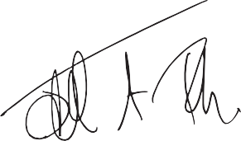
- make judgments and estimates that are reasonable and prudent,
Statement as to disclosure to the auditors
As far as the Trustees are aware at the time of approving our Trustees’ annual report:

There is no relevant audit information of which the charitable company’s auditor is unaware.

The Trustees have taken all steps that they ought reasonably to have taken to make themselves aware of any relevant audit information and to establish that the auditor is aware of that information.

Auditors
A resolution to reappoint CT Audit Limited as auditors will be put to the members at the Annual General Meeting.

The Trustees’ Report, incorporating the Directors’ Report and Strategic Report, was approved by the Board on 17th September 2026. By order of the Board.

Judith Turbyne Chair
17th September 2026
- state whether applicable UKAccounting Standards have been followed, subject to any material departures disclosed and explained in the accounts,
- prepare the accounts on the going concern basis unless it is inappropriate to presume that the charitable company will continue in operation.
The Trustees are responsible for keeping adequate accounting records that disclose with reasonable accuracy at any time the financial position of the charitable company and enable them to ensure that the accounts comply with the Companies Act 2006, the Charities and Trustee Investment (Scotland) Act 2005 and the Charities Accounts (Scotland) Regulations 2006 (as amended). They are also responsible for safeguarding the assets of the charitable
company and hence for taking reasonable steps
for the prevention and detection of fraud and other irregularities.

Introduction Highlights Stories of change Bold ten-year strategy Working into practice Looking ahead Accounts 68

Independent Auditor’s Report To The Trustees Of Corra Foundation

Opinion on accounts
We have audited the accounts of Corra Foundation (the ‘charitable company’) for the year ended 31 March 2026 which comprise the Statement of Financial Activities, the Statement of Financial Position, the Statement of Cash Flows and notes to the accounts, including significant accounting policies. The financial reporting framework that has been applied in their preparation is applicable law and United Kingdom Accounting Standards, including Financial Reporting Standard 102 The Financial Reporting Standard applicable in the UK and Republic of Ireland (United Kingdom Generally Accepted Accounting Practice).
In our opinion the accounts:
- give a true and fair view of the state of the charitable company’s affairs as at 31 March 2026, and of its incoming resources and application of resources, including its income and expenditure, for the year then ended;
- have been properly prepared in accordance with United Kingdom Generally Accepted Accounting Practice; and
- have been prepared in accordance with the Companies Act 2006, the Charities and Trustee Investment (Scotland) Act 2005 and regulation 8 of the Charities Accounts (Scotland) Regulations 2006.

Basis for opinion
We conducted our audit in accordance with International Standards on Auditing (UK) (ISAs (UK) and applicable law. Our responsibilities under those standards are further described
in the auditor’s responsibilities for the audit of the accounts section of our report. We are independent of the charitable company in
accordance with the ethical requirements that are relevant to our audit of the accounts in the UK, including the Financial Reporting Council’s Ethical Standard and we have fulfilled our other ethical responsibilities in accordance with these requirements. We believe that the audit evidence we have obtained is sufficient and appropriate to provide a basis for our opinion.

Conclusions relating to going concern
In auditing the accounts, we have concluded that the trustees’ use of the going concern basis of accounting in the preparation of the accounts is appropriate.
Based on the work we have performed, we have not identified any material uncertainties relating to events or conditions that, individually or collectively, may cast significant doubt on the charitable company’s ability to continue as a going concern for a period of at least twelve months from when the accounts are authorised for issue.
Our responsibilities and the responsibilities of the trustees with respect to going concern are described in the relevant sections of this report.

Introduction Highlights Stories of change Bold ten-year strategy Working into practice Looking ahead Accounts 69

Other information
The other information comprises the information included in the trustees annual report, other than the accounts and our auditor’s report thereon.
The trustees are responsible for the other information contained within the annual report. Our opinion on the accounts does not cover other information and, except to the extent otherwise explicitly stated in our report, we do not express any form of assurance conclusion thereon.
Our responsibility is to read the other information and, in doing so, consider whether the other information is materially inconsistent with the accounts or our knowledge obtained in the course of the audit or otherwise appears to
be materially misstated. If we identify such material inconsistencies or apparent material misstatements, we are required to determine whether this gives rise to a material misstatement in the accounts themselves. If, based on the work we have performed, we conclude that there is a material misstatement of this other information, we are required to report that fact.
We have nothing to report in this regard.

Opinion on other matters prescribed by the Companies Act 2006
In our opinion, based on the work undertaken in the course of the audit:
- the information given in the Trustee’s Annual Report, (which includes the Directors’ Report and the Strategic Report) for the period for which the accounts are prepared is consistent with the accounts; and
- the Trustee’s Annual Report (which includes the Directors’ Report and the Strategic Report), have been prepared in accordance with applicable legal requirements.

Matters on which we are required to report by exception
In the light of the knowledge and understanding of the charitable company and its environment obtained in the course of the audit, we have not identified material misstatements in the Trustees’ Annual Report.
We have nothing to report in respect of the

following matters where the Companies Act 2006 and the Charities Accounts (Scotland) Regulations 2006 requires us to report to you if, in our opinion:
- the charitable company has not kept proper and adequate accounting records, or returns adequate for our audit have not been received from branches not visited by us; or
- the accounts are not in agreement with the accounting records and returns; or
- certain disclosures of trustees’ remuneration specified by law are not made; or
- we have not received all the information and explanations we require for our audit.

Introduction Highlights Stories of change Bold ten-year strategy Working into practice Looking ahead Accounts 70

Responsibilities of Trustees
As explained more fully in the statement of trustees’ responsibilities set out on page 64, the trustees (who are also the directors of the charitable company for the purposes of company law) are responsible for the preparation of the accounts and for being satisfied that they give
a true and fair view, and for such internal control as the trustees determine is necessary to enable the preparation of accounts that are free from material misstatement, whether due to fraud
or error.
In preparing the accounts, the trustees are responsible for assessing the charitable company’s ability to continue as a going concern, disclosing, as applicable, matters related to going concern and using the going concern basis of accounting unless the trustees either intend to liquidate the charitable company or to cease operations, or have no realistic alternative but
to do so.

Auditor’s responsibilities for the audit of the accounts
We have been appointed as auditor under section 44(1)(c) of the Charities and Trustee Investment (Scotland) Act 2005 and under the Companies Act 2006 and report in accordance with regulations made under those Acts.
Our objectives are to obtain reasonable assurance about whether the accounts as a whole are free from material misstatement, whether due to fraud or error, and to issue an auditor’s report that includes our opinion. Reasonable assurance is a high level of assurance, but is not a guarantee that an audit conducted in accordance with ISAs (UK) will always detect a material misstatement when it exists. Misstatements can arise from fraud or error and are considered material if, individually or in the aggregate, they could reasonably be expected to influence the economic decisions of users taken on the basis of these accounts.
Irregularities, including fraud, are instances of non-compliance with laws and regulations. We design procedures in line with our responsibilities,

outlined above, to detect material misstatements in respect of irregularities, including fraud. The extent to which our procedures are capable of detecting irregularities, including fraud is detailed below:
We gained an understanding of the legal and regulatory framework applicable to the
charitable company and the sector in which it operates and considered the risk of acts by the charitable company which were contrary to applicable laws and regulations, including
fraud. These included but were not limited to the Companies Act 2006, the Charities and Trustee Investment (Scotland) Act 2005, and the Charities Accounts (Scotland) Regulations 2006.
Our audit procedures were designed to respond to risks of material misstatement in the accounts, recognising that the risk of not detecting a material misstatement due to fraud is higher than the risk of not detecting one resulting from error, as fraud may involve deliberate concealment
by, for example, forgery, misrepresentations or through collusion.

Introduction Highlights Stories of change Bold ten-year strategy Working into practice Looking ahead Accounts 71

We focused on laws and regulations that could give rise to a material misstatement in the charitable company’s accounts. Our tests included, but were not limited to:
- agreement of the financial statement disclosures to underlying supporting documentation;
- enquiries of management and the Trustees;
- review of minutes of board meetings throughout the period, and
- obtaining an understanding of the control environment in monitoring compliance with laws and regulations.
Because of the inherent limitations of an audit, there is a risk that we will not detect all irregularities, including those leading to a
material misstatement in the financial statements or non-compliance with regulation. This risk increases the more that compliance with a law
or regulation is removed from the events and transactions reflected in the financial statements, as we will be less likely to become aware of

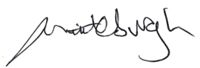
instances of non-compliance. The risk is also greater regarding irregularities occurring due to fraud rather than error, as fraud involves intentional concealment, forgery, collusion, omission or misrepresentation.
Use of our report
This report is made solely to the members, as a body, in accordance with Chapter 3 of Part 16 of the Companies Act 2006, and to the charitable company’s trustees, as a body, in accordance with section 44(1) (c) of the Charities and Trustee Investment (Scotland) Act 2005 and regulation 10 of the Charities Accounts (Scotland) Regulations 2006 (as amended). Our audit work has been undertaken so that we might state to the members and the charitable company’s trustees those matters we are required to state to them
in an auditor’s report and for no other purpose. To the fullest extent permitted by law, we do not accept or assume responsibility to anyone other than the charitable company, its members as a body, and its trustees as a body, for our audit work, for this report, or for the opinions we have formed.

Jeremy Chittleburgh BSc CA
Senior Statutory Auditor For and on Behalf of CT Audit Limited
Chartered Accountants and Statutory Auditor 61 Dublin Street, Edinburgh, EH3 6NL

Date: 17th September 2026
CT is eligible to act as an auditor in terms of section 1212 of the Companies Act 2006
A further description of our responsibilities for the audit of the financial statements is located at the Financial Reporting Council’s website at: www.frc. org.uk/auditorsresponsibilities. This description forms part of our auditor’s report.

Introduction Highlights Stories of change Bold ten-year strategy Working into practice Looking ahead Accounts 72

Statement of financial activities
For the period 1/4/25–31/3/26

Income from | Note |  | Unrestricted Funds  2025–26 £000s |  | Restricted Funds  2025–26 £000s |  | Total Funds  2025–26 £000s |  | Unrestricted Funds  2024–25 £000s |  | Restricted Funds  2024–25 £000s |  | Total Funds  2024–25 £000s
Charitable activities | 3 |  | 120 |  | 29,515 |  | 29,635 |  | 458 |  | 38,934 |  | 39,392
Investments | 5 |  | 768 |  | - |  | 768 |  | 909 |  | - |  | 909
Other | 4 |  | 1 |  | - |  | 1 |  | 11 |  | - |  | 11
Total income |  |  | 889 |  | 29,515 |  | 30,404 |  | 1,378 |  | 38,934 |  | 40,312
Expenditure on
Raising funds | 6 |  | (144) |  | - |  | (144) |  | (177) |  | - |  | (177)
Charitable activities | 7 |  | (3,106) |  | (28,266) |  | (31,372) |  | (3,220) |  | (37,602) |  | (40,822)
Total expenditure |  |  | (3,250) |  | (28,266) |  | (31,516) |  | (3,397) |  | (37,602) |  | (40,999)
Gain / (loss) on investment | 14 |  | 873 |  | - |  | 873 |  | 21 |  | - |  | 21
Net income |  |  | (1,488) |  | 1,249 |  | (239) |  | (1,998) |  | 1,332 |  | (666)
Net movement in funds |  |  | (1,488) |  | 1,249 |  | (239) |  | (1,998) |  | 1,332 |  | (666)
RECONCILIATION OF FUNDS
Total funds brought forward |  |  | 20,702 |  | 17,407 |  | 38,109 |  | 22,700 |  | 16,075 |  | 38,775
Total funds carried forward |  |  | 19,214 |  | 18,656 |  | 37,870 |  | 20,702 |  | 17,407 |  | 38,109
There are no recognised gains or losses other than those shown above. All activities relate to continuing operations.

Introduction Highlights Stories of change Bold ten-year strategy Working into practice Looking ahead Accounts 73

Statement of financial position
For the period 1/4/25–31/3/26

The accounts constitute the requirement of the Companies Act 2006 and are for circulation to the members.
Fixed assets | Note |  | 2025–26  £000s |  | 2024-25  £000s
Tangible assets | 12 |  | 11 |  | 22
Intangible assets | 13 |  | - |  | -
Investments | 14 |  | 19,272 |  | 20,442
Total fixed assets |  |  | 19,283 |  | 20,464
Current assets
Receivables | 15 |  | 291 |  | 1,129
Cash | 19 |  | 18,541 |  | 18,966
Total current assets |  |  | 18,832 |  | 20,095
Current liabilities
Grants made and payable | 16 |  | - |  | 882
Payables due within one year | 17 |  | 245 |  | 1,568
Total current liabilities |  |  | 245 |  | 2,450
Net current assets |  |  | 18,587 |  | 17,645
Net assets |  |  | 37,870 |  | 38,109
The funds of the Foundation
Restricted funds | 21 |  | 18,656 |  | 17,407
Unrestricted funds
-General fund | 21 |  | 16,195 |  | 17,783
-Designated fund | 21 |  | 3,019 |  | 2,919
Total unrestricted funds |  |  | 19,214 |  | 20,702
Total Foundation funds |  |  | 37,870 |  | 38,109

The notes form part of these accounts which were approved and authorised for issue by the Trustees on 17th September 2026 by:

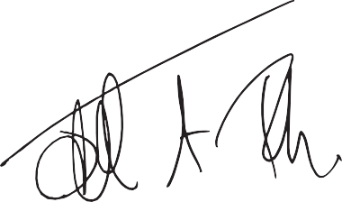

Judith Turbyne Chair
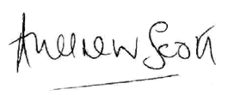

Andrew Scott
Audit Committee Chair
Company Number SC096068

Introduction Highlights Stories of change Bold ten-year strategy Working into practice Looking ahead Accounts 74

Statement of Cashflows

 | Note |  | 2025-26  £000s |  | 2024-25  £000s
Net cash generated / (used) in operating activities | 20 |  | (3,093) | (4,373)
Cash flows from investing activities
Investment income |  |  | 768 |  | 909
Purchase of tangible assets |  |  | (1) |  | (19)
Proceeds of sale of investments |  |  | 1,900 |  | 1,600
Net cash provided by investing activities |  |  | 2,667 | 2,490
Net change in cash | 19 |  | (425) |  | (1,882)
Cash at start of period |  |  | 18,966 |  | 20,848
Cash at end of period |  |  | 18,541 | 18,966

Introduction Highlights Stories of change Bold ten-year strategy Working into practice Looking ahead Accounts 75

Notes to the Accounts

Accounting policies
The principal accounting policies adopted, judgements and key sources of estimation uncertainty in the preparation of the accounts.

General Information
Corra is a Company Limited by Guarantee, incorporated in the UK and registered in Scotland, company registration number SC096068. It is also a registered charity with the Office of the Scottish Charity Regulator,
SC009481. The address of Corra’s registered office and principal place of business is: The Corra Foundation, Pure Office Suites, 4-5 Lochside Way, Edinburgh, City of Edinburgh, Scotland, EH12 9DT.
Corra’s principal activities and nature of its operations are outlined in the Trustees’ report.

Basis of preparation
The accounts have been prepared under the historical cost convention unless otherwise specified within these accounting policies, and in accordance with Accounting and Reporting by Charities: Statement of Recommended Practice applicable to charities preparing their accounts in accordance with the Financial Reporting Standard applicable in the UK and Republic of Ireland (FRS 102) (effective 1 January 2019) (the Charities SORP), the Financial Reporting Standard applicable in the UK and Republic of Ireland (FRS 102), the Companies Act 2006, the Charities and Trustee Investment (Scotland) Act 2005 and the Charities Accounts (Scotland) Regulations 2006 (as amended).

The accounts are stated in Corra’s functional currency of £ sterling.
Corra meets the definition of a public benefit entity under FRS 102. Assets and liabilities are initially recognised at historical cost or transaction value unless otherwise stated in the relevant accounting policy notes.

Going concern
Financial Reporting Standard 102 requires that, if appropriate, Corra’s accounts are prepared on the going concern basis, which means that the organisation can operate for the foreseeable future based on known and reasonable projected resources. Cash flow projections over the 12-month period from the approval of the accounts have provided the Trustees with the confidence to continue with the foundation’s charitable activities and be satisfied that the going concern basis of accounting is appropriate.
Going concern is considered by Trustees on an ongoing basis, by regularly reviewing cashflow projections, investment reports, future grant commitments and contingent liabilities. The charity has a strong Statement of Financial Position supported by its investment portfolio. The Trustees are satisfied that it is appropriate for Corra’s accounts to be prepared on
a going concern basis.

Introduction Highlights Stories of change Bold ten-year strategy Working into practice Looking ahead Accounts 76

Fund accounting
General funds are available for use at the discretion of the Trustees in furtherance of the general objectives of Corra and which have not been designated for any other purpose. Designated funds comprise unrestricted funds that have been set aside by the Trustees for specific purposes. The aim and use of each designated fund is set out in the notes to the accounts. Restricted funds are funds which are to be used in accordance with specific restrictions imposed by donors. The aim and use of each restricted fund is also set out in the notes to the accounts.

Grant income
Grant income is recognised when Corra has entitlement to the funds, any conditions attached to the items of income have been met, it is probable that the income will be received, and the amount can be measured reliably.

Income from the rendering of services
Income from a contract to provide services is recognised in the period in which the services are provided in accordance with the stage of completion of the contract when the income can be measured reliably, and it is probable that it will be received.

Income from Interest and dividends
Interest on funds held on deposit and dividends on funds held in the investment portfolio are included when receivable and the amount can be measured reliably by Corra; this is normally upon notification of the
interest paid or payable by the bank or the dividend paid is notified by the investment managers.

Expenditure
Expenditure is recognised once there is a legal or constructive obligation to make a payment to a third party, it is probable that settlement will
be required, and the amount of the obligation can be measured reliably. Expenditure is considered as expenditure on charitable activities and includes the costs of running Corra as well as grants. All costs are inclusive of any irrecoverable VAT.

Grant Expenditure
Grants payable are charged in the year when the offer is conveyed, and a valid expectation created with the recipient that the grant will be paid. Where the grant offer is conditional, such grants will not be recognised as expenditure until the conditions attached are fulfilled when a constructive
obligation arises. Grants offered subject to conditions which have not been met at the period end, are noted as a contingent liability, but not accrued as expenditure.

Introduction Highlights Stories of change Bold ten-year strategy Working into practice Looking ahead Accounts 77

Allocation of support costs
Support costs consist of direct and indirect costs expended to facilitate Corra’s charitable activities. Support costs include grant administration, trust administration, finance, personnel, payroll, governance, and other costs, which all support Corra’s grant and community-based programmes.

Cost allocation
All expenditure for Corra is allocated according to the direct programme of work for which it was incurred, or the amount of staff time spent on these activities. Costs allocated to restricted funds are limited to the levels and nature of expenditure allowable under the terms of the specific grants.

Post-retirement benefits
Corra operates a defined contribution pension scheme. The assets of the scheme are held separately from those of Corra in an independently
administered fund. The amount included within expenditure represents the contributions payable to the scheme in respect of the accounting period.

Tangible fixed assets & depreciation
Fixed assets comprise office furniture and equipment and leasehold improvements and are depreciated on a straight-line basis. All additions costing more than £800 are capitalised at cost on acquisition. Amounts below the capitalisation limit are charged to the Statement of Financial Activities in the year. Depreciation is provided to write of the cost less the estimated residual value of tangible fixed assets by equal instalments over their estimated useful economic lives as follows:
Equipment: 33% straight line Leasehold improvements: 25% straight line.

Intangible fixed assets & amortisation
Intangible fixed assets comprise computer software. Software costs are capitalised based on the cost incurred to acquire and bring into use specific software developments provided that:
- the asset created is separately identifiable,
- it is probable that the asset will generate future economic benefits; and
- the development cost of the asset can be measured reliably.
Intangible assets are amortised in equal annual instalments over their estimated useful lives from the date the asset is available for use as follows: Computer software: 20% straight line.
Computer software integral to the related hardware equipment is accounted for as equipment.

Introduction Highlights Stories of change Bold ten-year strategy Working into practice Looking ahead Accounts 78

Investments
Investments are stated at market value at each quarter end. Realised and unrealised gains and losses are calculated as the difference between the market value at the quarter end and the opening market value brought forward. Any gains and losses are combined in the Statement
of Financial Activities.

Financial Instruments
Corra only has financial assets and financial liabilities of a kind that qualify as basic financial instruments. Basic financial instruments are initially recognised at transaction value and subsequently measured at their settlement value.

Financial Assets
Debtors - Debtors which are receivable within one year and which do not constitute a financing transaction are initially measured at the transaction price. Debtors are subsequently measured at amortised cost, being the transaction price less any amounts settled and any impairment losses.

Cash
Cash at bank and in hand includes cash and short-term highly liquid investments with a short maturity of three months or less from the date of acquisition or opening of the deposit or similar account.

Financial Liabilities
Trade creditors - Trade creditors payable within one year that do not constitute a financing transaction are initially measured at the transaction price and subsequently measured at amortised cost, being the transaction price less any amounts settled. Where the arrangement with a trade creditor constitutes a financing transaction, the creditor is initially and subsequently measured at the present value of future payments discounted at a market rate of interest for a similar instrument.

Taxation
Corra is registered by OSCR as a Charity for the purposes of the Charities and Trustee Investment (Scotland) Act 2005 and is entitled under section 13(2) of the Act to describe itself as a Scottish Charity and is exempt from Corporation Tax on income and gains to the extent that these are applied to its charitable objects.

Critical accounting estimates and areas of judgement
The preparation of the accounts requires the use of certain critical accounting estimates. It also requires the trustees to exercise judgement in applying the charity’s accounting policies. The trustees have reviewed these and concluded there are no areas requiring a higher degree of judgement, or complexity, and no areas where assumptions are most significant to the accounts.

Introduction Highlights Stories of change Bold ten-year strategy Working into practice Looking ahead Accounts 79

Legal status of Corra
Corra is a company limited by guarantee and has no share capital. The liability of the members is limited by the Articles of Association to £1 each.

Income from charitable activities
Total income from charitable activities was £29.5m (2024/5 £38.9m).

Income from other trading activities
Total income from other trading activities is unrestricted.

 | 2025-26  £000s |  | 2024-25  £000s
Consultancy Fees | - |  | 10
Miscellaneous income | 1 |  | 1
 | 1 |  | 11

Income from investments
Grants received | 2025-26  £000s |  | 2024-25  £000s
The Scottish Government | 26,010 |  | 37,403
Other | 3,505 |  | 1,531
Total grants received | 29,515 |  | 38,934
Income from contracted services (unrestricted) | 120 |  | 458
Total income from charitable activities | 29,635 |  | 39,392

Total income during the period from investments.

 | 2025-26  £000s |  | 2024-25  £000s
Dividend and interest income (unrestricted) | 768 |  | 909
 | 768 |  | 909

Introduction Highlights Stories of change Bold ten-year strategy Working into practice Looking ahead Accounts 80

Costs of raising funds
Total costs of raising funds during the period.

Charitable expenditure
Corra’s charitable expenditure was a total of £31.3m (2024/25 £41m) of which £28.2m was restricted (2024/5 £37.6m) and £3.1m unrestricted (2024/5
£3.4m).
Investment manager charges | 2025-26  £000s |  | 2024-25  £000s
Investment manager charges | 144 |  | 177
 | 144 |  | 177

All expenditure incurred by Corra is considered a charitable activity. Charitable activities are those resources applied in the delivery of services to meet Corra’s charitable objectives and include grants approved, management and accommodation costs, support costs, staff employment and development, and information and marketing.
Governance costs are those associated with the public accountability of Corra and its compliance with regulation and good practice. These costs include costs related to the statutory audit and legal fees as associated with the general running of the charity.

Restricted | 2025-26  £000s |  | 2024-25  £000s
Restricted | 28,266 |  | 37,602
Unrestricted | 3,106 |  | 3,220
 | 31,372 |  | 40,822

Introduction Highlights Stories of change Bold ten-year strategy Working into practice Looking ahead Accounts 81

7. Charitable expenditure continued

Grant Programmes delivered | Grants  £000s |  | Other direct and support costs  £000s |  | 2025-26 Total  £000s |  | 2024-25 Total  £000s
Henry Duncan Grants | 724 |  | 149 |  | 873 |  | 955
Way Forward for Families Partnership | 646 |  | 150 |  | 796 |  | 658
National Drugs Mission | 12,603 |  | 565 |  | 13,168 |  | 12,167
Everyone Has a Story | - |  | 8 |  | 8 |  | 119
CYPFEIF & ALEC/CYPFAL | 8,988 |  | 117 |  | 9,105 |  | 18,206
Drugs Death Task Force Innovation | (7) |  | - |  | (7) |  | (22)
Make It Happen Fund | 149 |  | 30 |  | 179 |  | 17
Birth Parents Fund | 771 |  | 117 |  | 888 |  | 799
Boost Small Grants | 932 |  | 142 |  | 1,074 |  | 399
UNCRC Innovation Fund | - |  | - |  | - |  | 115
Drug Checking Project | 688 |  | 25 |  | 713 |  | 8
Independent Human Rights Fund | 537 |  | 82 |  | 619 |  | 576
Racial Justice Fund | 200 |  | 8 |  | 208 |  | 17

Introduction Highlights Stories of change Bold ten-year strategy Working into practice Looking ahead Accounts 82

- Charitable expenditure continued

Grant Programmes delivered | Grants  £000s |  | Other direct and support costs  £000s |  | 2025-26 Total  £000s |  | 2025-24 Total  £000s
The Challenge Fund | (7) |  | - |  | (7) |  | -
Stewart Investors Racial Equity Fund | - |  | - |  | - |  | 1
Chanel Fondation | - |  | 20 |  | 20 |  | -
The Henry Smith Promise | 300 |  | 23 |  | 323 |  | 5,356
Household Hardship Fund | 1,357 |  | 90 |  | 1,447
2025–26 Sub-totals | 27,881 |  | 1,526 |  | 29,407 |  | 39,371
Place Programmes delivered
People in Place | 60 |  | 550 |  | 610 |  | 576
Community Leadership Collective | - |  | 85 |  | 85 |  | 5
Appetite for Change | - |  | 27 |  | 27 |  | 72
Every One Every Day | - |  | 278 |  | 278 |  | 1
2025–26 Sub-totals | 60 |  | 940 |  | 1,000 |  | 654
Development & Sustainability
Corra Retained | 30 |  | 935 |  | 965 |  | 797
2025–26 Sub-totals | 30 |  | 935 |  | 965 |  | 797
2025–26 Total | 27,971 |  | 3,401 |  | 31,372 |  | 40,822

Introduction Highlights Stories of change Bold ten-year strategy Working into practice Looking ahead Accounts 83

Analysis of expenditure on support costs

Staff costs | Office recharge costs  £000s |  | Governance costs  £000s |  | 2025-26 Totals  £000s |  | 2024-25 Totals  £000s
Staff costs | 693 |  | 84 |  | 777 |  | 737
Accommodation costs | 64 |  | - |  | 64 |  | 62
Bank charges | 2 |  | - |  | 2 |  | 2
Professional, Consultancy & Communication fees | 214 |  | 18 |  | 232 |  | 224
Depreciation | 10 |  | - |  | 10 |  | 8
Travel & subsistence | 8 |  | - |  | 8 |  | 7
Governance – Trustees & advisory groups | - |  | 2 |  | 2 |  | 3
Miscellaneous / Other expenses | 65 |  | - |  | 65 |  | 33
 | 1,056 |  | 104 |  | 1,160 |  | 1,076

Introduction Highlights Stories of change Bold ten-year strategy Working into practice Looking ahead Accounts 84

Analysis of staff costs, Trustee remuneration and expenses and
the cost of key management personnel

Wages and salaries | 2025-26  £000s |  | 2024-25  £000s
Wages and salaries | 2,031 |  | 1,988
Social security costs | 266 |  | 210
Other pension costs | 240 |  | 234
Trustee remuneration | - |  | -
Other staff costs | 119 |  | 72
Total Staff & Trustee  Remuneration Costs | 2,656 |  | 2,504
Key Management Personnel Costs | 588 |  | 512

The key management personnel of Corra comprise the Trustees and Senior Management Team as set out in the Trustees’ Report. Included within wages and salaries costs are payments made to staff in connection with reorganisation amounting to £25,000.

Salary band disclosure, excluding pension contributions are as follows:

Salary Bands |  | 2025-26 No of Employees |  | 2024-25 No of Employees
£90,001 - £100,000 |  | 1 |  | 1
£80,001 - £90,000 |  | - |  | -
£70,001 - £80,000 |  | - |  | -
£60,001 - £70,000 |  | 3 |  | 1

The Trustees received no remuneration during the period 2025/6 (2024/5 nil) and no Trustee received payment for professional or other services supplied to the charity during 2025/6 (2024/5 nil). Four Trustees received aggregate expenses totaling less than £1k (2024/5 Four Trustees totaling less than £1k) during the period for travel, in connection with their duties.

Introduction Highlights Stories of change Bold ten-year strategy Working into practice Looking ahead Accounts 85

Staff numbers
The average number of full-time equivalent employees in the period.

Auditor’s remuneration
Grant-making National Drugs Mission | 2025-26 FTE |  | 2024-25 FTE
Grant-making National Drugs Mission | 6.8 |  | 7.5
Grant-making CYPFEIF & ALEC/CYPFAL | 3.4 |  | 4.1
Grant-making Other | 7.7 |  | 9.3
People in Place | 14.4 |  | 10.7
Development & Sustainability | 11.9 |  | 13.1
Total FTE staff numbers | 44.2 |  | 44.7
Average number of employees during the period | Headcount 54 |  | Headcount 53

Audit services | 2025-26  £000s |  | 2024-25  £000s
Audit services | 18 |  | 17
Total auditor's remuneration | 18 |  | 17

Auditor’s remuneration is included within governance costs.

Introduction Highlights Stories of change Bold ten-year strategy Working into practice Looking ahead Accounts 86

Tangible fixed assets
All fixed assets are held for charitable purposes.

Intangible fixed assets

Cost |  | Equipment Total  £000s
At beginning of period |  | 68
Additions |  | 1
Disposals |  | (14)
At end of period |  | 55
Depreciation
At beginning of period |  | 46
Charge for period |  | 10
On disposals |  | (12)
At end of period |  | 44
Net Book Value
As at 31 March 2026 |  | 11
As at 31 March 2025 |  | 22

Cost |  | Computer software  £000s
At beginning of period |  | 60
Additions |  | -
Disposals |  | -
At end of period |  | 60
Amortisation
At beginning of period |  | 60
Charge for period |  | -
On disposals |  | -
At end of period |  | 60
Net Book Value
As at 31 March 2026 |  | -
As at 31 March 2025 |  | -

Introduction Highlights Stories of change Bold ten-year strategy Working into practice Looking ahead Accounts 87

Fixed asset investments
During the period, Corra’s investment portfolio was managed equally by Sarasin LLP and Cazenove Capital. The portfolio was valued at £19.2m as at 31 March 2026 (2024/5 £20.4m).

Movement in investment portfolio | 2025-26  £000s |  | 2025-26  £000s
Market value as at 1 April 2025 |  |  | 20,442
Net sales and purchases |  |  | (1,899)
Gain / (Loss) on investments | 873
Investment manager charge | (144)
Net gain / (Loss) |  |  | 729
Market value as at 31 March 2026 |  |  | 19,272

Movement in investment portfolio | 2024-25  £000s |  | 2024-25  £000s
Market value as at 1 April 2024 |  |  | 22,198
Net sales and purchases |  |  | (1,600)
Gain / (Loss) on investments | 21
Investment management charge | (177)
Net gain / (loss) |  |  | (156)
Market value as at 31 March 2024 |  |  | 20,442

Introduction Highlights Stories of change Bold ten-year strategy Working into practice Looking ahead Accounts 88

Receivables 16. Grants made and payable

Accounts receivable | 2025-26  £000s |  | 2024-25  £000s
Accounts receivable | 1 |  | 874
Prepayments and accrued income | 290 |  | 255
Total receivables | 291 |  | 1,129

Payable in less than one year | 2025-26  £000s |  | 2024-25  £000s
Grants made in current year | - |  | 482
Grants made in previous years | - |  | 400
Total grants made and payable | - |  | 882

A reconciliation of the grants made in the period.

Balance as at 1 April 2025 | £000s |  | £000s
Balance as at 1 April 2025 | £000s |  | 882
Grants approved in the period | 28,001
Grants returned in the period | (90)
 |  |  | 27,911
Grants paid in the period |  |  | (28,597)
Grants returned to funders (Scot Govt) |  |  | (196)
Balance as at 31 March 2026 |  |  | -
A full list of grants paid during the year is detailed on Corra’s website at www.corra.scot

Introduction Highlights Stories of change Bold ten-year strategy Working into practice Looking ahead Accounts 89

Payables due within one year

Trade creditors | 2025-26  £000s |  | 2024-25  £000s
Trade creditors | 81 |  | 66
Deferred income | - |  | 1,283
Other creditors | 23 |  | -
Accruals | 50 |  | 129
Other taxation and social security | 91 |  | 90
Total Payables | 245 |  | 1,568
Included within Other taxation and social security are pension contributions payable amounting to £25k (2024/5 £25k).

Contingent liabilities
In addition to the grants made and payable in Note 16, the Trustees have authorised certain grants (conditional grants) which are subject to recipients fulfilling certain conditions, £12.2m (2024/5 £23.8m) of which is in relation to the Scottish Government, National Drugs Mission, funded by grant income receivable in future years.

Payment possible, due within one year | 2025-26  £000s |  | 2024-25  £000s
Payment possible, due within one year | 16,639 |  | 15,210
Payment possible, due in more than one year | 4,004 |  | 12,183
Total contingent liabilities | 20,643 |  | 27,393

Introduction Highlights Stories of change Bold ten-year strategy Working into practice Looking ahead Accounts 90

Cash flow statement
Analysis of net funds.

Reconciliation of net movement in funds to net cash flow from
operating activities

Cash at bank | At beginning of period 1 April 2025  £000s |  | Cash flow  £000s |  | At end of period 31  March 2026  £000s
Cash at bank | 18,966 |  | (425) |  | 18,541
Total net funds | 18,966 |  | (425) |  | 18,541

As the charity has no borrowings or obligations under finance leases, a reconciliation of net debt has not been disclosed.
Cashflow from operating activity | 2025-26  £000s |  | 2024-25  £000s
Deficit for the year | (239) |  | (667)
Adjustments for
Depreciation | 10 |  | 8
Amortisation | - |  | -
Investment income | (768) |  | (909)
Investment movement/charges | (729) |  | 156
 | (1,726) |  | (1,412)
(Increase) / Decrease in receivables | 837 |  | (885)
Decrease in grants payable | (882) |  | (3,079)
(Decrease) / increase in payables | (1,322) |  | 1,003
Net cash generated / (used) from operations | (3,093) |  | (4,373)

Reconciliation of net cash flow to movement in net funds.

Net funds as at 1 April 2025 | 2025-26  £000s |  | 2024-25  £000s
Net funds as at 1 April 2025 | 18,966 |  | 20,848
Movement in the period | (425) |  | (1,882)
Net funds as at 31 March 2026 | 18,541 |  | 18,966

Introduction Highlights Stories of change Bold ten-year strategy Working into practice Looking ahead Accounts 91

Statement of Funds
(a) Restricted Funds 2025/26

Way Forward for Families Partnership | Balance at 1 April 2025  £000s |  | Total income in period  £000s |  | Charitable activities  expenditure  £000s |  | Transfers in / (out)  £000s |  | Closing balance at 31 March 2026  £000s
Way Forward for Families Partnership | 899 |  | 435 |  | (445) |  | - |  | 912
National Drugs Mission | 13,771 |  | 13,993 |  | (13,168) |  | 14 |  | 14,610
CYPFEIF & ALEC/CYPFAL | - |  | 8,988 |  | (8,956) |  | - |  | 32
Drug Checking Project | 1,446 |  | 232 |  | (713) |  | - |  | 965
The Henry Smith Promise | - |  | 372 |  | (323) |  | - |  | 49
Birth Parents Fund | 105 |  | 863 |  | (888) |  | - |  | 80
Independent Human Rights Fund | 140 |  | 447 |  | (505) |  | - |  | 82
Henry Duncan Grants | - |  | 108 |  | (108) |  | - |  | -
Boost Small Grants | 101 |  | 1,630 |  | (984) |  | - |  | 747
Make it Happen | 79 |  | 252 |  | (180) |  | - |  | 151
Chanel Fondation | - |  | 224 |  | (20) |  | - |  | 204
Household Hardship Fund | - |  | 1,500 |  | (1,447) |  | - |  | 53

Introduction Highlights Stories of change Bold ten-year strategy Working into practice Looking ahead Accounts 92

Statement of Funds continued
  - Restricted Funds 2025/26

Community Leadership Collective | Balance at 1 April 2025  £000s |  | Total income in period  £000s |  | Charitable activities  expenditure  £000s |  | Transfers in / (out)  £000s |  | Closing balance at 31 March 2026  £000s
Community Leadership Collective | - |  | 210 |  | (67) |  | - |  | 143
Every One Every Day | 239 |  | 185 |  | (185) |  | - |  | 239
Other funds | 627 |  | 76 |  | (277) |  | (14) |  | 412
Total for 2025-26 | 17,407 |  | 29,515 |  | (28,266) |  | - |  | 18,656
Total for 2024-25 | 16,076 |  | 38,933 |  | (37,602) |  | - |  | 17,407

Introduction Highlights Stories of change Bold ten-year strategy Working into practice Looking ahead Accounts 93

21. Statement of Funds continued
A description is given for each fund held by Corra in 2025/6.
Way Forward for Families Partnership is a partnership between the Scottish Government and Corra Foundation to support the voluntary sector working with children and young people affected by drugs and alcohol.
National Drugs Mission is a group of Scottish Government funded programmes to improve frontline services to support people who use drugs, are in recovery, and their families; support for drug service resources with
a particular focus on residential rehabilitation and associated services; and to support children and families affected by alcohol and drugs. This is a five year programme that started during 2021.
The Scottish Government CYPFEIF & ALEC/CYPFAL Fund supports charities to deliver improvements for Scotland’s children, young people, and families.
Drug Checking Project is a Scottish Government funded programme of work with the aim of implementing Drug Checking Point of Care sites within four city pilots across Scotland.

The Henry Smith Foundation have provided funds towards two funding streams
- The Promise which supports the ‘care system’ in Scotland to apply and embed the changes needed to #KeepThePromise, helping drive forward change that matters to children, young people and families,
- Corra’s Henry Duncan Grants which provides unrestricted funding to charities and registered not for profit organisations, each year focus is on a specific theme, with Black, Asian, and Minority Ethnic Led Community Groups for 2025.

The Birth Parents Fund is a Scottish Government funded programme providing funding to community based organisations with significant experience in supporting parents affected by child protection proceedings and which deliver frontline services.
The Independent Human Rights Fund for Scotland supports action to realise and defend rights, and tackle immediate rights issues affecting people’s daily lives. The Fund is independent of government. It is supported by a group of funders that includes: AB Charitable Trust, The Baring Foundation, The Binks Trust, Elevate Great, Corra Foundation, Indigo Trust, The Robertson Trust, and William Grant Foundation.

Introduction Highlights Stories of change Bold ten-year strategy Working into practice Looking ahead Accounts 94

Boost Small Grants (including funds from STV Children’s Appeal, Foundation Scotland, Postcode Lottery and Comic Relief) is a fund for small community led organisations across Scotland supporting local people affected by poverty or disadvantage.
Make It Happen Fund (including funds from Northwood Foundation, William Grant Foundation, BBC Children in Need, and The Robertson Trust) supports community led change by enabling families, children and young people in Dundee and Clackmannanshire to set local funding priorities and decide how resources are invested in projects that make a positive difference in their communities.
Chanel Fondation are providing funds to Corra to support a funding programme for small/medium women led groups supporting women and girls facing the greatest barriers to gender equality in Scotland.
The Scottish Government Household Hardship Fund provides small grants to charities, community groups and social enterprises across Scotland who could pass the funding on directly to families and children on low incomes. The funding was used to provide cash or vouchers to meet pressing needs such as food, fuel, household items or clothing.

People in Place develops and delivers long-term place-based work alongside local people and partners with a focus on collaboration, co-production and community leadership. The final year of the Getting Alongside Communities programme was resourced by Corra, with contributions from some local authority partners towards work in specific communities. Corra’s investment in the Community Leadership Collective was matched by Esmee Fairbairn Foundation and Rank Foundation, two UK-wide funding partners with
a shared interest in supporting community leadership and place-based approaches.
Every One Every Day Kirkcaldy was funded by Corra, Fife Council and the National Lottery Community Fund who have each made an initial 3-year commitment to a programme of community led initiatives.

Introduction Highlights Stories of change Bold ten-year strategy Working into practice Looking ahead Accounts 95

21. Statement of Funds continued
  - Designated funds 2025/26

Henry Duncan grants | Balance at 1 April 2025  £000s |  | Transfer of funds  £000s |  | Charitable activities  expenditure  £000s |  | Closing balance at 31 March 2026  £000s
Henry Duncan grants | 1,653 |  | 995 |  | (766) |  | 1,882
Way Forward for Families Partnership | 899 |  | 300 |  | (351) |  | 848
Independent Human Rights Fund | 60 |  | 100 |  | (113) |  | 47
Boost Small Grants | 39 |  | 150 |  | (91) |  | 98
Community Leadership Collective | - |  | 54 |  | (17) |  | 37
Every One Every Day | - |  | 93 |  | (93) |  | -
Other funds | 268 |  | 459 |  | (620) |  | 107
Total for 2025-26 | 2,919 |  | 2,151 |  | (2,051) |  | 3,019
Total for 2024-25 | 2,691 |  | 2,217 |  | (1,989) |  | 2,919

Introduction Highlights Stories of change Bold ten-year strategy Working into practice Looking ahead Accounts 96

21. Statement of Funds continued
A total of £3m (2024/5 £2.2m) was designated from Corra’s general reserves in 2025/6.
A description is given for each fund held by Corra in 2025/6.
Henry Duncan Grants provides unrestricted funding to charities and registered not for profit organisations, each year the focus is on a specific theme, with Black, Asian and Minority Ethnic Led Community Groups
for 2025.
Way Forward for Families Partnership is to support the voluntary sector working with children and young people affected by drugs and alcohol.
The Independent Human Rights Fund for Scotland supports action to realise and defend rights, and tackle immediate rights issues affecting people’s daily lives.
Boost Small Grants is a fund for small community-led organisations across Scotland supporting local people affected by poverty or disadvantage.
People in Place develops and delivers long-term place-based work alongside local people and partners with a focus on collaboration, co-production and community leadership. Corra’s investment is across two funds; Community Leadership Collective and Every One Every Day.

Introduction Highlights Stories of change Bold ten-year strategy Working into practice Looking ahead Accounts 97

21. Statement of Funds continued
  - Unrestricted general funds 2025/26

Balance as at 1 April 2025 | 2025-26  £000s |  | 2024-25  £000s
Balance as at 1 April 2025 | 17,783 |  | 20,008
Income | 889 |  | 1,377
Expenditure | (1,199) |  | (1,406)
Investment gains | 873 |  | 21
Transfer to designated funds | (2,151) |  | (2,217)
Balance as at 31 March 2026 | 16,195 |  | 17,783

Introduction Highlights Stories of change Bold ten-year strategy Working into practice Looking ahead Accounts 98

21. Statement of Funds continued
  - Restricted Funds 2024/25
Way Forward for Families Partnership / Everyone Has a Story | Balance at 1 April 2024  £000s |  | Total income in period  £000s |  | Charitable activities  expenditure  £000s |  | Transfers in / (out)  £000s |  | Closing balance at 31 March 2025  £000s
Way Forward for Families Partnership / Everyone Has a Story | 972 |  | 475 |  | (535) |  | - |  | 912
National Drugs Mission | 12,295 |  | 13,591 |  | (12,168) |  | 53 |  | 13,771
CYPFEIF & ALEC/CYPFAL | - |  | 18,003 |  | (17,998) |  | - |  | 5
Drug Checking Project | 970 |  | 484 |  | (8) |  | - |  | 1,446
The Promise Partnership | 880 |  | 4,200 |  | (5,080) |  | - |  | -
Birth Parents | 15 |  | 889 |  | (799) |  | - |  | 105
Independent Human Rights Fund | 44 |  | 588 |  | (492) |  | - |  | 140
Racial Justice Fund | - |  | 470 |  | (17) |  | (250) |  | 203
Other funds | 900 |  | 233 |  | (505) |  | 197 |  | 825
Total for 2024-25 | 16,076 |  | 38,933 |  | (37,602) |  | - |  | 17,407
Total for 2023-24 | 18,087 |  | 36,140 |  | (38,151) |  | - |  | 16,076

Introduction Highlights Stories of change Bold ten-year strategy Working into practice Looking ahead Accounts 99

21. Statement of Funds continued
A description is given for each fund held by Corra in 2024/5.
Way Forward for Families Partnership (formerly Partnership Drugs Initiative) is a partnership between the Scottish Government and Corra Foundation to support the voluntary sector to work with children and young people affected by drugs and alcohol.
National Drugs Mission is a group of Scottish Government funded programmes to improve frontline services to support people who use drugs, are in recovery, and their families; support for drug service resources with
a particular focus on residential rehabilitation and associated services; and support children and families affected by alcohol and drugs. This is a five year programme that started during 2021.
The Scottish Government CYPFEIF & ALEC/CYPFAL Fund supports charities to deliver improvements for Scotland’s children, young people, and families. Drug Checking Project is a Scottish Government funded programme of work with the aim of implementing Drug Checking Point of Care sites within four city pilots across Scotland.

The Promise Partnership is an investment from Scottish Government, Elevate Great and STV Children’s Appeal intended to deliver change in line with Scotland’s commitment to creating capacity in the ‘care system’ to #KeepThePromise and provide holistic family support.
The Birth Parents Fund is a Scottish Government funded programme providing funding to community-based organisations with significant experience in supporting parents affected by child protection proceedings and which deliver frontline services.
The Independent Human Rights Fund for Scotland supports action to realise and defend rights, and tackle immediate rights issues affecting people’s daily lives. The Fund is independent of government. It is supported by a group of funders that includes: AB Charitable Trust, The Baring Foundation, The Binks Trust, Elevate Great, Corra Foundation, Indigo Trust, The Robertson Trust, and William Grant Foundation.
The Racial Justice Fund is funded by Comic Relief and provided proactive funding to organisations doing strong work in the area of Racial Justice in Scotland.

Introduction Highlights Stories of change Bold ten-year strategy Working into practice Looking ahead Accounts 100

Further details of these funds are available on Corra Foundation’s website. Other funds are:
- Boost Small Grants (including funds from STV Children’s Appeal and Comic Relief)
- Make It Happen Fund (including funds from Northwood Foundation, William Grant Foundation, BBC Children in Need, and The Robertson Trust)
- Maternal and Child Wellbeing Fund (including funds from the Scottish Government)
- Every One Every Day (including funds from Fife Council and the National Lottery Community Fund)

Introduction Highlights Stories of change Bold ten-year strategy Working into practice Looking ahead Accounts 101

- Statement of Funds continued
  - Designated funds 2024/25

A total of £2.2m (2023/4 £2.3m) was designated from Corra’s general reserves in 2024/5.
Henry Duncan Grants focuses on different themes each year, with women and girls the theme for 2024. This fund is fully funded by Corra Foundation. Since 2021, 30% of the fund has been ring-fenced for Black and racially minoritsed led organisations, rising to 50% in 2025.
 | Balance at 1  April 2024  £000s |  | Transfer of funds  £000s |  | Charitable activities expenditure  £000s |  | Closing balance at 31  March 2025  £000s
Henry Duncan grants | 1,529 |  | 1,078 |  | (954) |  | 1,653
Way Forward for Families Partnership / Everyone Has a Story | 840 |  | 300 |  | (242) |  | 899
H People in Place enry Duncan grants | - |  | 100 |  | (84) |  | 60
People in Place | 177 |  | 530 |  | (519) |  | 187
Other funds | 145 |  | 209 |  | (190) |  | 120
Total for 2024-25 | 2,691 |  | 2,217 |  | (1,989) |  | 2,919
Total for 2023-24 | 2,396 |  | 2,375 |  | (2,080) |  | 2,691

Way Forward for Families Partnership (formerly Partnership Drugs Initiative) is a partnership between the Scottish Government and Corra Foundation to support the voluntary sector to work with children and young people affected by drugs and alcohol.
The Independent Human Rights Fund for Scotland supports action to realise and defend rights, and tackle immediate rights issues affecting people’s daily lives. The Fund is independent of government. It is supported by a group of funders that includes: AB Charitable Trust, The Baring Foundation, The Binks Trust, Elevate Great, Corra Foundation, Indigo Trust, The Robertson Trust, and William Grant Foundation.

Introduction Highlights Stories of change Bold ten-year strategy Working into practice Looking ahead Accounts 102

People in Place works alongside communities supporting local people to connect, collaborate on ideas and take action to create positive change. The programme currently comprises three elements: Getting Alongside Communities which is primarily funded by Corra and Lankelly Chase; Every One Every Day Kirkcaldy funded by Corra, Fife Council and the National Lottery Community Fund; Community Leadership Collective funded by Corra, Esmée Fairbairn Foundation and Rank Foundation.
Other funds are:
- Boost Small Grants
- Human Rights Fund
- Appetite for Change
- Strategic Grants

Introduction Highlights Stories of change Bold ten-year strategy Working into practice Looking ahead Accounts 103

Analysis of net assets between funds

Volunteer time
Corra places great value on the contribution that volunteers make to the organisation.
Restricted Funds | Fixed assets  £000s |  | 2025-26 Net  current assets  £000s |  | Totals  £000s
Restricted Funds | - |  | 18,656 |  | 18,656
Unrestricted Funds | 19,283 |  | (3,088) |  | 16,195
Designated Funds | - |  | 3,019 |  | 3,019
Totals | 19,283 |  | 18,587 |  | 37,870

We benefitted greatly from the considerable time, energy and expertise given by the committed Board of Trustees, co-optees and advisory groups.
Rob Scholes, co-opted member of the Finance and Investment Committee (from 14 May 2024 - 11 December 2025)

Way Forward for Families Partnership Steering Group Promise Partnership Advisory Group
Restricted Funds | Fixed assets  £000s |  | 2024-25 Net  current assets  £000s |  | Totals  £000s
Restricted Funds | - |  | 17,407 |  | 17,407
Unrestricted Funds | 20,464 |  | (2,681) |  | 17,783
Designated Funds | - |  | 2,919 |  | 2,919
Totals | 20,464 |  | 17,645 |  | 38,109

National Drugs Mission Advisory Group

Introduction Highlights Stories of change Bold ten-year strategy Working into practice Looking ahead Accounts 104

Related Party Transactions
During the year, the Charity paid a grant of £196,875 (2024/25: £393,750) to Children in Scotland, an organisation of which Judith Turbyne, Chair, is the Chief Executive. The Trustee declared their interest and took no part in
the discussion or decision relating to the award of the grant. The grant was made on the same terms and through the same approval process as grants awarded to other organisations.
There were no other related party transactions in 2025/26 (2024/25 no others).



