
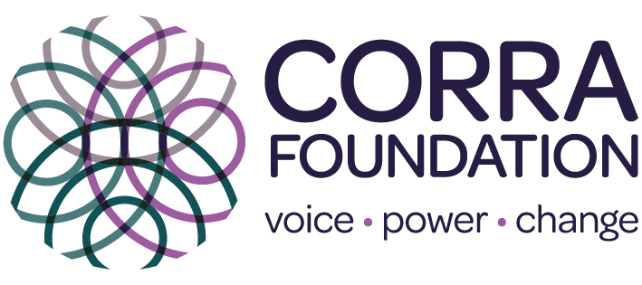

ro
Promise Partnership
Youth Led Grant Programme

Promise Partnership Youth-led Grant Programme

Overview
The Promise Partnership recognises the importance of children and young people with experience of care being meaningfully heard.
This Youth-Led Grant Programme is designed to give children and young people with care experience the opportunity to say what matters to them and for them to decide what change needs to happen in their communities to make them feel loved, safe and respected. The programme aligns with "The Promise Scotland's Plan 24-30," by focusing on voice, and enhancing the well-being and opportunities for children and young people with care experience.
Youth-led is an approach where children and young people with care experience lead in the design, development and delivery of the distribution of funding.
The programme is open to local authorities and third sector organisations. Applicants must have a commitment to embedding the Promise and be able to evidence how they actively listen and respond to children and young people with care experience. The Promise Partnership will make up to ten one-off grants of £75,000.

Objective
The purpose of this programme is to facilitate and support children and young people with care experience in their community put their ideas into action and make change happen.
The one-off grant will be split, a £50,000 “grant pot” to enable the ideas developed by children and young people with care experience to become a reality. The remaining £25,000 to support delivery costs such as payments for participation, applicant staffing and resources.
The “grant pot” allocated should support projects that matter most to the care community. This can be one idea, or several depending on what has been identified with children and young people. Final decisions on which projects/activities will be funded must be made by children and young people, guided by the appropriate links in the relevant ‘host’ organisation. These may include things like:
- Improving community/statutory spaces and facilities.
- Enhancing services and resources for care-experienced young people.
- Foster inclusion and participation in community activities.
- Designing and delivering events to raise awareness and challenge stigma.
As this is a youth led approach successful applicants are expected to have ongoing open and trusting relationships with children and young people with care experience. Previous experience of supporting community led grant decision making would be beneficial.

Eligibility
- Applicants must be local authorities or third sector organisations with a proven commitment to embedding the Promise.

- You must be able to demonstrate strong engagement and existing relationships with children and young people with care experience.

- There needs to be close connections to an established youth participation network.

- You must have existing staff members in place with time and capacity to start delivering this programme immediately.

- You must be able to spend or allocate grant funds by March 2025 and provide a lessons learned report in September 2025.

- Notes of interest must be endorsed by the Promise Lead in your area.

Application Requirements
- Completion of a note of interest which includes a detailed description of established participation networks which will lead on developing the ideas and have responsibility for decision making.
- Youth Participation: Evidence of active participation and decision-making roles for children and young people with care experience in the project planning and implementation stages.
- Network Evidence: Proof of a strong, established network with young people, including past projects or initiatives that highlight relationship-based practice and effective collaboration.
- Details on your relationship with the Promise Lead in your area.
- A clear plan on how you will engage and support children and young people with care experience in the process. This should include how to identify and review ideas and decide on fund allocation, whilst ensuring that the selected projects genuinely reflect their needs and aspirations.

What this grant can’t support
- Service delivery or existing project costs.
- Ideas that are not identified by children and young people in the care community.
- Ideas which are not in line with the Promise and the plan 24-30.

How decisions will be made

This is a one stage application process. All completed notes of interest will be reviewed by the Promise Partnership team to ensure fit with eligibility criteria.

Notes of interest that meet eligibility will be assessed by the Promise Partnership Decision Makers Panel, who will make final decisions. The Promise Partnership Team may be in touch with potential eligible applicants to seek clarification on their plans.

Timeline
This fund will launch week commencing 15th July 2024.
The closing date for notes of interest is at noon on 26th August 2024. Send completed forms to promisepartnership@corra.scot
Decisions will be made by the decision makers panel by 15th September 2024, with grant payments made shortly after.
All funds must be spent (or allocated) by March 2025, and a report providing details on spend and impact provided by September 2025.
Corra will work alongside the lead partners to offer advice, track progress and spending.

Youth-Led Grant Programme Note of Interest Application Form
Section 1
Applicant Information
Organisation
Name:
Type of organisation:
☐ Local Authority
☐ Third Sector Organisation

Organisation Lead Contact
Name:
Position:
Phone Number:
Email Address:

Promise Lead Contact
Name:
Phone Number:
Has the Promise Lead endorsed this application? Yes/No

Section 2: Youth Participation and Engagement
Established Links and Relationships
Provide details of your organisation’s existing relationships with children and young people with care experience. How do you support children and young people to ensure participation is accessible and inclusive? Include details/examples of past projects, such as any involvement in community led grant making, youth participation initiatives or groups. (max 300 words).
Youth Participation
Describe how children and young people with care experience will be involved in the overall planning of this project and the timescale for this stage. (max 300 words).
Support
Explain how you will support children and young people with care experience in the design, development, and decision-making process such as reviewing ideas and deciding on fund allocation, whilst ensuring that the selected projects genuinely reflect their needs and aspirations. (max 300 words).
Timeline
Provide a clear timeline of your plan to ensure that the funds will be spent/allocated by March 2025. Do you envisage any challenges to this? If so, how do you plan to overcome them (max 300 words).

Section 3: Network and Partnerships
Partnerships
List any partner organisations involved in this project. Describe their roles and how they will contribute to the project's success (max 200 words).
Promotion
Please tell us how you will promote this initiative and share across networks to provide opportunities for a wide range of children and young people with care experience to become involved. (max 200 words).

Section 4: Summary
Explain what drove you to apply for this funding and why your organisation is best placed to deliver. (max 200 words).

Section 5: Declaration
Authorised Signature
I hereby declare that the information provided in this application is true and accurate to the best of my knowledge.
Name:
Position:
Signature:
Date:



About Corra Foundation
Corra Foundation exists to make a difference to the lives of people and communities. It works
with others to encourage positive change, opportunity, fairness and growth of aspirations which improve quality of life. Corra wants to see a society in which people create positive change and enjoy fulfilling lives.
In 2020 Corra launched a ten-year strategy. It is long term because making a different on the big challenges will take time. At its heart is the strong belief that when people find their voice, they unlock the power to make change happen.
Our ways of working
At Corra we have a set of principles that we strive to put into practice across our roles as an
employer, independent funder, charity and partner, as well as in our influencing activity.
We will:
- Listen and respond to people, communities and organisations and amplify voices that are less well heard – their wisdom is at the heart of Corra’s approach.
- Build relationships, always working alongside others on the basis of shared power, mutual trust and shared learning.
- Pursue diversity, equity and inclusion (DEI), trying to challenge structural discrimination and contribute to radical shifts in the funding sector.
- Be an open, trusting and flexible grant maker.
- Ensure we contribute to tackling climate change, through our investments, operations and grant making and encouraging others to take action alongside us.
- Be bold, taking considered risks and supporting others to do the same.

Date of publication: 16 July 2024

Corra Foundation
Office Suite 30 Pure Offices
4 Lochside Way
Edinburgh EH12 9DT
e: hello@corra.scot
t: 0131 444 4020

